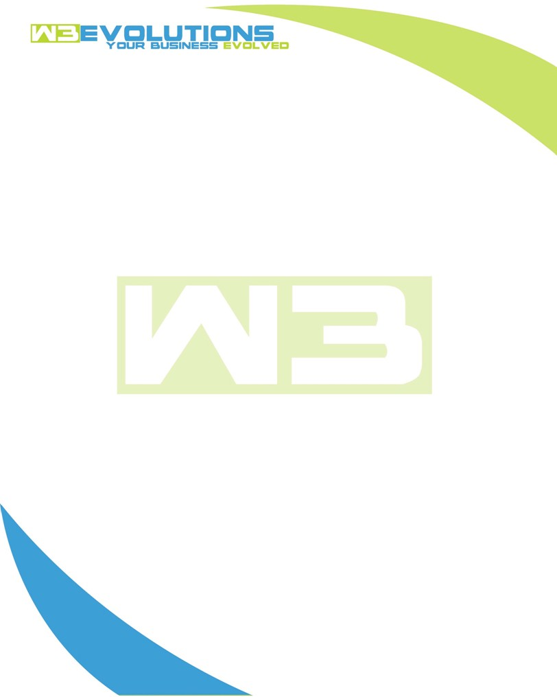

INVOICE

|  |  |
| --- | --- |
| **Bill To:** National Exemption Service, LLC 604 Packard Ct  Safety Harbor, FL 34695 | Invoice No.: NES01-5455  Customer ID: NES01 |

|  |  |  |  |  |  |  |
| --- | --- | --- | --- | --- | --- | --- |
| Date | Invoice No. | Sales Rep. | Ship Via | Terms | Date Due |  |
| 5/25/23 | NES01-5455 | Brandon Kozak | Email | NET 30 | - |  |

|  |  |  |  |  |  |  |
| --- | --- | --- | --- | --- | --- | --- |
| Quantity | Item | Description | Discount | Taxable | Unit Price | Total |
| 38 | Environment setup and Software Development | Determine mock test for outbound API calls from dev server, test blocking API, billing screen import and changes | $49 / hr off $175 / hr | No | $126 | $4,788 |
|  |  |  |  |  |  |  |
|  |  |  |  |  |  |  |
|  |  |  |  |  |  |  |
|  |  |  |  |  |  |  |

|  |  |
| --- | --- |
| Subtotal: | $4,788 |
| Tax: | 0.00 |
| Balance Due: | $4,788 |

**Please make all checks payable to:** W3Evolutions LLC **Please send checks to:** 4826 Troydale Rd Tampa FL 33615 **Zelle**: chase.zelle[@w3evolutions.com](mailto:brandon@w3evolutions.com)