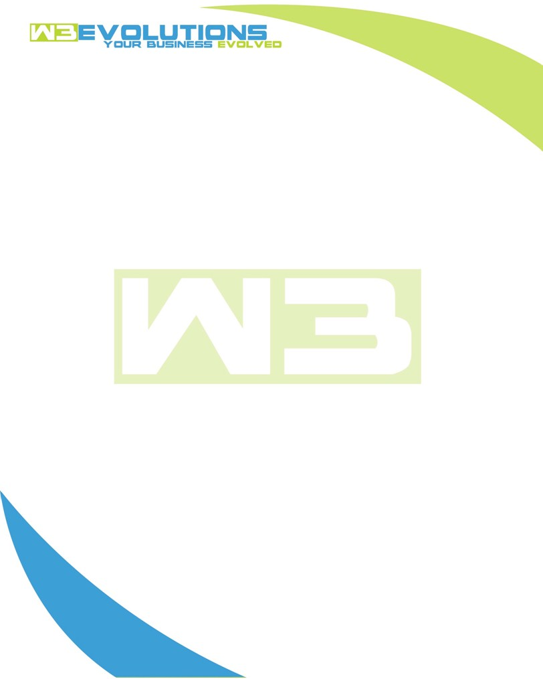

INVOICE

|  |  |
| --- | --- |
| **Bill To:** National Exemption Service, LLC 604 Packard Ct  Safety Harbor, FL 34695 | Invoice No.: NES01-5457  Customer ID: NES01 |

|  |  |  |  |  |  |  |
| --- | --- | --- | --- | --- | --- | --- |
| Date | Invoice No. | Sales Rep. | Ship Via | Terms | Date Due |  |
| 6/30/23 | NES01-5457 | Brandon Kozak | Email | NET 30 | - |  |

|  |  |  |  |  |  |  |
| --- | --- | --- | --- | --- | --- | --- |
| Quantity | Item | Description | Discount | Taxable | Unit Price | Total |
| 54 | Software Development | Research sm_billing dupes, rewrite query for billing_list, dedupe process, try to retrieve stored procedures, upload audit, UI and CSS issues, merging branches | $49 / hr off $175 / hr | No | $126 | $6,804 |
| 12 | QA | Testing new prod data on dev, stage branch, SQL safety updates, testing deduper | $49 / hr off $175 / hr | No | $126 | $1,512 |
| 3 | Management | Review next steps, peer-review code changes, communication with NES team | $49 / hr off $175 / hr | No | $126 | $378 |
|  |  |  |  |  |  |  |
|  |  |  |  |  |  |  |

|  |  |
| --- | --- |
| Subtotal: | $8,694 |
| Tax: | 0.00 |
| Balance Due: | $8,694 |

**Please make all checks payable to:** W3Evolutions LLC **Please send checks to:** 4826 Troydale Rd Tampa FL 33615 **Zelle**: chase.zelle[@w3evolutions.com](mailto:brandon@w3evolutions.com)