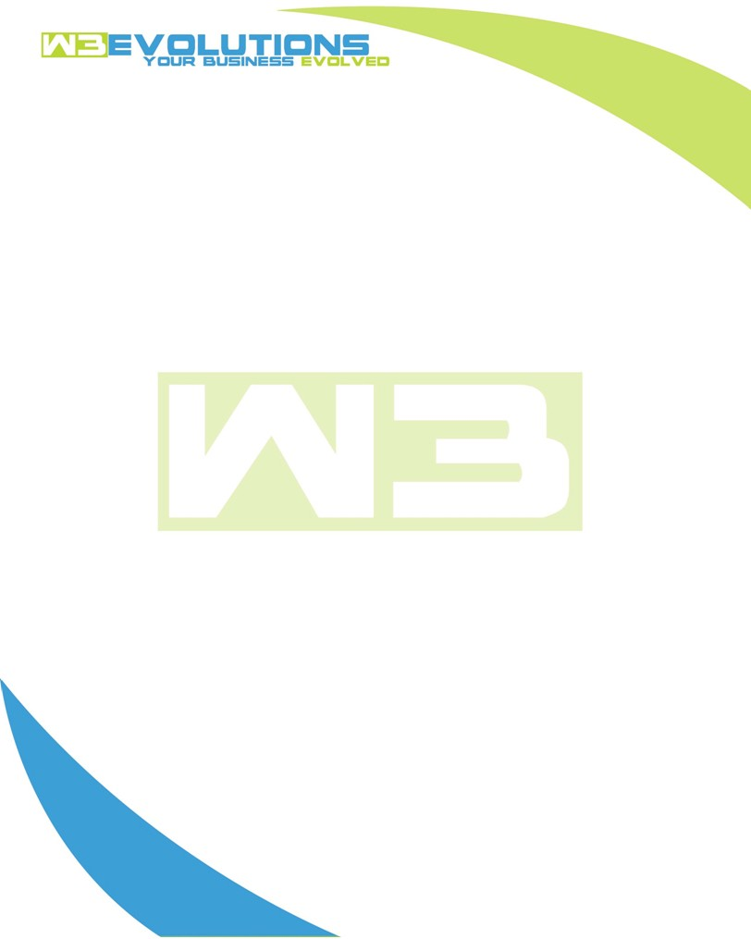

INVOICE

|  |  |
| --- | --- |
| **Bill To:** National Exemption Service, LLC 604 Packard Ct  Safety Harbor, FL 34695 | Invoice No.: NES01-5458  Customer ID: NES01 |

|  |  |  |  |  |  |  |
| --- | --- | --- | --- | --- | --- | --- |
| Date | Invoice No. | Sales Rep. | Ship Via | Terms | Date Due |  |
| 7/9/23 | NES01-5458 | Brandon Kozak | Email | NET 30 | - |  |

|  |  |  |  |  |  |  |
| --- | --- | --- | --- | --- | --- | --- |
| Quantity | Item | Description | Discount | Taxable | Unit Price | Total |
| 10 | Software Development | Review stored procedures, and impact of mail function on dev/stage and prod for launch | $49 / hr off $175 / hr | No | $143.50 | $1,435.00 |
| 9 | QA/Management | Update stage site, testing, merging, meeting, delivery of staging site, obtaining new reqs | $49 / hr off $175 / hr | No | $143.50 | $1,291.50 |
|  |  |  |  |  |  |  |
|  |  |  |  |  |  |  |
|  |  |  |  |  |  |  |

|  |  |
| --- | --- |
| Subtotal: | $2,726.50 |
| Tax: | 0.00 |
| Balance Due: | $2,726.50 |

**Please make all checks payable to:** W3Evolutions LLC **Please send checks to:** 4826 Troydale Rd Tampa FL 33615 **Zelle**: chase.zelle[@w3evolutions.com](mailto:brandon@w3evolutions.com)