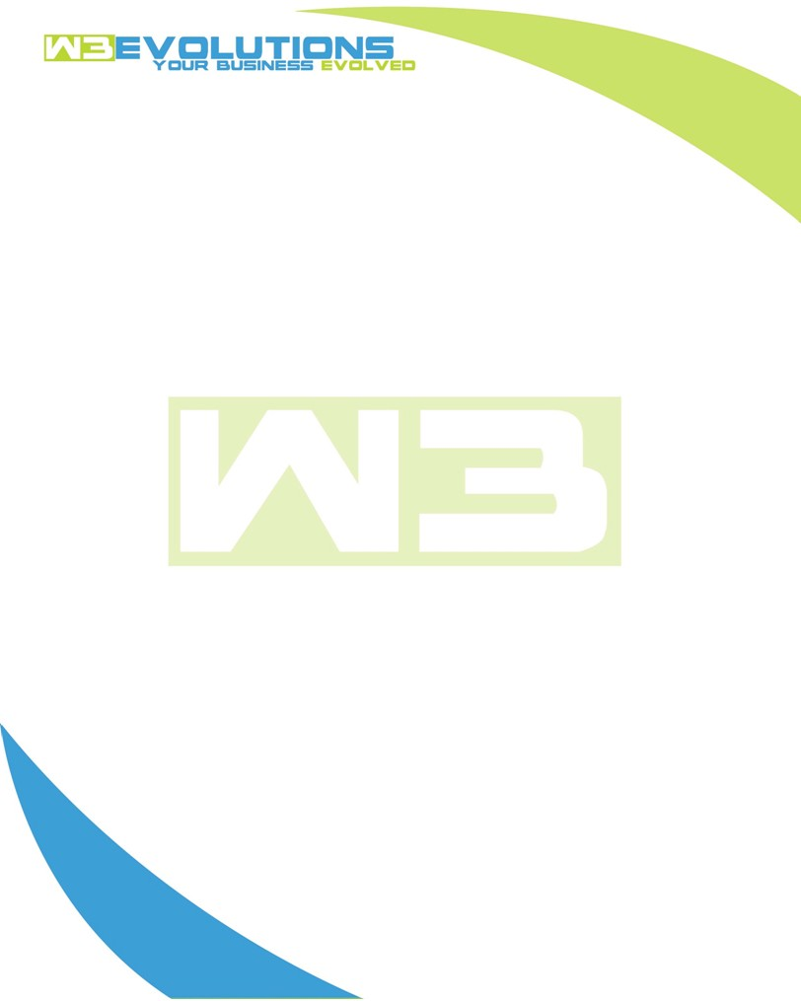

INVOICE

|  |  |
| --- | --- |
| **Bill To:** National Exemption Service, LLC 604 Packard Ct  Safety Harbor, FL 34695 | Invoice No.: NES01-5461  Customer ID: NES01 |

|  |  |  |  |  |  |  |
| --- | --- | --- | --- | --- | --- | --- |
| Date | Invoice No. | Sales Rep. | Ship Via | Terms | Date Due |  |
| 8/14/23 | NES01-5461 | Brandon Kozak | Email | NET 30 | - |  |

|  |  |  |  |  |  |  |
| --- | --- | --- | --- | --- | --- | --- |
| Quantity | Item | Description | Discount | Taxable | Unit Price | Total |
| 14 | Software Development  (w/e 7/27) | R&D on “always waive” process and workflow, attribute sql and code | $31.50 / hr off $175 / hr | No | $143.50 | $2,009 |
| 23 | Management | Setting up VPN, dev-db1, dev-app1, incremental database copier | $49 / hr off $175 / hr | No | $126 | $2,898 |
| 34 | Software Development  (w/e 8/13) | Reconfigure stage server to improve performance, researching INNODB updates/triggers, tuning mysql, file upload/import issues and process for new import templates | $49 / hr off $175 / hr | No | $126 | $4,284 |
|  |  |  |  |  |  |  |
|  |  |  |  |  |  |  |

|  |  |
| --- | --- |
| Subtotal: | $9,191 |
| Tax: | 0.00 |
| Balance Due: | $9,191 |

**Please make all checks payable to:** W3Evolutions Systems LLC

**Please send checks to:** 4826 Troydale Rd, Tampa FL 33615

**Zelle**: zelle.wf[@w3evolutions.com](mailto:brandon@w3evolutions.com)