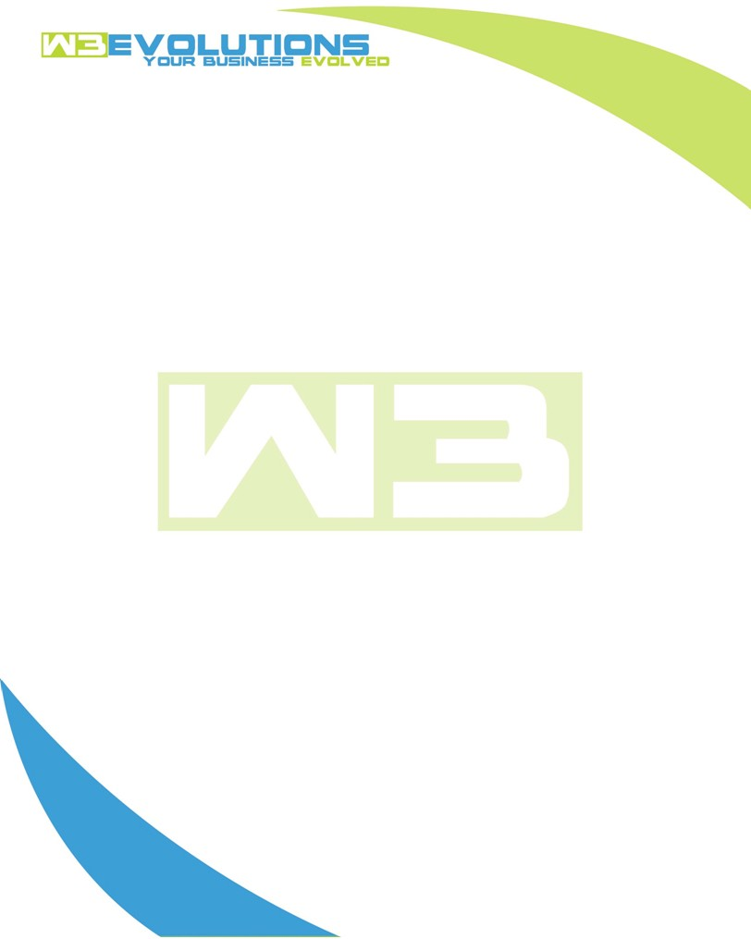

INVOICE

|  |  |
| --- | --- |
| **Bill To:** National Exemption Service, LLC 604 Packard Ct  Safety Harbor, FL 34695 | Invoice No.: NES01-5463  Customer ID: NES01 |

|  |  |  |  |  |  |  |
| --- | --- | --- | --- | --- | --- | --- |
| Date | Invoice No. | Sales Rep. | Ship Via | Terms | Date Due |  |
| 9/20/23 | NES01-5463 | Brandon Kozak | Email | NET 30 | - |  |

|  |  |  |  |  |  |  |
| --- | --- | --- | --- | --- | --- | --- |
| Quantity | Item | Description | Discount | Taxable | Unit Price | Total |
| 59 | Software Development | Phase 1 updates & testing, Merge push to new stage, Minor updates for Phase 1 additions, Fixing workflow for request homework email, Deduping Billing Screen, Deployment Prep, CSV Export, Attributes under units section, Update data copier | $49 / hr off $175 / hr | No | $126 | $7,434 |
| 23 | Management | Jira management, Meeting with Ralph & Scott, Confluence pages, Documentation, Weekly Meeting, Bill Pull List epic, Gather requirements for import charge | $49 / hr off $175 / hr | No | $126 | $2,898 |
|  |  |  |  |  |  |  |
|  |  |  |  |  |  |  |

|  |  |
| --- | --- |
| Subtotal: | $10,332 |
| Tax: | 0.00 |
| Balance Due: | $10,332 |

**Please make all checks payable to:** W3Evolutions Systems LLC

**Please send checks to:** 4826 Troydale Rd, Tampa FL 33615

**Zelle**: zelle.wf[@w3evolutions.com](mailto:brandon@w3evolutions.com)