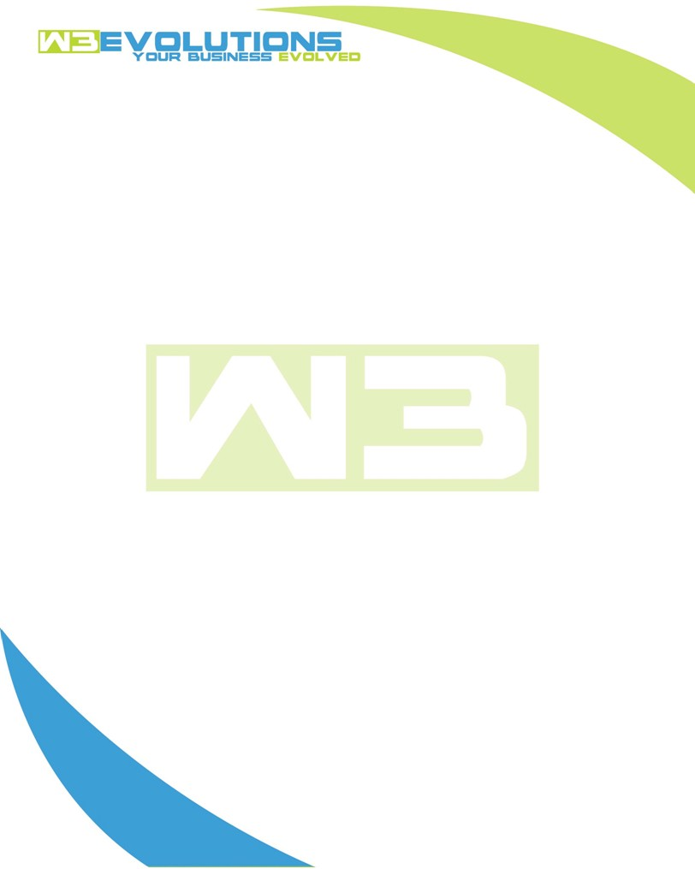

INVOICE

|  |  |
| --- | --- |
| **Bill To:** National Exemption Service, LLC 604 Packard Ct  Safety Harbor, FL 34695 | Invoice No.: NES01-5465  Customer ID: NES01 |

|  |  |  |  |  |  |  |
| --- | --- | --- | --- | --- | --- | --- |
| Date | Invoice No. | Sales Rep. | Ship Via | Terms | Date Due |  |
| 10/6/23 | NES01-5465 | Brandon Kozak | Email | NET 30 | - |  |

|  |  |  |  |  |  |  |
| --- | --- | --- | --- | --- | --- | --- |
| Quantity | Item | Description | Discount | Taxable | Unit Price | Total |
| 21 | Software Development | Fix dedupe, build scrubber for incoming ghseet data, update database obj, put together list of unknowns from sheet, demo of AiDA send to GSheet maker, Gsheet syncer, deduper, code clean up | $49 / hr off $175 / hr | No | $126 | $2,646 |
| 2 | Management | Meeting regarding the different ways to update GSheet from Aida | $49 / hr off $175 / hr | No | $126 | $252 |
|  |  |  |  |  |  |  |
|  |  |  |  |  |  |  |

|  |  |
| --- | --- |
| Subtotal: | $2,898 |
| Tax: | 0.00 |
| Balance Due: | $2,898 |

**Please make all checks payable to:** W3Evolutions Systems LLC

**Please send checks to:** 4826 Troydale Rd, Tampa FL 33615

**Zelle**: zelle.wf[@w3evolutions.com](mailto:brandon@w3evolutions.com)