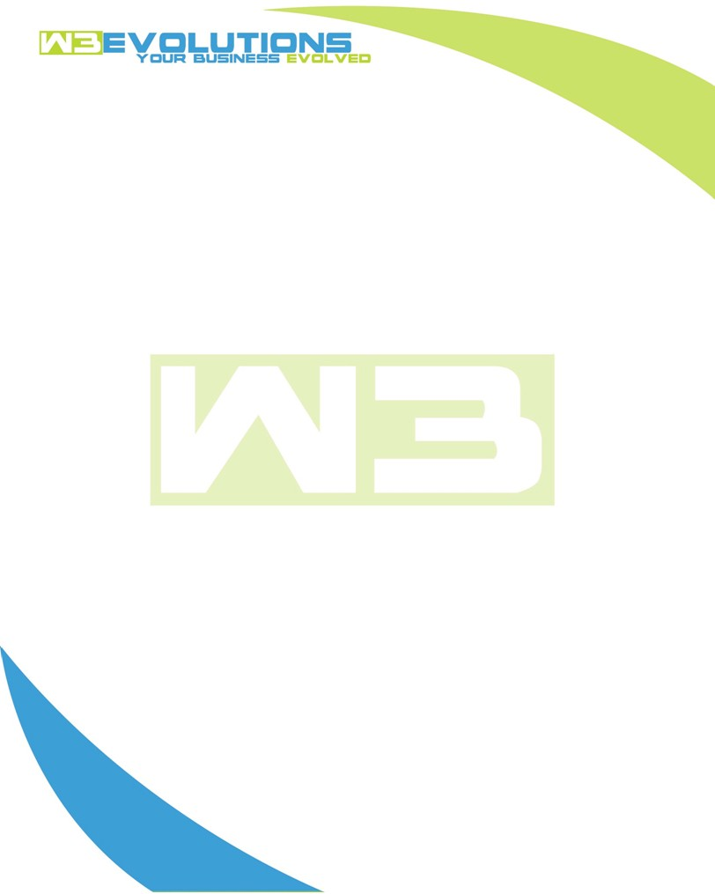

INVOICE

|  |  |
| --- | --- |
| **Bill To:** National Exemption Service, LLC 604 Packard Ct  Safety Harbor, FL 34695 | Invoice No.: NES01-5466  Customer ID: NES01 |

|  |  |  |  |  |  |  |
| --- | --- | --- | --- | --- | --- | --- |
| Date | Invoice No. | Sales Rep. | Ship Via | Terms | Date Due |  |
| 10/19/23 | NES01-5466 | Brandon Kozak | Email | NET 30 | - |  |

|  |  |  |  |  |  |  |
| --- | --- | --- | --- | --- | --- | --- |
| Quantity | Item | Description | Discount | Taxable | Unit Price | Total |
| 127 | Software Development | Cycle Notes Refresh Issues, Testing GSheet Syncers, GSheet Bidirectional Sync, Script to Mass Update Monthly Rates Attribute, Preparing GSheet Sync for Production, testing, and cleanup | $49 / hr off $175 / hr | No | $126 | $16,002 |
|  |  |  |  |  |  |  |
|  |  |  |  |  |  |  |
|  |  |  |  |  |  |  |

|  |  |
| --- | --- |
| Subtotal: | $16,002 |
| Tax: | 0.00 |
| Balance Due: | $16,002 |

**Please make all checks payable to:** W3Evolutions Systems LLC

**Please send checks to:** 4826 Troydale Rd, Tampa FL 33615

**Zelle**: zelle.wf[@w3evolutions.com](mailto:brandon@w3evolutions.com)