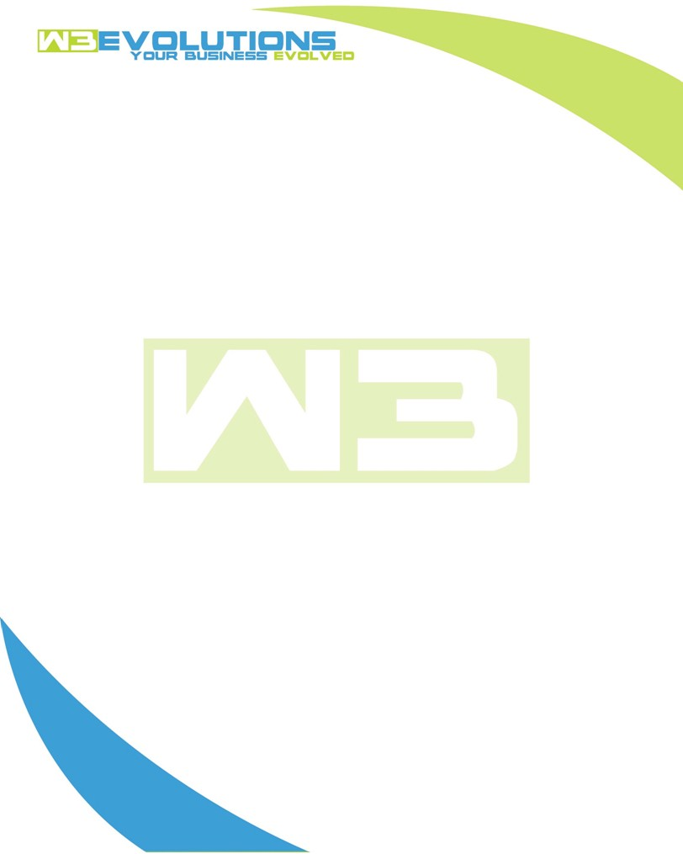

INVOICE

|  |  |
| --- | --- |
| **Bill To:** National Exemption Service, LLC 604 Packard Ct  Safety Harbor, FL 34695 | Invoice No.: NES01-5474  Customer ID: NES01 |

|  |  |  |  |  |  |  |
| --- | --- | --- | --- | --- | --- | --- |
| Date | Invoice No. | Sales Rep. | Ship Via | Terms | Date Due |  |
| 12/26/23 | NES01-5474 | Brandon Kozak | Email | NET 30 | - |  |

|  |  |  |  |  |  |  |
| --- | --- | --- | --- | --- | --- | --- |
| Quantity | Item | Description | Discount | Taxable | Unit Price | Total |
| 54 | Software Development | See attached | $49 / hr off $175 / hr | No | $126 | $6804 |
|  |  |  |  |  |  |  |
|  |  |  |  |  |  |  |
|  |  |  |  |  |  |  |

|  |  |
| --- | --- |
| Subtotal: | $6804 |
| Tax: | 0.00 |
| Balance Due: | $6804 |

**Please make all checks payable to:** W3Evolutions Systems LLC

**Please send checks to:** 4826 Troydale Rd, Tampa FL 33615

**Zelle**: zelle.wf[@w3evolutions.com](mailto:brandon@w3evolutions.com)

|  |  |  |  |  |
| --- | --- | --- | --- | --- |
| **Date** | **Hours** | **Category** | **Task/Work** | **Persons** |
| 12/11/2023 | 4 | Software Development | AAE-22 - new upload file with missing data add code to hanlde this | BK |
| 12/12/2023 | 4 | Software Development | AAE-22 - Test code rework fro new file with missing data | BK |
| 12/13/2023 | 4 | Software Development | AAE-37 - Research proc issues for MySQL8 | BK |
| 12/14/2023 | 4 | Software Development | AAE-22 - Prepare for weekend prod release | BK |
| 12/15/2023 | 6 | Software Development | Wekend Release prep | BK |
| 12/18/2023 | 2 | Software Development | Release | BK |
| 12/18/2023 | 4 | Software Development | AAE-37 - Continue Proc research for MySQL 8 | BK |
| 12/19/2023 | 4 | Software Development | AAE-37 - Continue Proc research for MySQL 8 | BK |
| 12/20/2023 | 4 | Software Development | AAE-22 - Review final data sets from multiple sheets with different data | BK |
| 12/21/2023 | 4 | Software Development | AAE-22 - Bug fixing and retesting on stage with data sync from read replica | BK |
| 12/22/2023 | 2 | Software Development | Wekend Release prep | BK |
| 12/25/2023 | 2 | Software Development | Release | BK |
| 12/23/2023 | 4 | Software Development | AAE-30 - Bill Scraping - Automating Download of PDFs | DH |
| 12/24/2023 | 4 | Software Development | AAE-30 - Bill Scraping - Automating Download of PDFs | DH |
| 12/25/2023 | 2 | Software Development | AAE-30 - Bill Scraping - Automating Download of PDFs | DH |