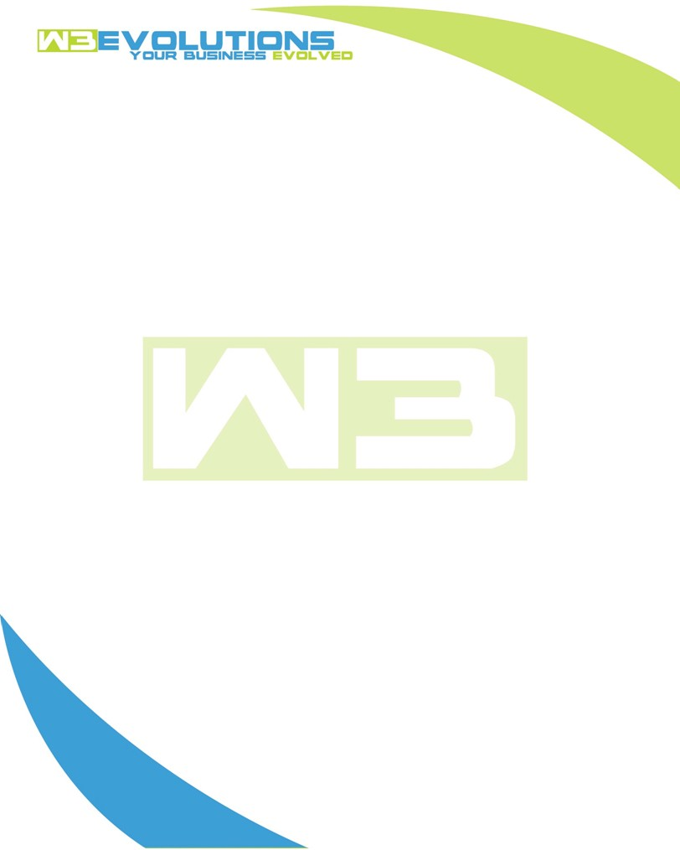

INVOICE

|  |  |
| --- | --- |
| **Bill To:** National Exemption Service, LLC 604 Packard Ct  Safety Harbor, FL 34695 | Invoice No.: NES01-5476  Customer ID: NES01 |

|  |  |  |  |  |  |  |
| --- | --- | --- | --- | --- | --- | --- |
| Date | Invoice No. | Sales Rep. | Ship Via | Terms | Date Due |  |
| 2/1/24 | NES01-5477 | Brandon Kozak | Email | NET 30 | - |  |

|  |  |  |  |  |  |  |
| --- | --- | --- | --- | --- | --- | --- |
| Quantity | Item | Description | Discount | Taxable | Unit Price | Total |
| 72 | Software Development | See attached | $49 / hr off $175 / hr | No | $126 | $9,072 |
|  |  |  |  |  |  |  |
|  |  |  |  |  |  |  |
|  |  |  |  |  |  |  |

|  |  |
| --- | --- |
| Subtotal: | $9,072 |
| Tax: | 0.00 |
| Balance Due: | $9,072 |

**Please make all checks payable to:** W3Evolutions Systems LLC

**Please send checks to:** 4826 Troydale Rd, Tampa FL 33615

**Zelle**: zelle.wf[@w3evolutions.com](mailto:brandon@w3evolutions.com)

|  |  |  |  |  |
| --- | --- | --- | --- | --- |
| **Date** | **Hours** | **Category** | **Task/Work** | **Persons** |
|  |  |  |  |  |
| **01/28/2024** | **8** | **Software Development** | **AAE-93 - Rebuild server with MariaDB @latest and retest** | **DH** |
| **01/28/2024** | **8** | **Software Development** | **AAE-97 - Launch latest version of AAE-97 + prepare for Monday support** | **BK** |
| **01/29/2024** | **8** | **Software Development** | **AAE-93 - Rebuild server with MariaDB @latest and retest** | **DH** |
| **01/29/2024** | **8** | **Software Development** | **AAE-97 - Finalize remaning batch reassignment feature** | **BK** |
| **01/30/2024** | **8** | **Software Development** | **AAE-97 - Finalize remaning batch reassignment feature** | **BK** |
| **01/30/2024** | **8** | **Software Development** | **AAE-93 - Rebuild server with MariaDB @latest and retest** | **DH** |
| **01/31/2024** | **8** | **Software Development** | **AAE-97 - Finalized and released AAE-97** | **BK** |
| **01/31/2024** | **8** | **Software Development** | **AAE-93 - Rebuild server with MariaDB @latest and retest** | **DH** |
| **02/01/2024** | **8** | **Software Development** | **AAE-87 - Continue with PHP upgrades for portal server** | **BK** |