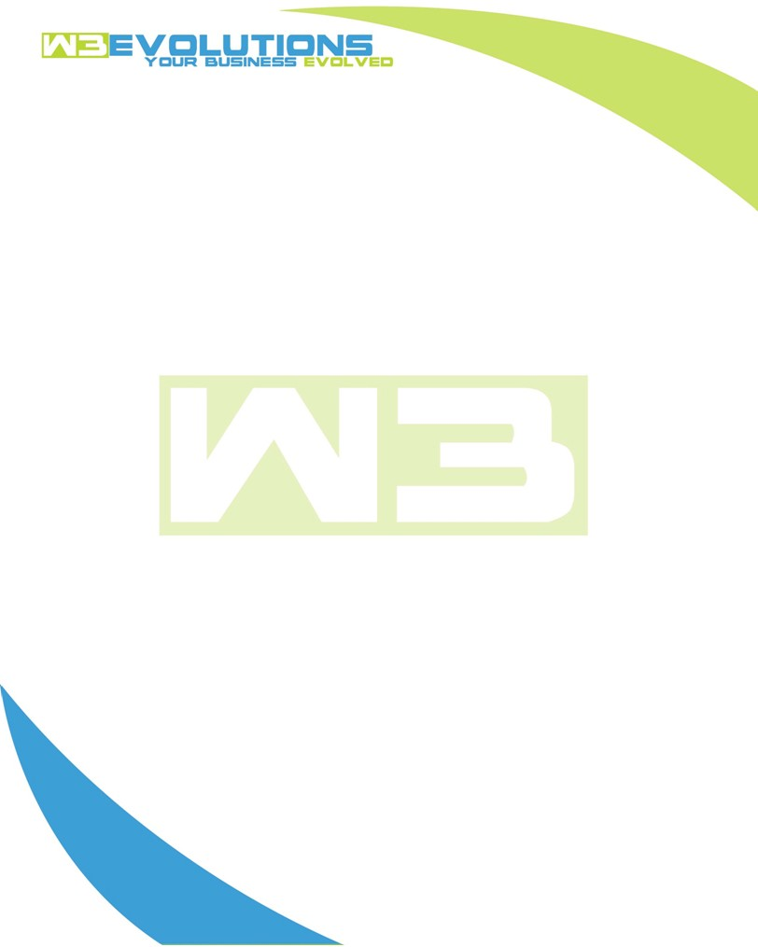

INVOICE

|  |  |
| --- | --- |
| **Bill To:** National Exemption Service, LLC 604 Packard Ct  Safety Harbor, FL 34695 | Invoice No.: NES01-5481  Customer ID: NES01 |

|  |  |  |  |  |  |  |
| --- | --- | --- | --- | --- | --- | --- |
| Date | Invoice No. | Sales Rep. | Ship Via | Terms | Date Due |  |
| 2/29/24 | NES01-5481 | Brandon Kozak | Email | NET 30 | - |  |

|  |  |  |  |  |  |  |
| --- | --- | --- | --- | --- | --- | --- |
| Quantity | Item | Description | Discount | Taxable | Unit Price | Total |
| 79 | Software Development | See attached | $49 / hr off $175 / hr | No | $126 | $9,954 |
|  |  |  |  |  |  |  |
|  |  |  |  |  |  |  |
|  |  |  |  |  |  |  |

|  |  |
| --- | --- |
| Subtotal: | $9,954 |
| Tax: | 0.00 |
| Balance Due: | $9,954 |

**Please make all checks payable to:** W3Evolutions Systems LLC

**Please send checks to:** 4826 Troydale Rd, Tampa FL 33615

**Zelle**: zelle.wf[@w3evolutions.com](mailto:brandon@w3evolutions.com)

|  |  |  |  |  |
| --- | --- | --- | --- | --- |
| **Date** | **Hours** | **Category** | **Task/Work** | **Persons** |
|  |  |  |  |  |
|  |  |  |  |  |
| **02/22/2024** | **6** | **Software Development** | **AAE-32 - Continued development on finding and downloading PDFs** | **BK** |
| **02/23/2024** | **4** | **Software Development** | **AAE-32 - Continued development on finding and downloading PDFs** | **BK** |
| **02/23/2024** | **4** | **Software Development** | **AAE-11 - Continue code development** | **BK** |
| **02/25/2024** | **4** | **Software Development** | **AAE-107 - Add Mongo Drivers to Audits branch** | **BK** |
| **02/26/2024** | **4** | **Software Development** | **AAE-107 - Add Mongo Drivers to Audits branch** | **BK** |
| **02/26/2024** | **4** | **Management** | **Review all tasks, meeting recordings, update jira** | **BK/DH** |
| **02/27/2024** | **8** | **Software Development** | **AAE-110 - Test 20.04 -> 22.04 upgrade of mysql stage server** | **BK** |
| **02/28/2024** | **8** | **Software Development** | **AAE-99 - reverse merge outdated sub map with new prod + AAE-52/AAE-107** | **BK** |
| **02/22/2024** | **4** | **Software Development** | **AAE-105 Bill Extractor - Management UI** | **DH** |
| **02/23/2024** | **5** | **Software Development** | **AAE-105 Bill Extractor - Management UI** | **DH** |
| **02/26/2024** | **8** | **Software Development** | **AAE-105 Bill Extractor - Management UI** | **DH** |
| **02/27/2024** | **8** | **Software Development** | **AAE-105 Bill Extractor - Management UI** | **DH** |
| **02/28/2024** | **10** | **Software Development** | **AAE-105 Bill Extractor - Management UI** | **DH** |
| **02/28/2024** | **2** | **Management** | **Review meeting videos and track waht parts of the videos are to what jira tickets** | **DH** |
|  |  |  |  |  |