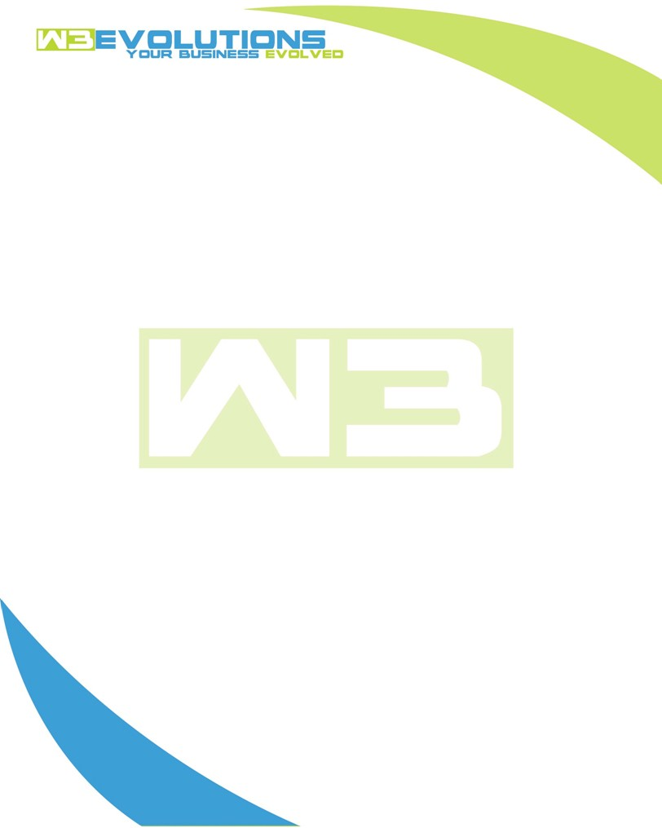

INVOICE

|  |  |
| --- | --- |
| **Bill To:** National Exemption Service, LLC 604 Packard Ct  Safety Harbor, FL 34695 | Invoice No.: NES01-5484  Customer ID: NES01 |

|  |  |  |  |  |  |  |
| --- | --- | --- | --- | --- | --- | --- |
| Date | Invoice No. | Sales Rep. | Ship Via | Terms | Date Due |  |
| 3/21/24 | NES01-5484 | Brandon Kozak | Email | NET 30 | - |  |

|  |  |  |  |  |  |  |
| --- | --- | --- | --- | --- | --- | --- |
| Quantity | Item | Description | Discount | Taxable | Unit Price | Total |
| 68 | Software Development | See attached | $49 / hr off $175 / hr | No | $126 | $8,568 |
|  |  |  |  |  |  |  |
|  |  |  |  |  |  |  |
|  |  |  |  |  |  |  |

|  |  |
| --- | --- |
| Subtotal: | $8,568 |
| Tax: | 0.00 |
| Balance Due: | $8,568 |

**Please make all checks payable to:** W3Evolutions Systems LLC

**Please send checks to:** 4826 Troydale Rd, Tampa FL 33615

**Zelle**: zelle.wf[@w3evolutions.com](mailto:brandon@w3evolutions.com)

|  |  |  |  |  |
| --- | --- | --- | --- | --- |
| **Date** | **Hours** | **Category** | **Task/Work** | **Persons** |
|  |  |  |  |  |
| **03/15/2024** | **10** | **Software Development** | **AAE-10 - Phase 2 - Prep for UAT** | **BK** |
| **03/16/2024** | **10** | **Software Development** | **AAE-10 - Phase 2 - Prep for UAT** | **BK** |
| **03/17/2024** | **10** | **Software Development** | **AAE-10 - Phase 2 - Prep for UAT** | **BK** |
| **03/18/2024** | **8** | **Software Development** | **AAE-10 - Phase 2 UAT started, data sync, logging, debugging and error handling as UAT starts** | **BK** |
| **03/19/2024** | **10** | **Software Development** | **AAE-10 - Phase 2 UAT started, data sync, logging, debugging and error handling as UAT starts** | **BK** |
| **03/20/2024** | **10** | **Software Development** | **AAE-13 - Portal stage site setup** | **BK** |
| **03/21/2024** | **10** | **Software Development** | **AAE-13 - Portal stage site + testing AAE-13 portal side** | **BK** |