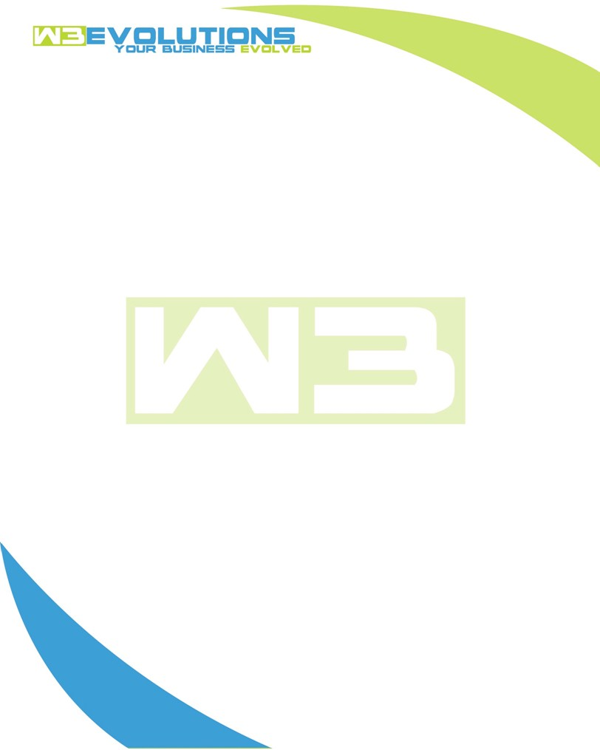

INVOICE

|  |  |
| --- | --- |
| **Bill To:** National Exemption Service, LLC 604 Packard Ct  Safety Harbor, FL 34695 | Invoice No.: NES01-5486  Customer ID: NES01 |

|  |  |  |  |  |  |  |
| --- | --- | --- | --- | --- | --- | --- |
| Date | Invoice No. | Sales Rep. | Ship Via | Terms | Date Due |  |
| 4/8/24 | NES01-5486 | Brandon Kozak | Email | NET 30 | - |  |

|  |  |  |  |  |  |  |
| --- | --- | --- | --- | --- | --- | --- |
| Quantity | Item | Description | Discount | Taxable | Unit Price | Total |
| 42 | Software Development | See attached | $49 / hr off $175 / hr | No | $126 | $5,292 |
|  |  |  |  |  |  |  |
|  |  |  |  |  |  |  |
|  |  |  |  |  |  |  |

|  |  |
| --- | --- |
| Subtotal: | $5,292 |
| Tax: | 0.00 |
| Balance Due: | $5,292 |

**Please make all checks payable to:** W3Evolutions Systems LLC

**Please send checks to:** 4826 Troydale Rd, Tampa FL 33615

**Zelle**: zelle.wf[@w3evolutions.com](mailto:brandon@w3evolutions.com)

|  |  |  |  |  |
| --- | --- | --- | --- | --- |
| **Date** | **Hours** | **Category** | **Task/Work** | **Persons** |
|  |  |  |  |  |
| **4/1/2024** | **10** | **Software Development** | **AAE-10 Start of UAT, start recoding of AAE-100** | **BK** |
| **4/2/2024** | **4** | **Software Development** | **AAE-100 - recoding,** | **BK** |
| **4/2/2024** | **4** | **Software Development** | **AAE-10 - monitor UAT and servers for Audits** | **BK** |
| **4/3/2024** | **4** | **Software Development** | **AAE-100 - testing updated from Chuck** | **BK** |
| **4/3/2024** | **4** | **Software Development** | **AAE-10 - monitor UAT and servers for Audits** | **BK** |
| **4/4/2024** | **8** | **Software Development** | **AAE-100 - Continued DevelopmentBK** | **BK** |
| **4/5/2024** | **4** | **Software Development** | **AAE-10 - Review Redis data + stability** | **BK** |
| **4/5/2024** | **4** | **Software Development** | **AAE-100 - Continued DevelopmentBK** | **BK** |