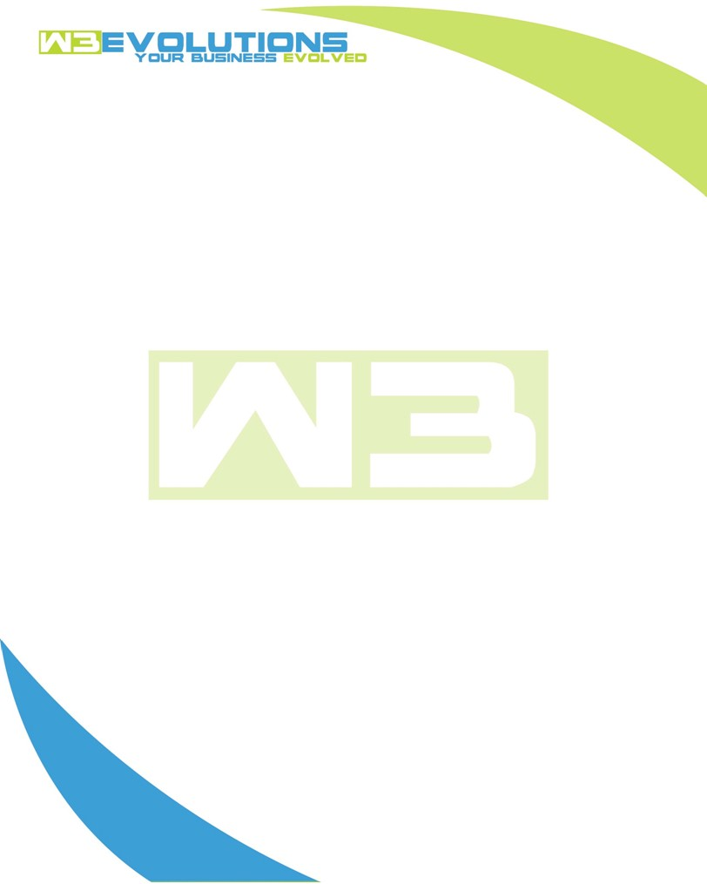

INVOICE

|  |  |
| --- | --- |
| **Bill To:** National Exemption Service, LLC 604 Packard Ct  Safety Harbor, FL 34695 | Invoice No.: NES01-5487  Customer ID: NES01 |

|  |  |  |  |  |  |  |
| --- | --- | --- | --- | --- | --- | --- |
| Date | Invoice No. | Sales Rep. | Ship Via | Terms | Date Due |  |
| 4/15/24 | NES01-5487 | Brandon Kozak | Email | NET 30 | - |  |

|  |  |  |  |  |  |  |
| --- | --- | --- | --- | --- | --- | --- |
| Quantity | Item | Description | Discount | Taxable | Unit Price | Total |
| 37 | Software Development | See attached | $49 / hr off $175 / hr | No | $126 | $4,662 |
|  |  |  |  |  |  |  |
|  |  |  |  |  |  |  |
|  |  |  |  |  |  |  |

|  |  |
| --- | --- |
| Subtotal: | $4,662 |
| Tax: | 0.00 |
| Balance Due: | $4,662 |

**Please make all checks payable to:** W3Evolutions Systems LLC

**Please send checks to:** 4826 Troydale Rd, Tampa FL 33615

**Zelle**: zelle.wf[@w3evolutions.com](mailto:brandon@w3evolutions.com)

|  |  |  |  |  |
| --- | --- | --- | --- | --- |
| **Date** | **Hours** | **Category** | **Task/Work** | **Persons** |
|  |  |  |  |  |
| **4/7/2024** | **1** | **Software Development** | **Weekend cleanup** | **BK** |
| **4/8/2024** | **8** | **Software Development** | **AAE-125 - Fix bug in portal stage** | **BK** |
| **4/9/0204** | **8** | **Software Development** | **AAE-125 - Fix bug in protal stage** | **BK** |
| **4/10/2024** | **6** | **Software Development** | **AAE-100 - Continued Development** | **BK** |
| **4/11/2024** | **6** | **Software Development** | **AAE-100 - Continued Development** | **BK** |
| **4/12/2024** | **8** | **Software Development** | **AAE-100 - Testing new workflows and debugging** | **BK** |