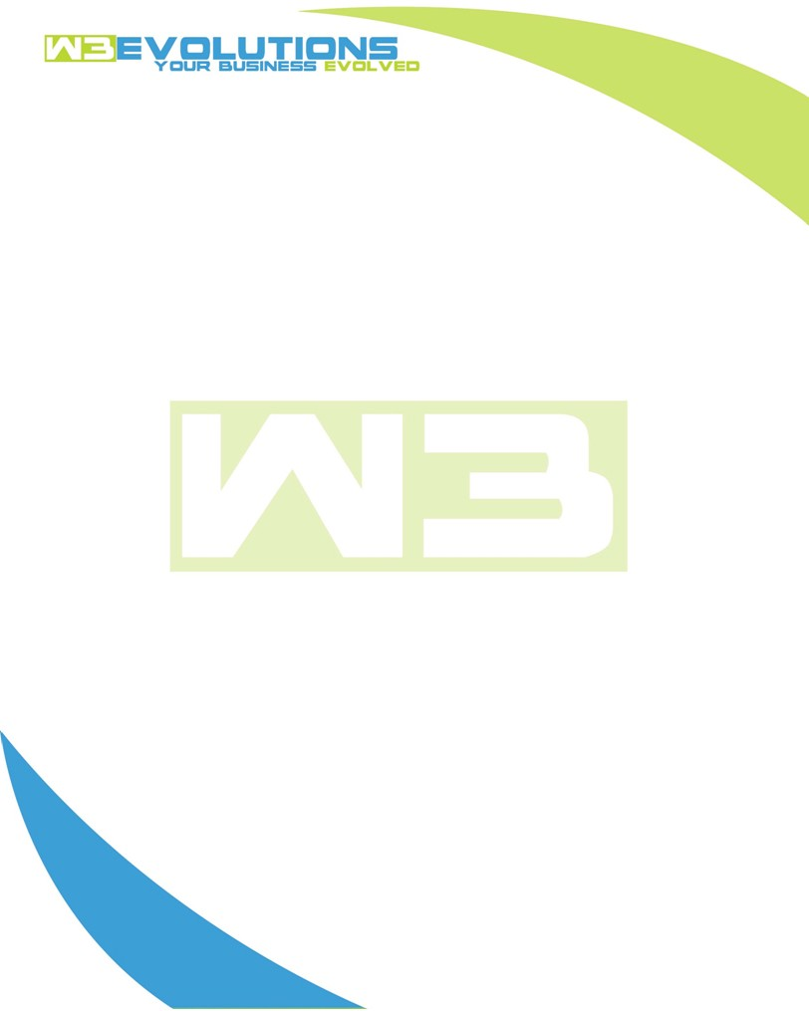

INVOICE

|  |  |
| --- | --- |
| **Bill To:** National Exemption Service, LLC 604 Packard Ct  Safety Harbor, FL 34695 | Invoice No.: NES01-5488  Customer ID: NES01 |

|  |  |  |  |  |  |  |
| --- | --- | --- | --- | --- | --- | --- |
| Date | Invoice No. | Sales Rep. | Ship Via | Terms | Date Due |  |
| 4/22/24 | NES01-5488 | Brandon Kozak | Email | NET 30 | - |  |

|  |  |  |  |  |  |  |
| --- | --- | --- | --- | --- | --- | --- |
| Quantity | Item | Description | Discount | Taxable | Unit Price | Total |
| 38 | Software Development | See attached | $49 / hr off $175 / hr | No | $126 | $4,788 |
|  |  |  |  |  |  |  |
|  |  |  |  |  |  |  |
|  |  |  |  |  |  |  |

|  |  |
| --- | --- |
| Subtotal: | $4,788 |
| Tax: | 0.00 |
| Balance Due: | $4,788 |

**Please make all checks payable to:** W3Evolutions Systems LLC

**Please send checks to:** 4826 Troydale Rd, Tampa FL 33615

**Zelle**: zelle.wf[@w3evolutions.com](mailto:brandon@w3evolutions.com)

|  |  |  |  |  |
| --- | --- | --- | --- | --- |
| **Date** | **Hours** | **Category** | **Task/Work** | **Persons** |
|  |  |  |  |  |
| 4/15/2024 | 6 | Software Development | AAE-10 - Bug fixes, git cleanup, branch cleanup | BK |
| 4/16/2024 | 6 | Software Development | AAE-10 - Bug fixes, git cleanup, branch cleanup | BK |
| 4/17/2024 | 4 | Management | AAE-10 - UAT recap, review AAE-100 | BK/DH |
| 4/17/2024 | 8 | Software Development | AAE-100 - Recode after meeting 4/17/24 | BK |
| 4/18/2024 | 8 | Software Development | AAE-99 - Bug fixes from UAT | BK |
| 4/19/2024 | 6 | Software Development | AAE-99 - Bug fixes from UAT | BK |