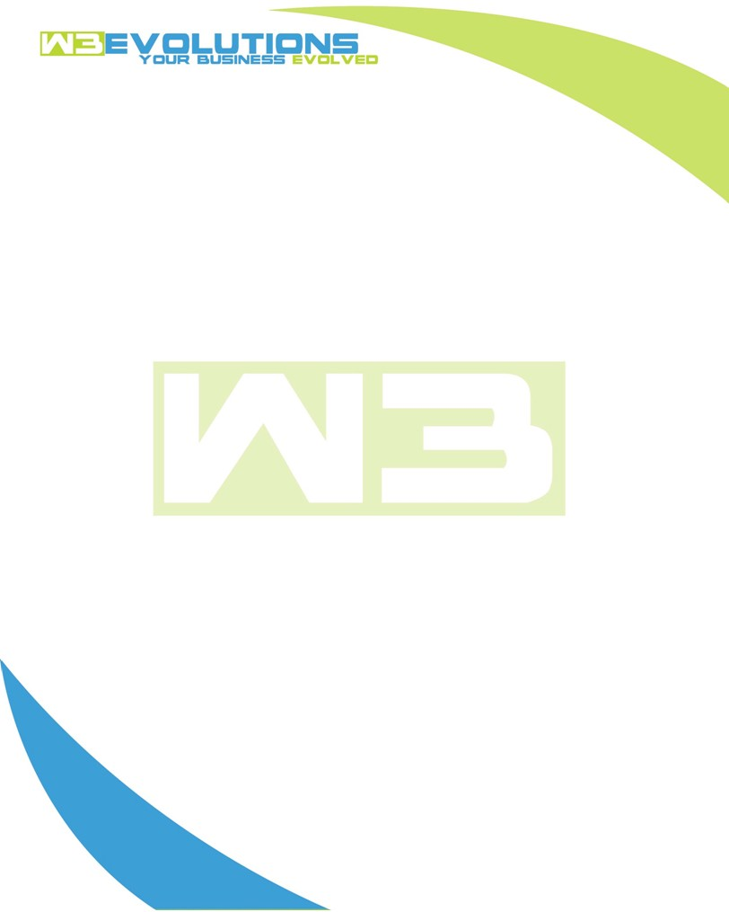

INVOICE

|  |  |
| --- | --- |
| **Bill To:** National Exemption Service, LLC 604 Packard Ct  Safety Harbor, FL 34695 | Invoice No.: NES01-5489  Customer ID: NES01 |

|  |  |  |  |  |  |  |
| --- | --- | --- | --- | --- | --- | --- |
| Date | Invoice No. | Sales Rep. | Ship Via | Terms | Date Due |  |
| 4/29/24 | NES01-5489 | Brandon Kozak | Email | NET 30 | - |  |

|  |  |  |  |  |  |  |
| --- | --- | --- | --- | --- | --- | --- |
| Quantity | Item | Description | Discount | Taxable | Unit Price | Total |
| 69 | Software Development | See attached | $49 / hr off $175 / hr | No | $126 | $8,694 |
|  |  |  |  |  |  |  |
|  |  |  |  |  |  |  |
|  |  |  |  |  |  |  |

|  |  |
| --- | --- |
| Subtotal: | $8,694 |
| Tax: | 0.00 |
| Balance Due: | $8,694 |

**Please make all checks payable to:** W3Evolutions Systems LLC

**Please send checks to:** 4826 Troydale Rd, Tampa FL 33615

**Zelle**: zelle.wf[@w3evolutions.com](mailto:brandon@w3evolutions.com)

|  |  |  |  |  |
| --- | --- | --- | --- | --- |
| **Date** | **Hours** | **Category** | **Task/Work** | **Persons** |
|  |  |  |  |  |
| **4/22/2024** | **4** | **Software Development** | **AAE-126 - Logical Unit Attributes QOL form addition** | **BK** |
| **4/23/2024** | **8** | **Software Development** | **AAE-126 - Logical Unit Attributes QOL form addition** | **BK** |
| **4/24/2024** | **8** | **Software Development** | **AAE-126 - Logical Unit Attributes QOL form addition** | **BK** |
| **4/25/2024** | **2** | **Management** | **AAE-126 - Meeting with Chuck Scott and Ralph** | **BK/DH** |
| **4/25/2024** | **4** | **Software Development** | **AAE-126 - Continued Development** | **BK** |
| **4/26/2024** | **6** | **Software Development** | **AAE-136 - Continued Development** | **BK/DH** |
| **4/27/2024** | **10** | **Software Development** | **AAE-136 - Completion and Close of Ticket** | **BK/DH** |
| **4/28/2024** | **12** | **Software Development** | **AAE-126, AAE-99 - Discovered complications with AAE-126 workflow, debugged tested and refactored AAE-99, requires clarification and testing with Jenn** | **BK/DH** |
| **4/29/2024** | **15** | **Software Development** | **AAE-99 - Rebuilt checking, retrieve logical_unit_id based on text permutations of label** | **BK/DH** |