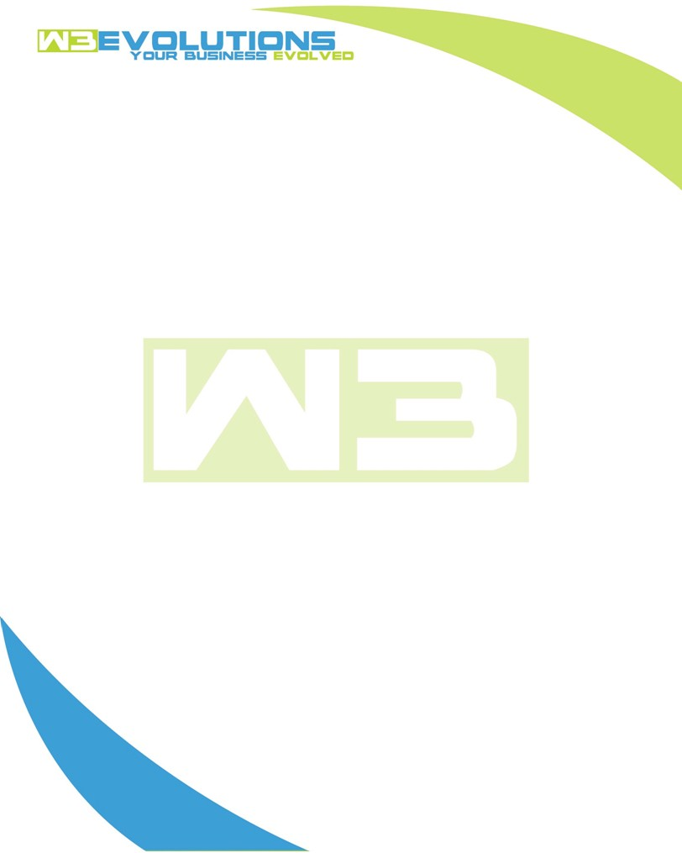

INVOICE

|  |  |
| --- | --- |
| **Bill To:** National Exemption Service, LLC 604 Packard Ct  Safety Harbor, FL 34695 | Invoice No.: NES01-5490  Customer ID: NES01 |

|  |  |  |  |  |  |  |
| --- | --- | --- | --- | --- | --- | --- |
| Date | Invoice No. | Sales Rep. | Ship Via | Terms | Date Due |  |
| 5/6/24 | NES01-5490 | Brandon Kozak | Email | NET 30 | - |  |

|  |  |  |  |  |  |  |
| --- | --- | --- | --- | --- | --- | --- |
| Quantity | Item | Description | Discount | Taxable | Unit Price | Total |
| 96 | Software Development | See attached | $49 / hr off $175 / hr | No | $126 | $12,096 |
|  |  |  |  |  |  |  |
|  |  |  |  |  |  |  |
|  |  |  |  |  |  |  |

|  |  |
| --- | --- |
| Subtotal: | $12,096 |
| Tax: | 0.00 |
| Balance Due: | $12,096 |

**Please make all checks payable to:** W3Evolutions Systems LLC

**Please send checks to:** 4826 Troydale Rd, Tampa FL 33615

**Zelle**: zelle.wf[@w3evolutions.com](mailto:brandon@w3evolutions.com)

|  |  |  |  |  |
| --- | --- | --- | --- | --- |
| **Date** | **Hours** | **Category** | **Task/Work** | **Persons** |
|  |  |  |  |  |
| **4/30/2024** | **18** | **Software Development** | **AAE-99 - Debugging, testing, and validating proper data** | **BK/DH** |
| **5/1/2024** | **2** | **Management** | **AAE-137 - Requirements Gathering, Meeting** | **BK/DH** |
| **5/1/2024** | **11** | **Software Development** | **AAE-99, AAE-139, AAE-140 - validation, testing, bug fixes** | **BK/DH** |
| **5/2/2024** | **14** | **Software Development** | **AAE-99 testing, AAE-134 completed and dev-tested** | **BK/DH** |
| **5/3/2024** | **13** | **Software Development** | **AAE-143 - completed, AAE-142 development** | **BK/DH** |
| **5/4/2024** | **12** | **Software Development** | **AAE-142 - completed** | **BK/DH** |
| **5/5/2024** | **11** | **Software Development** | **AAE-10 - production release** | **BK/DH** |
| **5/6/2024** | **15** | **Software Development** | **AAE-10 - production release** | **BK/DH** |