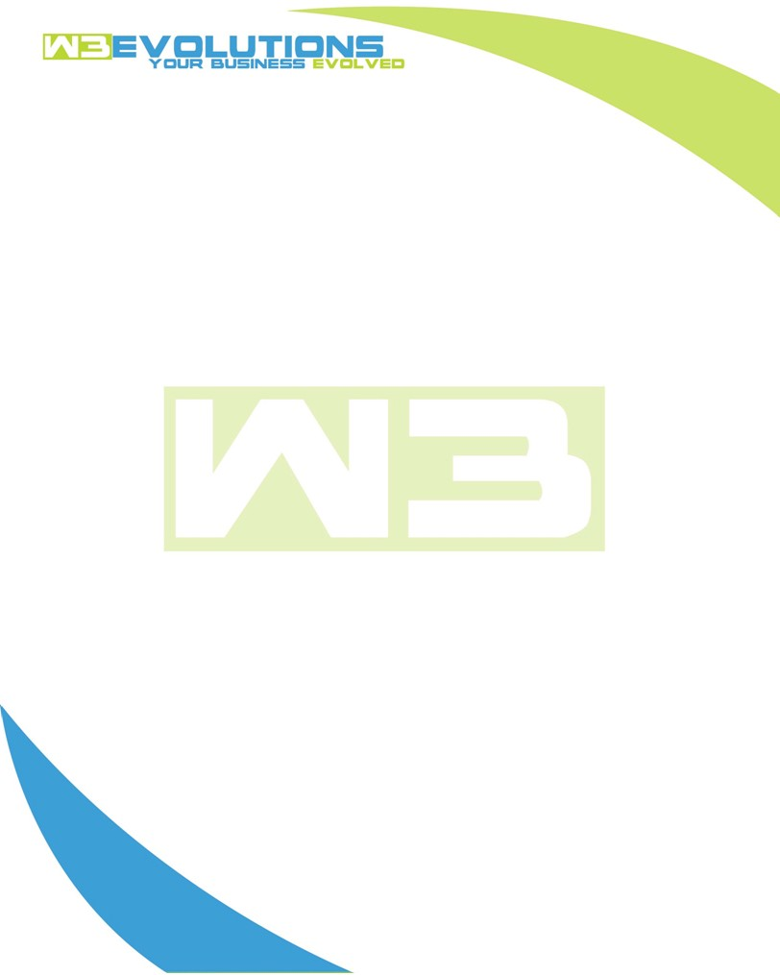

INVOICE

|  |  |
| --- | --- |
| **Bill To:** National Exemption Service, LLC 604 Packard Ct  Safety Harbor, FL 34695 | Invoice No.: NES01-5493  Customer ID: NES01 |

|  |  |  |  |  |  |  |
| --- | --- | --- | --- | --- | --- | --- |
| Date | Invoice No. | Sales Rep. | Ship Via | Terms | Date Due |  |
| 5/28/24 | NES01-5493 | Brandon Kozak | Email | NET 30 | - |  |

|  |  |  |  |  |  |  |
| --- | --- | --- | --- | --- | --- | --- |
| Quantity | Item | Description | Discount | Taxable | Unit Price | Total |
| 52 | Software Development | See attached | $49 / hr off $175 / hr | No | $126 | $6,552 |
|  |  |  |  |  |  |  |
|  |  |  |  |  |  |  |
|  |  |  |  |  |  |  |

|  |  |
| --- | --- |
| Subtotal: | $6,552 |
| Tax: | 0.00 |
| Balance Due: | $6,552 |

**Please make all checks payable to:** W3Evolutions Systems LLC

**Please send checks to:** 4826 Troydale Rd, Tampa FL 33615

**Zelle**: zelle.wf[@w3evolutions.com](mailto:brandon@w3evolutions.com)

|  |  |  |  |  |
| --- | --- | --- | --- | --- |
| **Date** | **Hours** | **Category** | **Task/Work** | **Persons** |
|  |  |  |  |  |
| **5/21/2024** | **14** | **Software Development** | **AAE-99, AAE-144, AAE-146, AAE-147, AAE-149, AAE-160, production release** | **BK/DH** |
| **5/22/2024** | **10** | **Software Development** | **AAE-99, AAE-144, AAE-146, AAE-147, AAE-149, AAE-160, AAE-164, production release** | **BK/DH** |
| **5/23/2024** | **8** | **Software Development** | **AAE-100 - start of button fixes and select disablers** | **BK/DH** |
| **5/24/2024** | **7** | **Software Development** | **AAE-165 getfilename method, AAE-166 cache permission issues, AAE-167** | **BK** |
| **5/27/2024** | **5** | **Software Development** | **AAE-100 - Continued Development** | **BK** |
| **5/28/2024** | **8** | **Software Development** | **AAE-100 - Continued Development, AAE-144 - Update S/S import for NULL and ''** | **BK** |