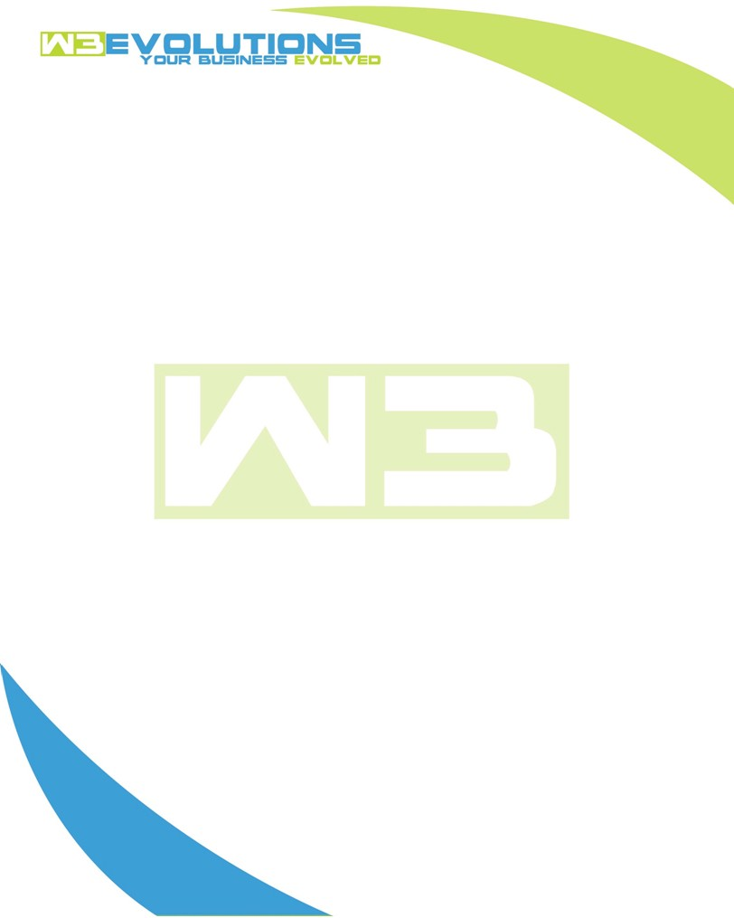

INVOICE

|  |  |
| --- | --- |
| **Bill To:** National Exemption Service, LLC 604 Packard Ct  Safety Harbor, FL 34695 | Invoice No.: NES01-5495  Customer ID: NES01 |

|  |  |  |  |  |  |  |
| --- | --- | --- | --- | --- | --- | --- |
| Date | Invoice No. | Sales Rep. | Ship Via | Terms | Date Due |  |
| 6/10/24 | NES01-5495 | Brandon Kozak | Email | NET 30 | - |  |

|  |  |  |  |  |  |  |
| --- | --- | --- | --- | --- | --- | --- |
| Quantity | Item | Description | Discount | Taxable | Unit Price | Total |
| 82 | Software Development | See attached | $49 / hr off $175 / hr | No | $126 | $10,332 |
|  |  |  |  |  |  |  |
|  |  |  |  |  |  |  |
|  |  |  |  |  |  |  |

|  |  |
| --- | --- |
| Subtotal: | $10,332 |
| Tax: | 0.00 |
| Balance Due: | $10,332 |

**Please make all checks payable to:** W3Evolutions Systems LLC

**Please send checks to:** 4826 Troydale Rd, Tampa FL 33615

**Zelle**: zelle.wf[@w3evolutions.com](mailto:brandon@w3evolutions.com)

|  |  |  |  |  |
| --- | --- | --- | --- | --- |
| **Date** | **Hours** | **Category** | **Task/Work** | **Persons** |
|  |  |  |  |  |
| **6/4/2024** | **9** | **Software Development** | **AAE-188 - R&D for data mining, AAE-184 - update NoSQL server and MongoDB configs/tuning** | **BK** |
| **6/5/2024** | **16** | **Software Development** | **AAE-123 - Braintree SDK development; AAE-100 - prep db for UAT, AAE-181 - R&D for data mining audits** | **BK/DH** |
| **6/6/2024** | **17** | **Software Development** | **AAE-123 - Braintree SDK development - dev ready; AAE-100 - prep db for UAT, AAE-181 - R&D for data mining audits** | **BK/DH** |
| **6/7/2024** | **8** | **Software Development** | **Jerry's Project, PM / Ticket clean up / Review P3 tickets** | **BK** |
| **6/8/2024** | **11** | **Software Development** | **Jerry's Project, PM / Ticket clean up / Review P3 tickets** | **BK/DH** |
| **6/9/2024** | **13** | **Software Development** | **AAE-100 - testing, discovery and fix of multiple unrelated issues; AAE-123 - staging for qa** | **BK/DH** |
| **6/10/2024** | **8** | **Software Development** | **AAE-154 - Discovery of tasks / start coding. AAE-185 - Investigate dupe MO, AAE-181 - Setup, install and test Metabase for mongoDB** | **BK** |