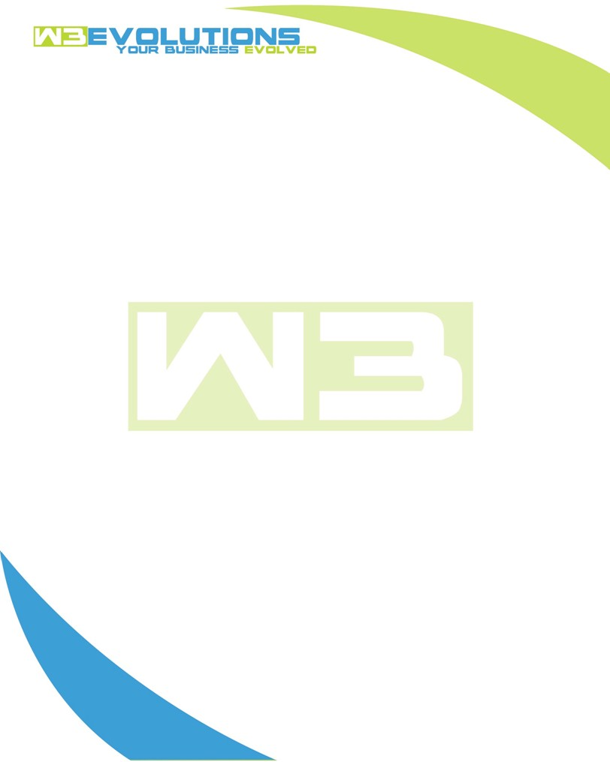

INVOICE

|  |  |
| --- | --- |
| **Bill To:** National Exemption Service, LLC 604 Packard Ct  Safety Harbor, FL 34695 | Invoice No.: NES01-5496  Customer ID: NES01 |

|  |  |  |  |  |  |  |
| --- | --- | --- | --- | --- | --- | --- |
| Date | Invoice No. | Sales Rep. | Ship Via | Terms | Date Due |  |
| 6/10/24 | NES01-5496 | Brandon Kozak | Email | NET 30 | - |  |

|  |  |  |  |  |  |  |
| --- | --- | --- | --- | --- | --- | --- |
| Quantity | Item | Description | Discount | Taxable | Unit Price | Total |
| 56 | Software Development | See attached | $49 / hr off $175 / hr | No | $126 | $7,056 |
|  |  |  |  |  |  |  |
|  |  |  |  |  |  |  |
|  |  |  |  |  |  |  |

|  |  |
| --- | --- |
| Subtotal: | $7,056 |
| Tax: | 0.00 |
| Balance Due: | $7,056 |

**Please make all checks payable to:** W3Evolutions Systems LLC

**Please send checks to:** 4826 Troydale Rd, Tampa FL 33615

**Zelle**: zelle.wf[@w3evolutions.com](mailto:brandon@w3evolutions.com)

|  |  |  |  |  |
| --- | --- | --- | --- | --- |
| **Date** | **Hours** | **Category** | **Task/Work** | **Persons** |
|  |  |  |  |  |
| **6/11/2024** | **8** | **Software Development** | **AAE-188 - Discovery / Start coding. AAE-185 - fix dupe MO** | **BK** |
| **6/12/2024** | **8** | **Software Development** | **AAE-188, AAE-176, AAE-186 - Coding** | **BK** |
| **6/13/2024** | **8** | **Software Development** | **AAE-188, AAE-176, AAE-186 - Coding** | **BK** |
| **6/14/2024** | **8** | **Software Development** | **AAE-189, AAE-190 - Coding, AAE-101 requirements gathering** | **BK** |
| **6/16/2024** | **9** | **Software Development** | **AAE-101 requirements gathering, AAE-186, AAE-188, AAE-176, AAE-154 completed discovery process / dev ready** | **BK/DH** |
| **6/17/2024** | **14** | **Software Development** | **AAE-189, AAE-190 pushed to production, branch merging, AAE-101 requirements gathering, AAE-153 & AAE-187 dev ready, AAE-177 portal issues** | **BK/DH** |