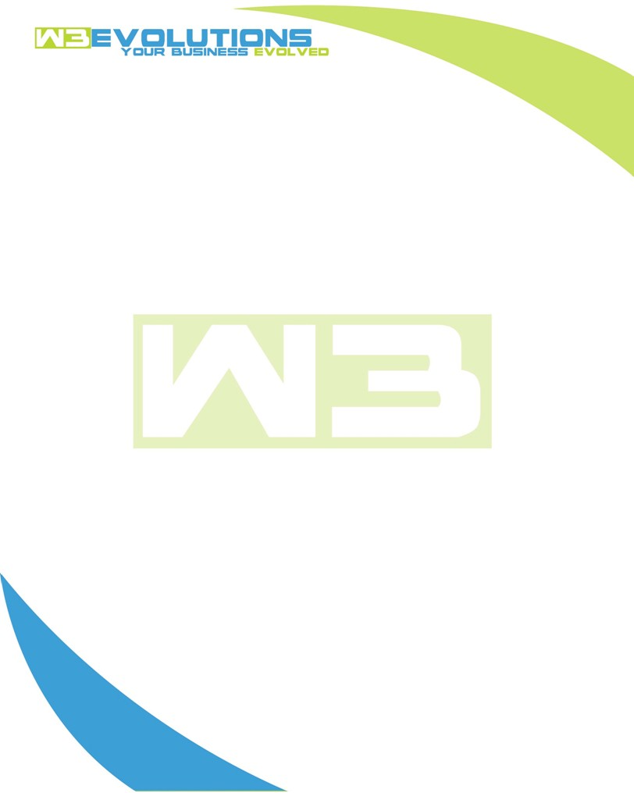

INVOICE

|  |  |
| --- | --- |
| **Bill To:** National Exemption Service, LLC 604 Packard Ct  Safety Harbor, FL 34695 | Invoice No.: NES01-5497  Customer ID: NES01 |

|  |  |  |  |  |  |  |
| --- | --- | --- | --- | --- | --- | --- |
| Date | Invoice No. | Sales Rep. | Ship Via | Terms | Date Due |  |
| 6/24/24 | NES01-5497 | Brandon Kozak | Email | NET 30 | - |  |

|  |  |  |  |  |  |  |
| --- | --- | --- | --- | --- | --- | --- |
| Quantity | Item | Description | Discount | Taxable | Unit Price | Total |
| 71 | Software Development | See attached | $49 / hr off $175 / hr | No | $126 | $8,946 |
|  |  |  |  |  |  |  |
|  |  |  |  |  |  |  |
|  |  |  |  |  |  |  |

|  |  |
| --- | --- |
| Subtotal: | $8,946 |
| Tax: | 0.00 |
| Balance Due: | $8,946 |

**Please make all checks payable to:** W3Evolutions Systems LLC

**Please send checks to:** 4826 Troydale Rd, Tampa FL 33615

**Zelle**: zelle.wf[@w3evolutions.com](mailto:brandon@w3evolutions.com)

|  |  |  |  |  |
| --- | --- | --- | --- | --- |
| **Date** | **Hours** | **Category** | **Task/Work** | **Persons** |
|  |  |  |  |  |
| **6/18/2024** | **8** | **Software Development** | **AAE-194 - Create ticket and investigate solution. AAE-153 - continue development, AAE-100 - Continued development** | **BK** |
| **6/19/2024** | **10** | **Software Development** | **AAE-194 - Create ticket and investigate solution. AAE-153 - continue development, AAE-100 - Continued development** | **BK/DH** |
| **6/20/2024** | **14** | **Software Development/Management** | **AAE-194 - Continue development, AAE-153 - continue development, AAE-100 - Continued development, Weekly Meeting, Jerry's Project** | **BK/DH** |
| **6/21/2024** | **13** | **Software Development** | **AAE-194 - Continue development, AAE-153 - continue development, AAE-123 Braintree Load Balancing** | **BK/DH** |
| **6/22/2024** | **11** | **Software Development** | **AAE-194 - Continue testing, AAE-153 - continue development** | **BK/DH** |
| **6/23/2024** | **7** | **Software Development** | **AAE-194 - Continue testing, AAE-153 - continue development** | **BK/DH** |
| **6/24/2024** | **8** | **Software Development** | **AAE-185 - investigate issue, AAE-194 - Continue testing, Assist in AiDA 504 issue with Ralpg/Peter** | **BK** |