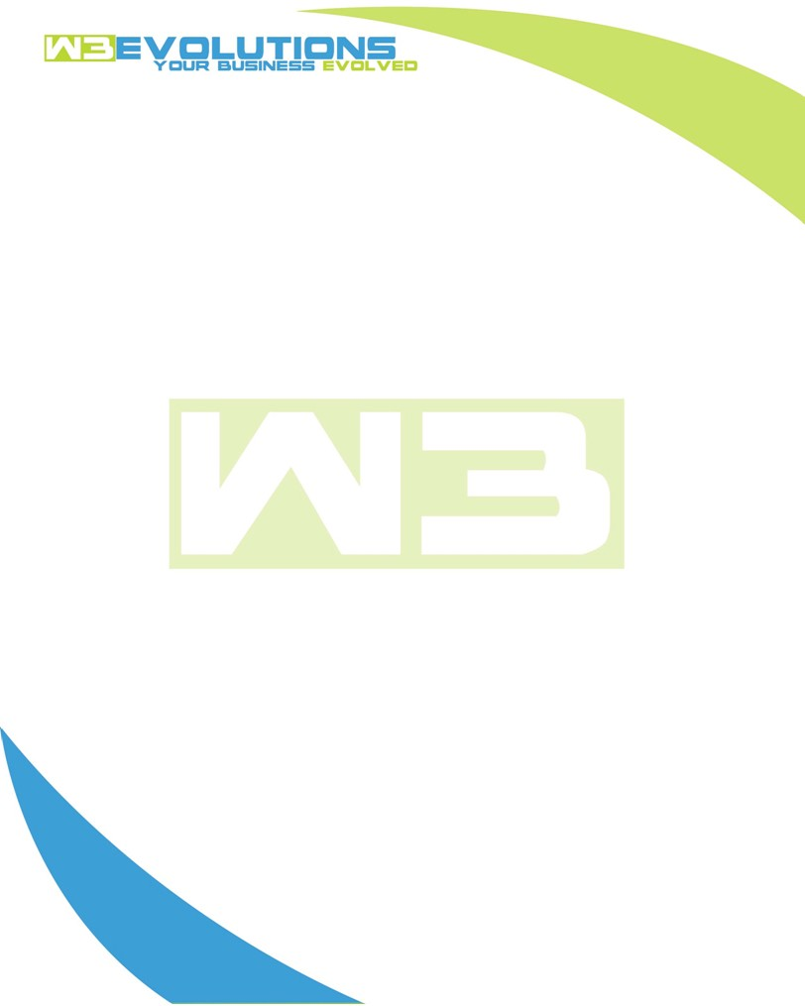

INVOICE

|  |  |
| --- | --- |
| **Bill To:** National Exemption Service, LLC 604 Packard Ct  Safety Harbor, FL 34695 | Invoice No.: NES01-5499  Customer ID: NES01 |

|  |  |  |  |  |  |  |
| --- | --- | --- | --- | --- | --- | --- |
| Date | Invoice No. | Sales Rep. | Ship Via | Terms | Date Due |  |
| 7/10/2024 | NES01-5499 | Brandon Kozak | Email | NET 30 | - |  |

|  |  |  |  |  |  |  |
| --- | --- | --- | --- | --- | --- | --- |
| Quantity | Item | Description | Discount | Taxable | Unit Price | Total |
| 58 | Software Development | See attached | $49 / hr off $175 / hr | No | $126 | $7,308 |
|  |  |  |  |  |  |  |
|  |  |  |  |  |  |  |
|  |  |  |  |  |  |  |

|  |  |
| --- | --- |
| Subtotal: | $7,308 |
| Tax: | 0.00 |
| Balance Due: | $7,308 |

**Please make all checks payable to:** W3Evolutions Systems LLC

**Please send checks to:** 4826 Troydale Rd, Tampa FL 33615

**Zelle**: zelle.wf[@w3evolutions.com](mailto:brandon@w3evolutions.com)

|  |  |  |  |  |
| --- | --- | --- | --- | --- |
| **Date** | **Hours** | **Category** | **Task/Work** | **Persons** |
|  |  |  |  |  |
| **7/3/2024** | **8** | **Software Development** | **AAE-153 - Fix bugs, retest. AAE-188 - Development** | **BK** |
| **7/5/2024** | **8** | **Software Development** | **AAE-186 - See how AAE-153 affect AAE-186 and what the cause could be, investigate relationships between code and DB** | **BK** |
| **7/6/2024** | **4** | **Software Development** | **AAE-178 - Start putting together stage-qa release** | **BK** |
| **7/7/2024** | **4** | **Software Development** | **AAE-178 - Continue on with prep for NES testing** | **BK** |
| **7/8/2024** | **11** | **Software Development** | **AAE-178 - AiDA data sync, AAE-178 - nginx, php-fpm, Portal logging, fail2ban review and test prerp, AAE-193 - identify issue** | **BK/DH** |
| **7/9/2024** | **12** | **Software Development** | **AAE-153 - finalzied testing. AAE-186, AAE-176, AAE-187 - Figure out how they relate and if other ticketr will fix; AAE-193 fix live on production; Biling screen issue confirm solved** | **BK/DH** |
| **7/10/2024** | **11** | **Software Development** | **. AAE-186, AAE-176, AAE-187 - Continued Dev; Prepare new portal server for production** | **BK/DH** |