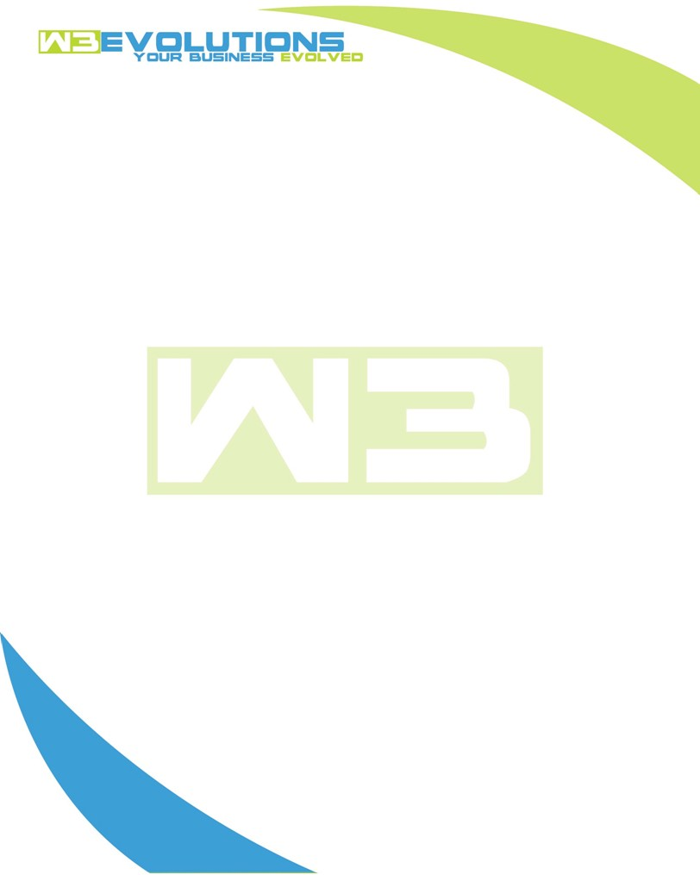

INVOICE

|  |  |
| --- | --- |
| **Bill To:** National Exemption Service, LLC 604 Packard Ct  Safety Harbor, FL 34695 | Invoice No.: NES01-5500  Customer ID: NES01 |

|  |  |  |  |  |  |  |
| --- | --- | --- | --- | --- | --- | --- |
| Date | Invoice No. | Sales Rep. | Ship Via | Terms | Date Due |  |
| 7/25/2024 | NES01-5500 | Brandon Kozak | Email | NET 30 | - |  |

|  |  |  |  |  |  |  |
| --- | --- | --- | --- | --- | --- | --- |
| Quantity | Item | Description | Discount | Taxable | Unit Price | Total |
| 122 | Software Development | See attached | $49 / hr off $175 / hr | No | $126 | $15,372 |
|  |  |  |  |  |  |  |
|  |  |  |  |  |  |  |
|  |  |  |  |  |  |  |

|  |  |
| --- | --- |
| Subtotal: | $15,372 |
| Tax: | 0.00 |
| Balance Due: | $15,372 |

**Please make all checks payable to:** W3Evolutions Systems LLC

**Please send checks to:** 4826 Troydale Rd, Tampa FL 33615

**Zelle**: zelle.wf[@w3evolutions.com](mailto:brandon@w3evolutions.com)

|  |  |  |  |  |
| --- | --- | --- | --- | --- |
| **Date** | **Hours** | **Category** | **Task/Work** | **Persons** |
|  |  |  |  |  |
| **7/11/2024** | **8** | **Software Development** | **. AAE-186, AAE-176, AAE-187 - Continued Dev; Prepare new portal server for production** | **BK** |
| **7/12/2024** | **8** | **Software Development** | **. AAE-186, AAE-176, AAE-187 - Continued Dev; Prepare new portal server for production** | **BK** |
| **7/13/2024** | **4** | **Software Development** | **. AAE-186, AAE-176, AAE-187 - Continued Dev; Prepare new portal server for production** | **BK** |
| **7/14/2024** | **4** | **Software Development** | **. AAE-186, AAE-176, AAE-187 - Continued Dev; Prepare new portal server for production** | **BK** |
| **7/15/2024** | **8** | **Software Development** | **AAE-100, AAE-153, AAE-188, AAE-176 - merge and clean branches, test roll-up to stage** | **BK** |
| **7/16/2024** | **13** | **Software Development** | **AAE-123 - merge and clean branches, test roll-up to stage** | **BK/DH** |
| **7/17/2024** | **12** | **Software Development** | **AAE-123 - Sync read replica to stage-qa, test stage-qa branches in both AiDA and Portal. Test nginx, logs, and portal -> NES DB and AidA -> NES DB in tandem** | **BK/DH** |
| **7/18/2024** | **12** | **Software Development** | **AAE-100, AAE-153, AAE-188, AAE-176, AAE-123 - Merge, test release plan** | **BK/DH** |
| **7/19/2024** | **8** | **Software Development** | **AAE-100, AAE-153, AAE-188, AAE-176, AAE-123 - Roll out Prep** | **BK** |
| **7/20/2024** | **8** | **Software Development** | **AAE-100, AAE-153, AAE-188, AAE-176, AAE-123 - Roll out Prep** | **BK** |
| **7/21/2024** | **13** | **Software Development** | **AAE-100, AAE-153, AAE-188, AAE-176, AAE-123 - Roll out Prep** | **BK/DH** |
| **7/22/2024** | **0** | **Software Development** |  | **BK** |
| **7/23/2024** | **8** | **Software Development** | **AAE-197, AAE-196 - Determine prod mirror setup. Research prod issues on AiDA and Portal.** | **BK** |
| **7/24/2024** | **8** | **Software Development** | **AAE-197, AAE-196 - continued prod mirror setup. AAE-196 - Continued code inspection and development** | **BK** |
| **7/25/2024** | **8** | **Software Development** | **AAE-197, AAE-196 - continued prod mirror setup. AAE-196 - Continued code inspection and development** | **BK** |