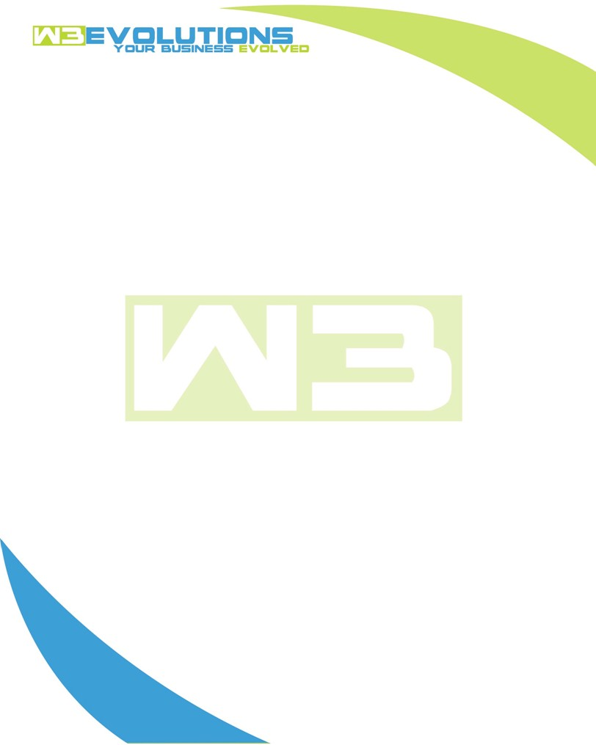

INVOICE

|  |  |
| --- | --- |
| **Bill To:** National Exemption Service, LLC 604 Packard Ct  Safety Harbor, FL 34695 | Invoice No.: NES01-5501  Customer ID: NES01 |

|  |  |  |  |  |  |  |
| --- | --- | --- | --- | --- | --- | --- |
| Date | Invoice No. | Sales Rep. | Ship Via | Terms | Date Due |  |
| 7/31/2024 | NES01-5501 | Brandon Kozak | Email | NET 30 | - |  |

|  |  |  |  |  |  |  |
| --- | --- | --- | --- | --- | --- | --- |
| Quantity | Item | Description | Discount | Taxable | Unit Price | Total |
| 78 | Software Development | See attached | $49 / hr off $175 / hr | No | $126 | $9,828 |
|  |  |  |  |  |  |  |
|  |  |  |  |  |  |  |
|  |  |  |  |  |  |  |

|  |  |
| --- | --- |
| Subtotal: | $9,828 |
| Tax: | 0.00 |
| Balance Due: | $9,828 |

**Please make all checks payable to:** W3Evolutions Systems LLC

**Please send checks to:** 4826 Troydale Rd, Tampa FL 33615

**Zelle**: zelle.wf[@w3evolutions.com](mailto:brandon@w3evolutions.com)

|  |  |  |  |  |
| --- | --- | --- | --- | --- |
| **Date** | **Hours** | **Category** | **Task/Work** | **Persons** |
|  |  |  |  |  |
| **7/26/2024** | **8** | **Software Development** | **AAE-197, AAE-196 - continued prod mirror setup. AAE-196 - Continued code inspection and development** | **BK** |
| **7/27/2024** | **16** | **Software Development** | **AAE-196 - Clean up and commits** | **BK/DH** |
| **7/28/2024** | **12** | **Software Development** | **AAE-196 - Clean up and commits** | **BK/DH** |
| **7/29/2024** | **16** | **Software Development** | **AAE-196 - Clean up and commits, testing; AAE-185 - Review Jen's info on how dupes could happen and update code** | **BK/DH** |
| **7/30/2024** | **12** | **Software Development** | **AAE-196 - Complete code configs for new /aida2 get server prepped** | **BK/DH** |
| **7/31/2024** | **14** | **Software Development** | **AAE-187, AAE-186 - Review code commits for issues, test, and prep for stage-qa -> production** | **BK/DH** |