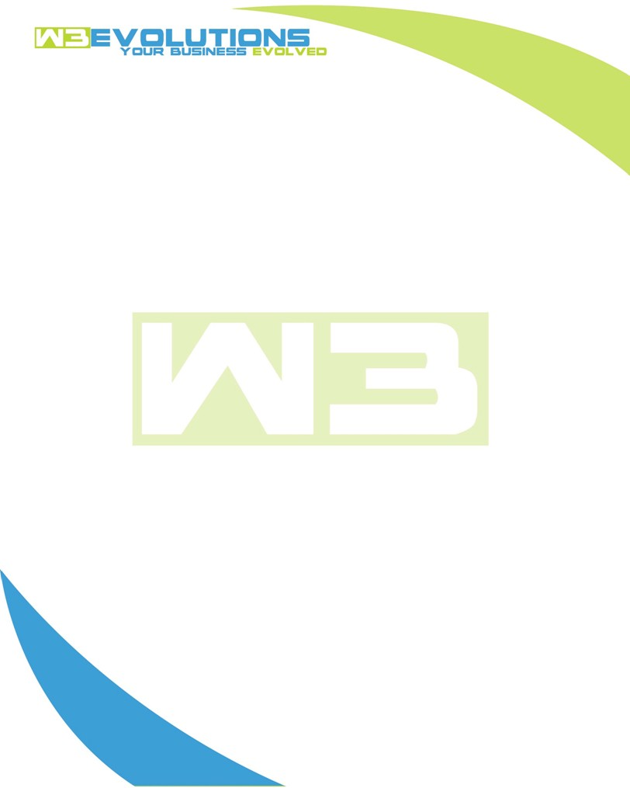

INVOICE

|  |  |
| --- | --- |
| **Bill To:** National Exemption Service, LLC 604 Packard Ct  Safety Harbor, FL 34695 | Invoice No.: NES01-5502  Customer ID: NES01 |

|  |  |  |  |  |  |  |
| --- | --- | --- | --- | --- | --- | --- |
| Date | Invoice No. | Sales Rep. | Ship Via | Terms | Date Due |  |
| 8/8/2024 | NES01-5502 | Brandon Kozak | Email | NET 30 | - |  |

|  |  |  |  |  |  |  |
| --- | --- | --- | --- | --- | --- | --- |
| Quantity | Item | Description | Discount | Taxable | Unit Price | Total |
| 95 | Software Development | See attached | $49 / hr off $175 / hr | No | $126 | $11,970 |
|  |  |  |  |  |  |  |
|  |  |  |  |  |  |  |
|  |  |  |  |  |  |  |

|  |  |
| --- | --- |
| Subtotal: | $11,970 |
| Tax: | 0.00 |
| Balance Due: | $11,970 |

**Please make all checks payable to:** W3Evolutions Systems LLC

**Please send checks to:** 4826 Troydale Rd, Tampa FL 33615

**Zelle**: zelle.wf[@w3evolutions.com](mailto:brandon@w3evolutions.com)

|  |  |  |  |  |
| --- | --- | --- | --- | --- |
| **Date** | **Hours** | **Category** | **Task/Work** | **Persons** |
|  |  |  |  |  |
| **8/1/2024** | **17** | **Software Development** | **AAE-196 - continued prod mirror setup. AAE-196 - Continued code inspection and development, AAE-199 - Development** | **BK/DH** |
| **8/2/2024** | **10** | **Software Development** | **AAE-196 - continued prod mirror setup. AAE-196 - Continued code inspection and development** | **BK/DH** |
| **8/3/2024** | **8** | **Software Development** | **AAE-196 - continued prod mirror setup. AAE-196 - Continued code inspection and development** | **BK** |
| **8/4/2024** | **4** | **Software Development** | **AAE-196 - continued prod mirror setup. AAE-196 - Continued code inspection and development** | **BK** |
| **8/5/2024** | **8** | **Software Development** | **AAE-203 - Development started** | **BK** |
| **8/6/2024** | **11** | **Software Development** | **AAE-203 - Development continued** | **BK/DH** |
| **8/7/2024** | **17** | **Software Development** | **AAE-196, AAE-153, AEE-100 - Development / debugging / checking against issues in tickets** | **BK/DH** |
| **8/8/2024** | **20** | **Software Development** | **AAE-196, AAE-153, AEE-100 - Development / debugging / checking against issues in tickets** | **BK/DH** |