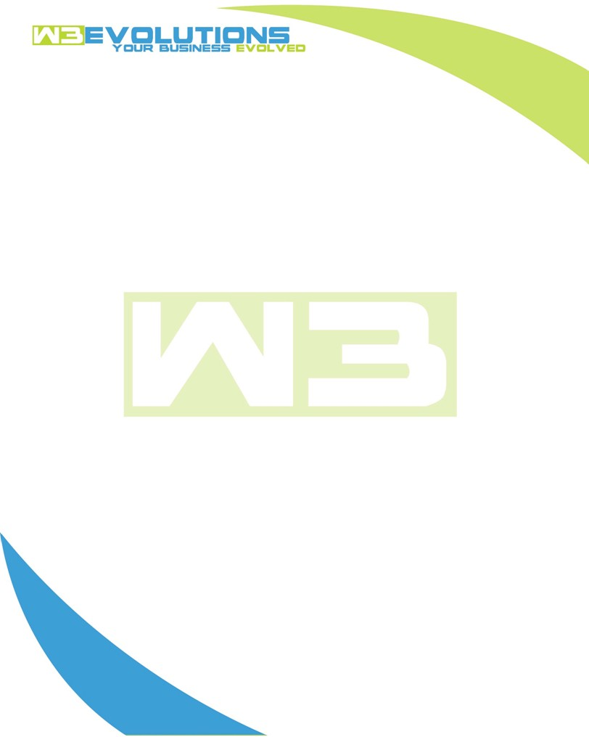

INVOICE

|  |  |
| --- | --- |
| **Bill To:** National Exemption Service, LLC 604 Packard Ct  Safety Harbor, FL 34695 | Invoice No.: NES01-5503  Customer ID: NES01 |

|  |  |  |  |  |  |  |
| --- | --- | --- | --- | --- | --- | --- |
| Date | Invoice No. | Sales Rep. | Ship Via | Terms | Date Due |  |
| 8/19/2024 | NES01-5503 | Brandon Kozak | Email | NET 30 | - |  |

|  |  |  |  |  |  |  |
| --- | --- | --- | --- | --- | --- | --- |
| Quantity | Item | Description | Discount | Taxable | Unit Price | Total |
| 151 | Software Development | See attached | $49 / hr off $175 / hr | No | $126 | $19,026 |
|  |  |  |  |  |  |  |
|  |  |  |  |  |  |  |
|  |  |  |  |  |  |  |

|  |  |
| --- | --- |
| Subtotal: | $19,026 |
| Tax: | 0.00 |
| Balance Due: | $19,026 |

**Please make all checks payable to:** W3Evolutions Systems LLC

**Please send checks to:** 4826 Troydale Rd, Tampa FL 33615

**Zelle**: zelle.wf[@w3evolutions.com](mailto:brandon@w3evolutions.com)

|  |  |  |  |  |
| --- | --- | --- | --- | --- |
| **Date** | **Hours** | **Category** | **Task/Work** | **Persons** |
|  |  |  |  |  |
| **8/9/24** | **12** | **Software Development** | **AAE-196, AAE-153, AAE-100** | **BK/DH** |
| **8/10/24** | **10** | **Software Development** | **AAE-208, AAE-209** | **BK** |
| **8/11/24** | **10** | **Software Development** | **AAE-208, AAE-209** | **BK** |
| **8/12/24** | **10** | **Software Development** | **AAE-209, AAE-210** | **BK** |
| **8/13/24** | **12** | **Software Development** | **AAE-209, AAE-210** | **BK/DH** |
| **8/14/24** | **14** | **Software Development** | **AAE-209, AAE-210, AAE-206, AAE-150** | **BK/DH** |
| **8/15/24** | **15** | **Software Development** | **AAE-209, AAE-210, AAE-206, AAE-150** | **BK/DH** |
| **8/16/24** | **13** | **Software Development** | **Jerry's Project** | **BK/DH** |
| **8/17/24** | **19** | **Software Development** | **Jerry's Project, AAE-209, AAE-206, AAE-150** | **BK/DH** |
| **8/18/24** | **18** | **Software Development** | **AAE-209, AAE-210, AAE-206, AAE-150** | **BK/DH** |
| **8/19/24** | **18** | **Software Development** | **AAE-208, AAE-209, AAE-210, AAE-206, AAE-150** | **BK/DH** |