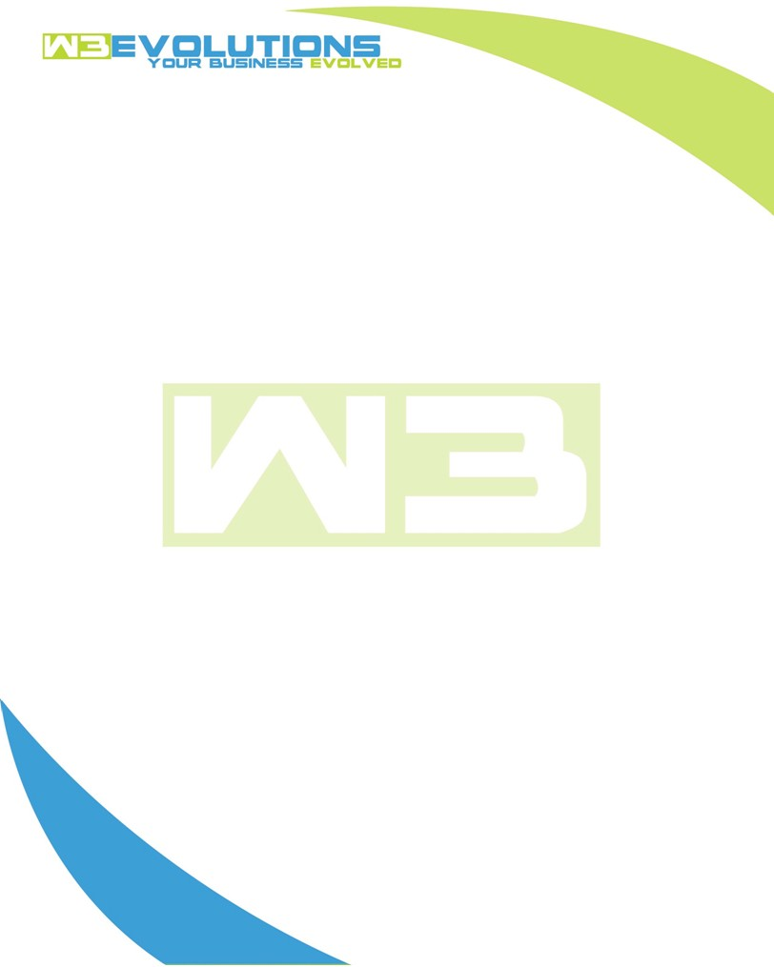

INVOICE

|  |  |
| --- | --- |
| **Bill To:** National Exemption Service, LLC 604 Packard Ct  Safety Harbor, FL 34695 | Invoice No.: NES01-5504  Customer ID: NES01 |

|  |  |  |  |  |  |  |
| --- | --- | --- | --- | --- | --- | --- |
| Date | Invoice No. | Sales Rep. | Ship Via | Terms | Date Due |  |
| 8/27/2024 | NES01-5504 | Brandon Kozak | Email | NET 30 | - |  |

|  |  |  |  |  |  |  |
| --- | --- | --- | --- | --- | --- | --- |
| Quantity | Item | Description | Discount | Taxable | Unit Price | Total |
| 105 | Software Development | See attached | $49 / hr off $175 / hr | No | $126 | $13,230 |
|  |  |  |  |  |  |  |
|  |  |  |  |  |  |  |
|  |  |  |  |  |  |  |

|  |  |
| --- | --- |
| Subtotal: | $13,230 |
| Tax: | 0.00 |
| Balance Due: | $13,230 |

**Please make all checks payable to:** W3Evolutions Systems LLC

**Please send checks to:** 4826 Troydale Rd, Tampa FL 33615

**Zelle**: zelle.wf[@w3evolutions.com](mailto:brandon@w3evolutions.com)

|  |  |  |  |  |
| --- | --- | --- | --- | --- |
| **Date** | **Hours** | **Category** | **Task/Work** | **Persons** |
|  |  |  |  |  |
| **8/20/24** | **15** | **Software Development** | **AAE-203 - R&D DataTables upgradges and stateRestore extension & development, AAE-214 - research tenant future move ins, AAE-150 continued development** | **BK/DH** |
| **8/21/24** | **11** | **Software Development** | **AAE-203 - Continued Development, AAE-214 - Development** | **BK/DH** |
| **8/22/24** | **10** | **Software Development** | **AAE-203 - Continuded development, AAE-214 Continued Development** | **BK** |
| **8/23/24** | **16** | **Software Development** | **AAE-203 - Continuded development, AAE-214 Continued Development, AAE-216 - development; Database Sync Issues** | **BK/DH** |
| **8/24/24** | **13** | **Software Development** | **AAE-203 - Continued Development, AAE-214 - dev testing, AAE-216 - development; Database Sync Issues** | **BK/DH** |
| **8/25/24** | **10** | **Software Development** | **AAE-203 - Continued Development, AAE-214 - dev testing, dev needs assistance,AAE-216 - deploy** | **BK** |
| **8/26/24** | **11** | **Software Development** | **AAE-203 - Dev testing, Continued Development; AAE-100 development to updated specs** | **BK/DH** |
| **8/27/24** | **19** | **Software Development** | **AAE-203 - Dev testing continued; AAE-100 development to updated specs; AAE-150 push to production** | **BK/DH** |