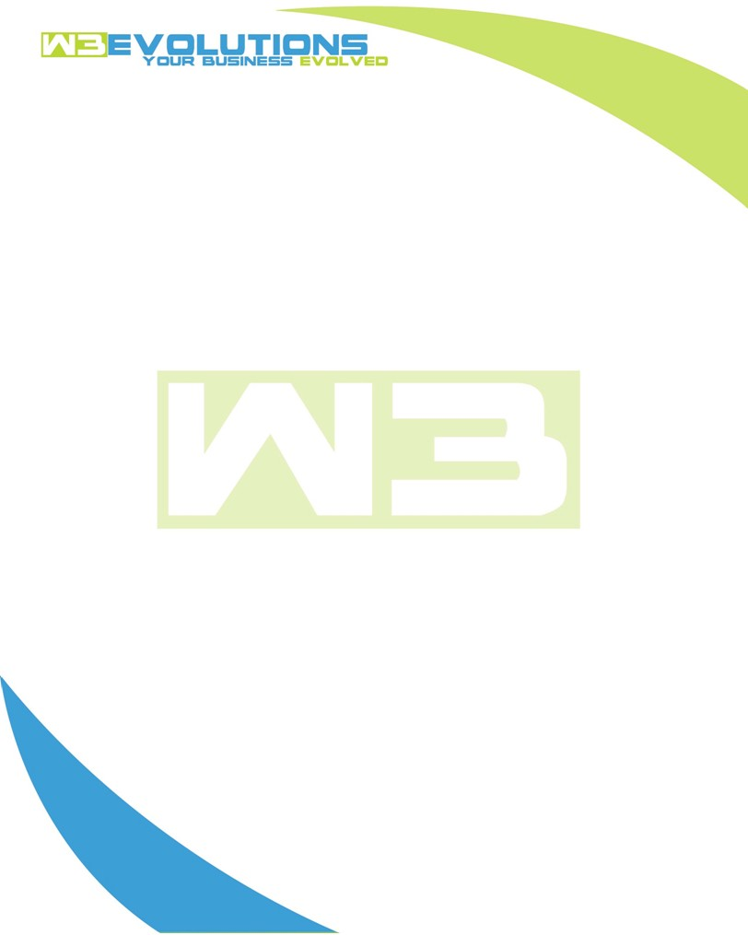

INVOICE

|  |  |
| --- | --- |
| **Bill To:** National Exemption Service, LLC 604 Packard Ct  Safety Harbor, FL 34695 | Invoice No.: NES01-5506  Customer ID: NES01 |

|  |  |  |  |  |  |  |
| --- | --- | --- | --- | --- | --- | --- |
| Date | Invoice No. | Sales Rep. | Ship Via | Terms | Date Due |  |
| 9/16/2024 | NES01-5506 | Brandon Kozak | Email | NET 30 | - |  |

|  |  |  |  |  |  |  |
| --- | --- | --- | --- | --- | --- | --- |
| Quantity | Item | Description | Discount | Taxable | Unit Price | Total |
| 86 | Software Development | See attached | $49 / hr off $175 / hr | No | $126 | $10,836 |
|  |  |  |  |  |  |  |
|  |  |  |  |  |  |  |
|  |  |  |  |  |  |  |

|  |  |
| --- | --- |
| Subtotal: | $10,836 |
| Tax: | 0.00 |
| Balance Due: | $10,836 |

**Please make all checks payable to:** W3Evolutions Systems LLC

**Please send checks to:** 4826 Troydale Rd, Tampa FL 33615

**Zelle**: zelle.wf[@w3evolutions.com](mailto:brandon@w3evolutions.com)

|  |  |  |  |  |
| --- | --- | --- | --- | --- |
| **Date** | **Hours** | **Category** | **Task/Work** | **Persons** |
|  |  |  |  |  |
| **9/9/24** | **13** | **Software Development** | **AAE-230 - Investigate issue, provide findings to Ralph. AAE-231 - Investigate issue and fix.; AAE-100 - summarize/research impacts of calculate only** | **BK/DH** |
| **9/10/24** | **12** | **Software Development** | **AAE-208 - Continued investigation into replica not replicating. AAE-153 - investigate why it is not working fron Jen testing; AAE-100 - summarize/research impacts of calculate only** | **BK/DH** |
| **9/11/24** | **12** | **Software Development** | **AAE-203 - Testing with new server settings. AAE-208 - Issues with server and VPN being 22 sec. Calls with Sterling.. AAE-152 - gathered more info from team, udpated code to make sure it matches on correct subs. AAE-214 - delete bad data; AAE-100 - meeting regarding impacts of calculate only and outstanding phase 3 items** | **BK/DH** |
| **9/12/24** | **10** | **Software Development** | **AAE-214 - review data sync, db2 not replicating with these updates.** | **BK** |
| **9/13/24** | **10** | **Software Development** | **AAE-208 - Review issues with read replicat and Sterling. re-run a full bd sync per call with Todd.** | **BK** |
| **9/14/24** | **10** | **Software Development** | **AAE-176 - Review after merge, debug, update to fix possible DB locking. AAE-208 - Investigate read replica possible non-replication issues. AAE-229 - update with findings and proposed solutions. AAE-111 - review code and ticket to see if there are any issues** | **BK** |
| **9/15/24** | **9** | **Software Development** | **AAE-188 - retest based on AAE-176's new logic. AAE-229 - review possible alternatives; Jerry's Project** | **BK/DH** |
| **9/16/24** | **10** | **Software Development** | **AAE-188 - continue recode and retest. AAE-232 - replace SSL. AAE-203 - Review sync code for users who currently may have multiple sets of saved filters across multiple browsers; Jerry's Project** | **BK/DH** |