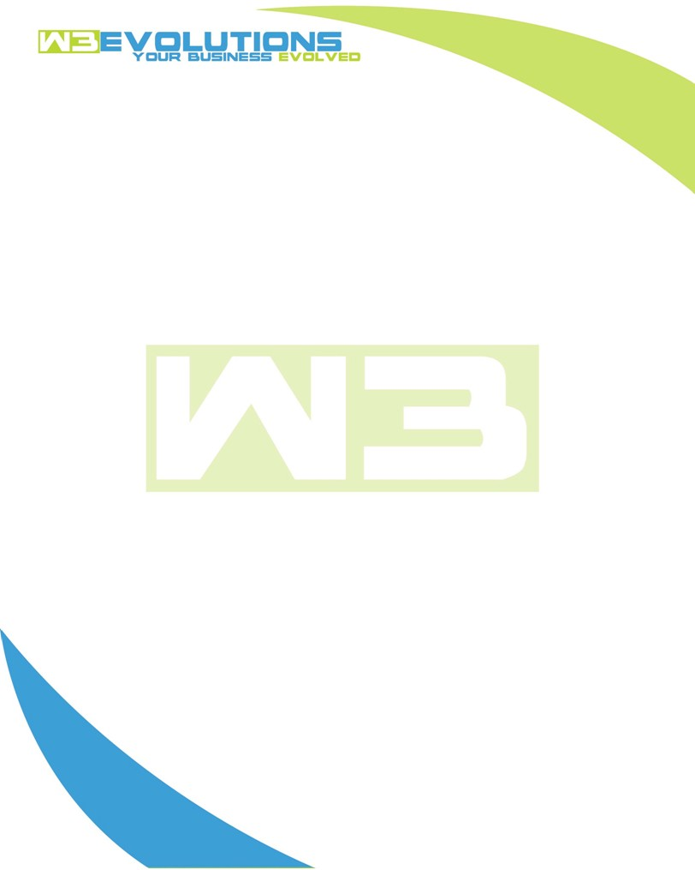

INVOICE

|  |  |
| --- | --- |
| **Bill To:** National Exemption Service, LLC 604 Packard Ct  Safety Harbor, FL 34695 | Invoice No.: NES01-5507  Customer ID: NES01 |

|  |  |  |  |  |  |  |
| --- | --- | --- | --- | --- | --- | --- |
| Date | Invoice No. | Sales Rep. | Ship Via | Terms | Date Due |  |
| 9/23/2024 | NES01-5507 | Brandon Kozak | Email | NET 30 | - |  |

|  |  |  |  |  |  |  |
| --- | --- | --- | --- | --- | --- | --- |
| Quantity | Item | Description | Discount | Taxable | Unit Price | Total |
| 78 | Software Development | See attached | $49 / hr off $175 / hr | No | $126 | $9,828 |
|  |  |  |  |  |  |  |
|  |  |  |  |  |  |  |
|  |  |  |  |  |  |  |

|  |  |
| --- | --- |
| Subtotal: | $9,828 |
| Tax: | 0.00 |
| Balance Due: | $9,828 |

**Please make all checks payable to:** W3Evolutions Systems LLC

**Please send checks to:** 4826 Troydale Rd, Tampa FL 33615

**Zelle**: zelle.wf[@w3evolutions.com](mailto:brandon@w3evolutions.com)

|  |  |  |  |  |
| --- | --- | --- | --- | --- |
| **Date** | **Hours** | **Category** | **Task/Work** | **Persons** |
|  |  |  |  |  |
| **9/17/24** | **8** | **Software Development** | **AAE-208 - Continued investigation into replica not replicating, AAE-235 - Coding** | **BK** |
| **9/18/24** | **8** | **Software Development** | **AAE-208 - Continued investigation into replica not replicating, AAE-235 - Coding** | **BK** |
| **9/19/24** | **14** | **Software Development** | **AAE-208 - Continued investigation into replica not replicating, AAE-235 - Coding; Jerry's Project** | **BK/DH** |
| **9/20/24** | **8** | **Software Development** | **AAE-157 - Discorvery / Coding** | **BK** |
| **9/21/24** | **13** | **Software Development** | **AAE-157 - Discorvery / Coding & Dev complete; Jerry's Project** | **BK/DH** |
| **9/22/24** | **14** | **Software Development** | **AAE-173/AAE-174/AAE-167 - Discorvery / Coding, AAE-208 - Continued investigation into replica not replicating; Jerry's Project** | **BK/DH** |
| **9/23/24** | **13** | **Software Development** | **AAE-173/AAE-174/AAE-167 - Coding, AE-208 - Replication is working!; AAE-153 - Recalculate Button** | **BK/DH** |