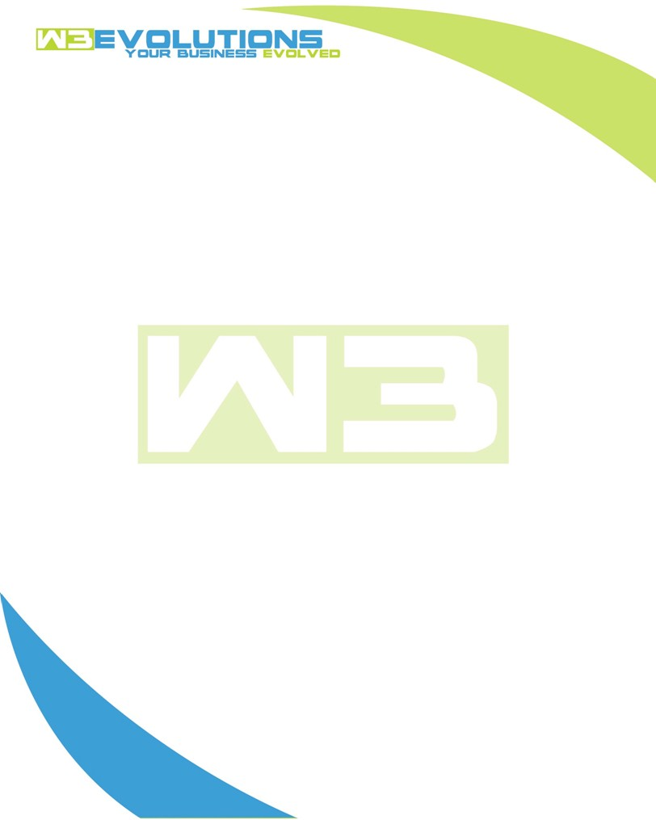

INVOICE

|  |  |
| --- | --- |
| **Bill To:** National Exemption Service, LLC 604 Packard Ct  Safety Harbor, FL 34695 | Invoice No.: NES01-5508  Customer ID: NES01 |

|  |  |  |  |  |  |  |
| --- | --- | --- | --- | --- | --- | --- |
| Date | Invoice No. | Sales Rep. | Ship Via | Terms | Date Due |  |
| 10/2/2024 | NES01-5508 | Brandon Kozak | Email | NET 30 | - |  |

|  |  |  |  |  |  |  |
| --- | --- | --- | --- | --- | --- | --- |
| Quantity | Item | Description | Discount | Taxable | Unit Price | Total |
| 81 | Software Development | See attached | $49 / hr off $175 / hr | No | $126 | $10,206 |
|  |  |  |  |  |  |  |
|  |  |  |  |  |  |  |
|  |  |  |  |  |  |  |

|  |  |
| --- | --- |
| Subtotal: | $10,206 |
| Tax: | 0.00 |
| Balance Due: | $10,206 |

**Please make all checks payable to:** W3Evolutions Systems LLC

**Please send checks to:** 4826 Troydale Rd, Tampa FL 33615

**Zelle**: zelle.wf[@w3evolutions.com](mailto:brandon@w3evolutions.com)

|  |  |  |  |  |
| --- | --- | --- | --- | --- |
| **Date** | **Hours** | **Category** | **Task/Work** | **Persons** |
|  |  |  |  |  |
| **9/24/24** | **14** | **Software Development** | **AAE-235 - Continued developent of DB Switcher and DB Migrator SH and PHP** | **BK** |
| **9/25/24** | **15** | **Software Development** | **AAE-235 - Continued developent of DB Switcher and DB Migrator SH and PHP** | **BK** |
| **9/26/24** | **13** | **Software Development** | **AAE-235 - Big fixes and Testing DB switcher & DB migrator** | **BK** |
| **9/27/24** | **10** | **Software Development** | **AAE-235 - Big fixes and Testing DB switcher & DB migrator** | **BK** |
| **9/28/24** | **11** | **Software Development** | **AAE-235 - Big fixes and Testing DB switcher & DB migrator** | **BK** |
| **9/30/24** | **9** | **Software Development** | **AAE-235 - Big fixes and Testing DB switcher & DB migrator** | **BK** |
| **10/1/24** | **5** | **Software Development** | **AAE-235 - Big fixes and Testing DB switcher & DB migrator** | **BK** |
| **10/2/24** | **4** | **Software Development** | **AAE-235 - Big fixes and Testing DB switcher & DB migrator** | **BK** |