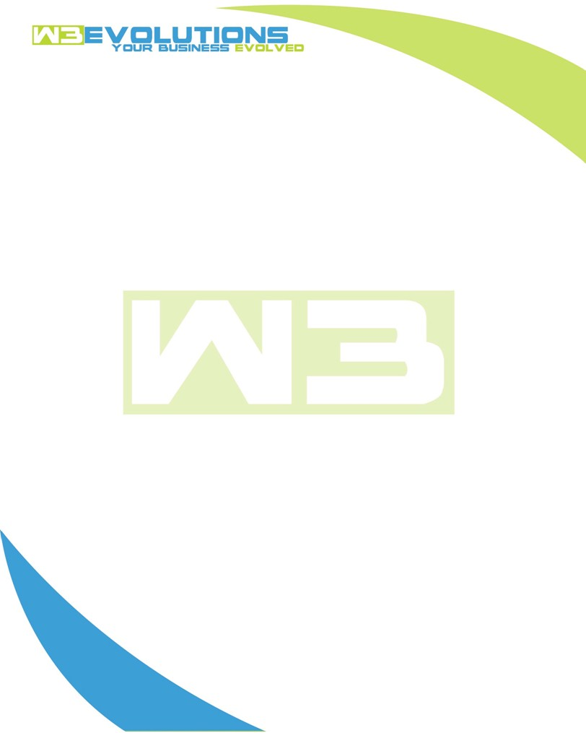

INVOICE

|  |  |
| --- | --- |
| **Bill To:** National Exemption Service, LLC 604 Packard Ct  Safety Harbor, FL 34695 | Invoice No.: NES01-5511 (revised)  Customer ID: NES01 |

|  |  |  |  |  |  |  |
| --- | --- | --- | --- | --- | --- | --- |
| Date | Invoice No. | Sales Rep. | Ship Via | Terms | Date Due |  |
| 10/22/2024 | NES01-5511 (revised) | Brandon Kozak | Email | NET 30 | - |  |

|  |  |  |  |  |  |  |
| --- | --- | --- | --- | --- | --- | --- |
| Quantity | Item | Description | Discount | Taxable | Unit Price | Total |
| 54 | Software Development | See attached | $49 / hr off $175 / hr | No | $126 | $6,804 |
|  |  |  |  |  |  |  |
|  |  |  |  |  |  |  |
|  |  |  |  |  |  |  |

|  |  |
| --- | --- |
| Subtotal: | $6,804 |
| Tax: | 0.00 |
| Balance Due: | $6,804 |

**Please make all checks payable to:** W3Evolutions Systems LLC

**Please send checks to:** 4826 Troydale Rd, Tampa FL 33615

**Zelle**: zelle.wf[@w3evolutions.com](mailto:brandon@w3evolutions.com)

|  |  |  |  |  |
| --- | --- | --- | --- | --- |
| **Date** | **Hours** | **Category** | **Task/Work** | **Persons** |
|  |  |  |  |  |
| **10/16/24** | **12** | **Software Development** | **AAE-208 - email working on all server! Finalizing nginx update for new endpoint for dev-db1 and dev-db2 to access to know when to notify when repliation fails.** | **BK** |
| **10/17/24** | **12** | **Software Development** | **AAE-208 - update read-replica replication process from new credentials from Scott and test the workflow** | **BK** |
| **10/18/24** | **2** | **Software Development** | **Issues with Aida prod user deletion** | **BK** |
| **10/18/24** | **8** | **Software Development** | **AAE-208 - Prepare for weekend launch** | **BK** |
| **10/20/24** | **8** | **Software Development** | **AAE-208 - launch** | **BK** |
| **10/21/24** | **12** | **Software Development** | **AAE-208 - launch** | **BK** |