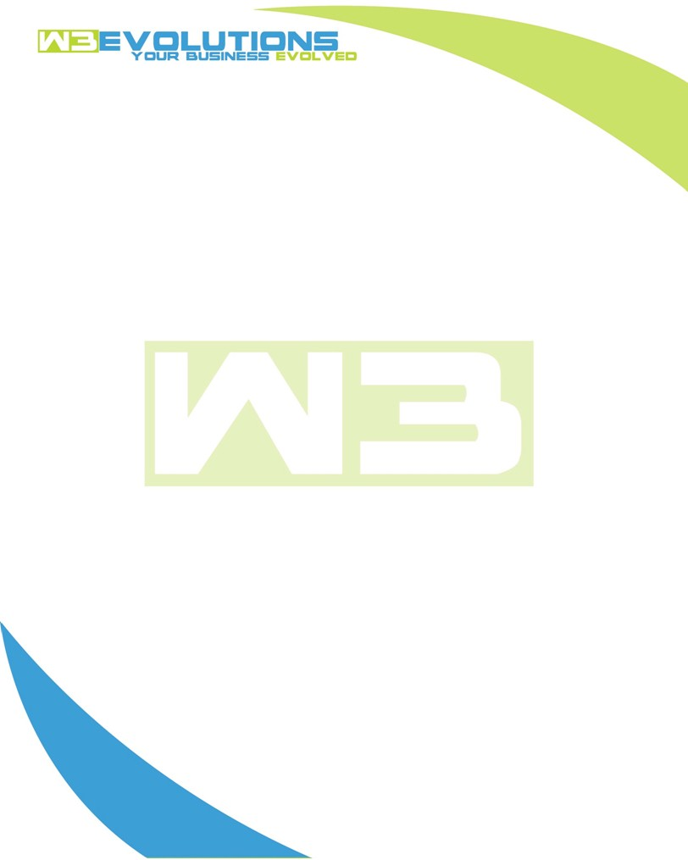

INVOICE

|  |  |
| --- | --- |
| **Bill To:** National Exemption Service, LLC 604 Packard Ct  Safety Harbor, FL 34695 | Invoice No.: NES01-5513  Customer ID: NES01 |

|  |  |  |  |  |  |  |
| --- | --- | --- | --- | --- | --- | --- |
| Date | Invoice No. | Sales Rep. | Ship Via | Terms | Date Due |  |
| 11/7/2024 | NES01-5513 | Brandon Kozak | Email | NET 30 | - |  |

|  |  |  |  |  |  |  |
| --- | --- | --- | --- | --- | --- | --- |
| Quantity | Item | Description | Discount | Taxable | Unit Price | Total |
| 109 | Software Development | See attached | $49 / hr off $175 / hr | No | $126 | $13,734 |
|  |  |  |  |  |  |  |
|  |  |  |  |  |  |  |
|  |  |  |  |  |  |  |

|  |  |
| --- | --- |
| Subtotal: | $13,734 |
| Tax: | 0.00 |
| Balance Due: | $13,734 |

**Please make all checks payable to:** W3Evolutions Systems LLC

**Please send checks to:** 4826 Troydale Rd, Tampa FL 33615

**Zelle**: zelle.wf[@w3evolutions.com](mailto:brandon@w3evolutions.com)

|  |  |  |  |  |
| --- | --- | --- | --- | --- |
| **Date** | **Hours** | **Category** | **Task/Work** | **Persons** |
|  |  |  |  |  |
| **10/30/24** | **8** | **Software Development** | **AAE-208 - Contiuned testing replication issues. AAE-245 - Continued Dev** | **BK** |
| **10/31/24** | **4** | **Management** | **Review tickets, update tickets / restructure. Move tickets in jira, general PM, AAE-247 & AAE-248 - Dev review / start of req. gathering for dev** | **BK** |
| **10/31/24** | **12** | **Software Development** | **AAE-245 - Continued Dev. AAE-208 - Continued testing / bug fixing for replication issues** | **BK/DH** |
| **11/1/24** | **4** | **Management** | **AAE-247, AAE-248, AAE-245, Continued reserach for dev/qa** | **BK/DH** |
| **11/1/24** | **8** | **Software Development** | **AAE-208, AAE-245, dev-db1/dev-db2 sync checking/updating** | **BK** |
| **11/2/24** | **4** | **Management** | **Jira clean up, review tickets, work on dev/QA ticket format** | **BK/DH** |
| **11/3/24** | **2** | **Software Development** | **AAE-208 - Prep watcher for monday** | **BK** |
| **11/4/24** | **8** | **Software Development** | **AAE-208, AAE-187 - review/debugging/researching,** | **BK** |
| **11/4/24** | **2** | **Management** | **AAE-247, AAE-248, AAE-245, AAE-250 - review tickets and reserach issues** | **BK/DH** |
| **11/4/24** | **3** | **Software Development** | **AAE-250 - Github workflow creation / testing** | **BK/DH** |
| **11/5/24** | **8** | **Software Development** | **AAE-203, AAE-208 - stage-qa merge and prep, AAE-250 - Setup and test more git workflow and forking** | **BK** |
| **11/5/24** | **4** | **Management** | **Prep tickets for stage-qa release and Ralph to send to team** | **BK/DH** |
| **11/6/2024** | **18** | **Software Development** | **AAE-230 - revamp EzPay for BT, AAE-173 research and development** | **BK/DH** |
| **11/7/2024** | **12** | **Software Development** | **AAE-230 - release, AAE-208 - clean up / support, AAE-167, AAE-157, AAE-153, AAE-185, AAE-214 - merge code, prep for stage-qa** | **BK** |
| **11/7/24** | **12** | **Management** | **AAE-167, AAE-157, AAE-153, AAE-185, AAE-214 - review, update ticket / QA / Dev tasks** | **DH** |