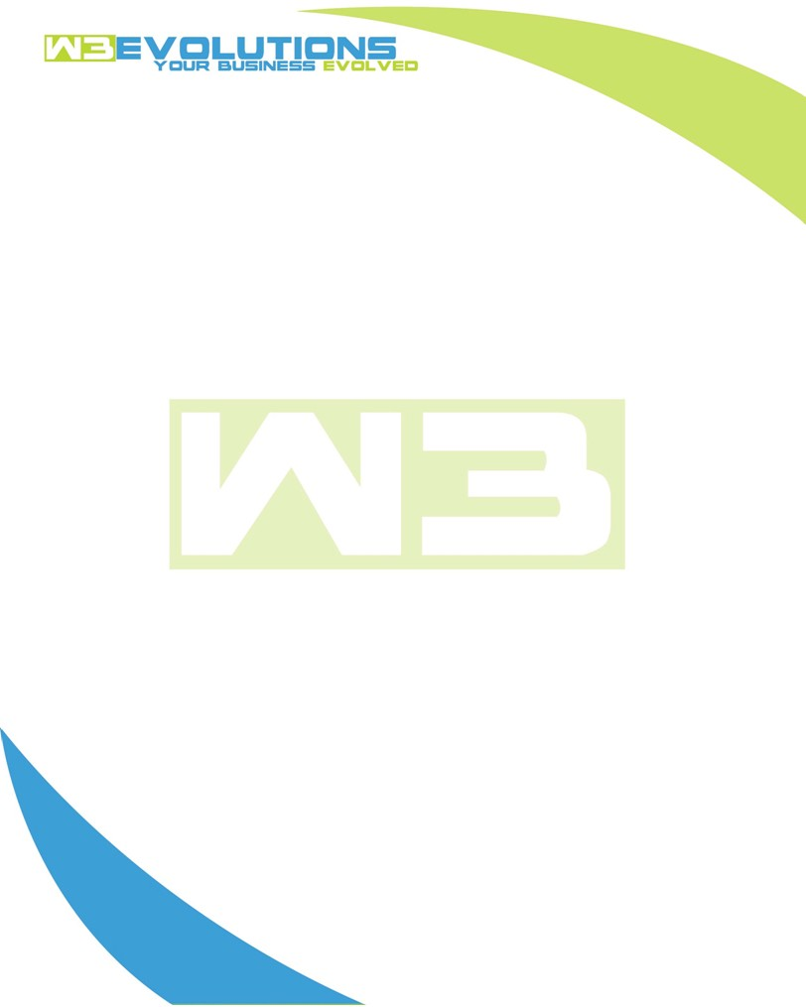

INVOICE

|  |  |
| --- | --- |
| **Bill To:** National Exemption Service, LLC 604 Packard Ct  Safety Harbor, FL 34695 | Invoice No.: NES01-5514  Customer ID: NES01 |

|  |  |  |  |  |  |  |
| --- | --- | --- | --- | --- | --- | --- |
| Date | Invoice No. | Sales Rep. | Ship Via | Terms | Date Due |  |
| 11/13/2024 | NES01-5514 | Brandon Kozak | Email | NET 30 | - |  |

|  |  |  |  |  |  |  |
| --- | --- | --- | --- | --- | --- | --- |
| Quantity | Item | Description | Discount | Taxable | Unit Price | Total |
| 61 | Software Development | See attached | $49 / hr off $175 / hr | No | $126 | $7,686 |
|  |  |  |  |  |  |  |
|  |  |  |  |  |  |  |
|  |  |  |  |  |  |  |

|  |  |
| --- | --- |
| Subtotal: | $7,686 |
| Tax: | 0.00 |
| Balance Due: | $7,686 |

**Please make all checks payable to:** W3Evolutions Systems LLC

**Please send checks to:** 4826 Troydale Rd, Tampa FL 33615

**Zelle**: zelle.wf[@w3evolutions.com](mailto:brandon@w3evolutions.com)

|  |  |  |  |  |
| --- | --- | --- | --- | --- |
| **Date** | **Hours** | **Category** | **Task/Work** | **Persons** |
|  |  |  |  |  |
| **11/8/24** | **2** | **Management** | **AAE-167, AAE-157, AAE-153, AAE-185, AAE-214 - review, update ticket / QA / Dev tasks** | **DH** |
| **11/8/24** | **7** | **Software Development** | **AAE-173, AAE-174, AAE-203 - continued development** | **BK** |
| **11/9/24** | **9** | **Software Development** | **AAE-208 - Weekend cleanup, AAE-173, AAE-174 - continued development** | **BK/DH** |
| **11/10/24** | **9** | **Software Development** | **AAE-208 - Weekend cleanup, AAE-173, AAE-174 - continued development** | **BK/DH** |
| **11/11/24** | **8** | **Software Development** | **AAE-203 - Determine if upgrading DT wil work vs custom code for filter saving** | **BK** |
| **11/11/24** | **4** | **Management** | **Jira ticket review/formatting/cleanup/questions** | **DH** |
| **11/12/24** | **8** | **Software Development** | **AAE-167, AAE-203, AAE-153 - continued development** | **BK** |
| **11/12/24** | **2** | **Management** | **Jira ticket review/formatting/cleanup/questions** | **DH** |
| **11/13/24** | **12** | **Software Development** | **AAE-255 - unicode pdf development** | **BK** |