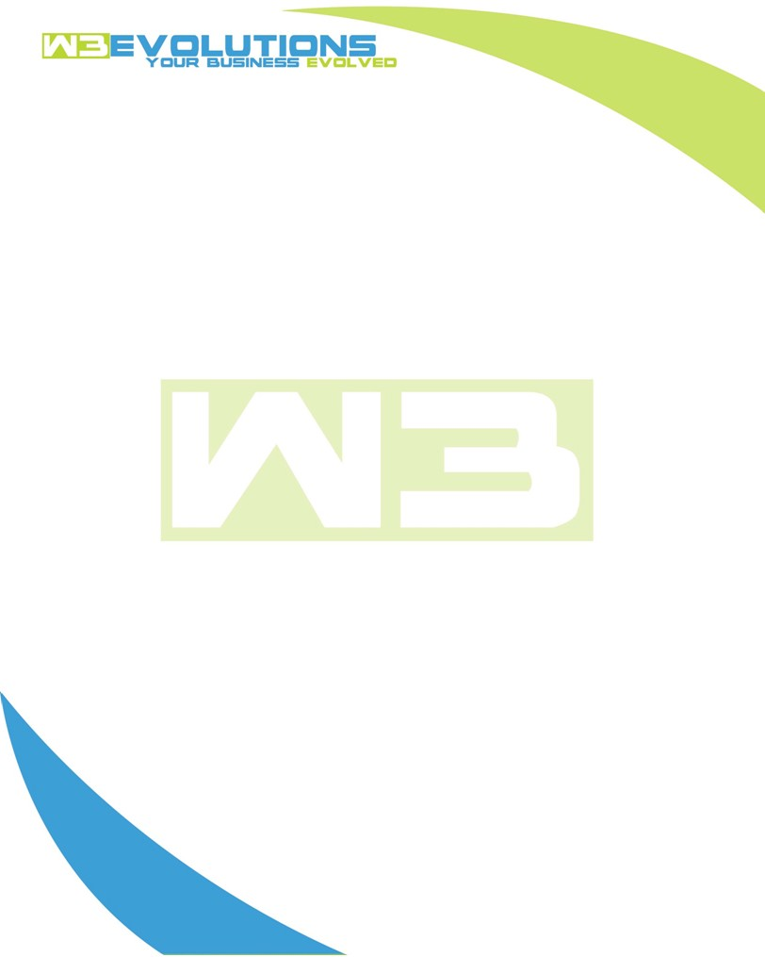

INVOICE

|  |  |
| --- | --- |
| **Bill To:** National Exemption Service, LLC 604 Packard Ct  Safety Harbor, FL 34695 | Invoice No.: NES01-5518  Customer ID: NES01 |

|  |  |  |  |  |  |  |
| --- | --- | --- | --- | --- | --- | --- |
| Date | Invoice No. | Sales Rep. | Ship Via | Terms | Date Due |  |
| 12/17/2024 | NES01-5518 | Brandon Kozak | Email | NET 30 | - |  |

|  |  |  |  |  |  |  |
| --- | --- | --- | --- | --- | --- | --- |
| Quantity | Item | Description | Discount | Taxable | Unit Price | Total |
| 103 | Software Development | See attached | $49 / hr off $175 / hr | No | $126 | $12,978 |
|  |  |  |  |  |  |  |
|  |  |  |  |  |  |  |
|  |  |  |  |  |  |  |

|  |  |
| --- | --- |
| Subtotal: | $12,978 |
| Tax: | 0.00 |
| Balance Due: | $12,978 |

**Please make all checks payable to:** W3Evolutions Systems LLC

**Please send checks to:** 4826 Troydale Rd, Tampa FL 33615

**Zelle**: zelle.wf[@w3evolutions.com](mailto:brandon@w3evolutions.com)

|  |  |  |  |  |
| --- | --- | --- | --- | --- |
| **Date** | **Hours** | **Category** | **Task/Work** | **Persons** |
|  |  |  |  |  |
| **12/11/24** | **10** | **Software Development** | **AAE-262 - Rework & development** | **BK** |
| **12/11/24** | **8** | **Software Development** | **AAE-203 - Continued development - Upgrading to Datatables v2** | **DH** |
| **12/12/24** | **10** | **Software Development** | **AAE-262 - Continued Development** | **BK** |
| **12/12/24** | **8** | **Software Development** | **AAE-203 - Continued development - Upgrading to Datatables v2** | **DH** |
| **12/13/24** | **10** | **Software Development** | **AAE-262 - Continued Development** | **BK** |
| **12/13/24** | **8** | **Software Development** | **AAE-203 - Continued development - Upgrading to Datatables v2** | **DH** |
| **12/14/24** | **5** | **Software Development** | **AAE-100 - determine recommendations for handling CO** | **DH** |
| **12/15/24** | **10** | **Software Development** | **AAE-262 - Continued Development** | **BK** |
| **12/16/24** | **10** | **Software Development** | **AAE-262 - Package and Release** | **BK** |
| **12/16/24** | **8** | **Software Development** | **AAE-203 - Continued development - Upgrading to Datatables v2** | **DH** |
| **12/17/24** | **8** | **Software Development** | **AAE-262 - Package and Release; review outstanding tickets** | **BK** |
| **12/17/24** | **8** | **Software Development** | **AAE-203 - Continued development - Upgrading to Datatables v2** | **DH** |