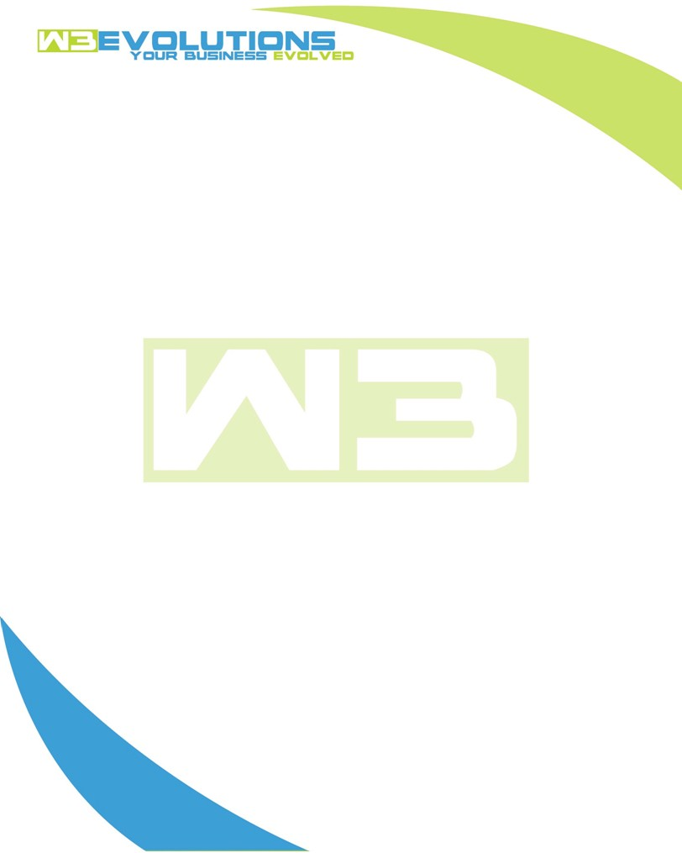

INVOICE

|  |  |
| --- | --- |
| **Bill To:** National Exemption Service, LLC 604 Packard Ct  Safety Harbor, FL 34695 | Invoice No.: NES01-5520  Customer ID: NES01 |

|  |  |  |  |  |  |  |
| --- | --- | --- | --- | --- | --- | --- |
| Date | Invoice No. | Sales Rep. | Ship Via | Terms | Date Due |  |
| 1/9/2025 | NES01-5520 | Brandon Kozak | Email | NET 30 | - |  |

|  |  |  |  |  |  |  |
| --- | --- | --- | --- | --- | --- | --- |
| Quantity | Item | Description | Discount | Taxable | Unit Price | Total |
| 237 | Software Development | See attached | $49 / hr off $175 / hr | No | $126 | $29,862 |
|  |  |  |  |  |  |  |
|  |  |  |  |  |  |  |
|  |  |  |  |  |  |  |

|  |  |
| --- | --- |
| Subtotal: | $29,862 |
| Tax: | 0.00 |
| Balance Due: | $29,862 |

**Please make all checks payable to:** W3Evolutions Systems LLC

**Please send checks to:** 4826 Troydale Rd, Tampa FL 33615

**Zelle**: zelle.wf[@w3evolutions.com](mailto:brandon@w3evolutions.com)

|  |  |  |  |  |
| --- | --- | --- | --- | --- |
| **Date** | **Hours** | **Category** | **Task/Work** | **Persons** |
|  |  |  |  |  |
| **12/23/24** | **4** | **Management** | **Jira ticket review/formatting/cleanup/questions/tasks** | **DH** |
| **12/23/24** | **8** | **Software Development** | **AAE-203 - Continued development - Upgrading to Datatables v2** | **DH** |
| **12/23/24** | **10** | **Software Development** | **AAE-203, AAE-100, AAE-153 - w3/stage-qa merge and clean up. Push to w3-stage for final internal QA. AAE-255 & AAE-256 - contiuned dev + merge down stage-qa. AAE-265 - investigating issue + possible fixes, AAE-261 - fork repo and GIT setup** | **BK** |
| **12/24/24** | **8** | **Software Development** | **AAE-229 - continnued development** | **DH** |
| **12/24/24** | **8** | **Software Development** | **AAE-255 & AAE-256 - contiuned dev, AAE-265 - investigating issue + possible fixes, AAE-261 - continue fork setup** | **BK** |
| **12/26/24** | **8** | **Software Development** | **AAE-255 & AAE-256 - contiuned dev, AAE-265 - investigating issue + possible fixes, AAE-261 - continue fork setup** | **BK** |
| **12/27/24** | **10** | **Software Development** | **AAE-265 - Complete and prep for prod release** | **BK** |
| **12/27/24** | **8** | **Software Development** | **AAE-229 - continnued development** | **DH** |
| **12/29/24** | **4** | **Management** | **Jira ticket review/formatting/cleanup/questions/tasks** | **DH** |
| **12/30/24** | **8** | **Software Development** | **AAE-257 - multi page dev, AAE-265 - clean up and testing** | **BK** |
| **12/30/24** | **8** | **Software Development** | **AAE-229 - continnued development** | **DH** |
| **12/31/24** | **8** | **Software Development** | **Sync dbs, fork portal stage, prep portal github, review portal prod for merge down,** | **BK** |
| **12/31/24** | **8** | **Software Development** | **AAE-229 - continnued development** | **DH** |
| **1/1/25** | **8** | **Software Development** | **AAE-229 - continnued development** | **DH** |
| **1/2/25** | **8** | **Software Development** | **AAE-260 - continue branch merging for stge-qa, AAE-257 - Multipage PDFs + Spanish continued development** | **BK** |
| **1/2/25** | **2** | **Management** | **Jira ticket review/formatting/cleanup/questions/tasks** | **DH** |
| **1/2/25** | **8** | **Software Development** | **AAE-229 - continnued development** | **DH** |
| **1/3/25** | **8** | **Software Development** | **AAE-262 , AAE-153, AAE-262, AAE-100, AAE-153, AAE-154, AAE-167, AAE-174, AAE-173 - merge prep for monday aida-stage** | **BK** |
| **1/3/25** | **8** | **Software Development** | **AAE-266, AAE-229 - continnued development** | **DH** |
| **1/4/25** | **8** | **Software Development** | **Prepping stage-qa Aida and Portal** | **BK** |
| **1/5/25** | **11** | **Software Development** | **Prepping stage-qa Aida and Portal** | **BK/DH** |
| **1/6/25** | **8** | **Software Development** | **AAE-175 fix issued, continue stage-qa prep for completion of P3** | **BK** |
| **1/6/25** | **4** | **Management** | **Prep QA Google docs for NES testing team** | **BK** |
| **1/6/25** | **8** | **Software Development** | **AAE-229 - continued development** | **DH** |
| **1/7/25** | **10** | **Software Development** | **AAE-175 fix issued, continue stage-qa prep for completion of P3** | **BK** |
| **1/7/25** | **8** | **Software Development** | **AAE-229, AAE-174, AAE-173 - continued development** | **DH** |
| **1/8/25** | **8** | **Software Development** | **AAE-229 - debugging** | **DH** |
| **1/8/25** | **12** | **Software Development** | **AAE-240, AAE-175, AAE-266 - completed, teted and stage-qa merged, AAE-258 - test/stage-qa prep, AAE-248 - test and prep stage-qa, AAE-229 - finalize decmial conversion, test and stage-qa prep** | **BK** |
| **1/9/25** | **10** | **Software Development** | **AAE-258 - contnued test/stage-qa prep, AAE-203 - test/stage-qa prep, AAE-174 - test and rebuild stored procs for stage-qa prep, Prep deb_db1 & dev_db2 for resync** | **BK** |
| **1/9/25** | **8** | **Software Development** | **AAE-203 - Add feature, debugging** | **DH** |