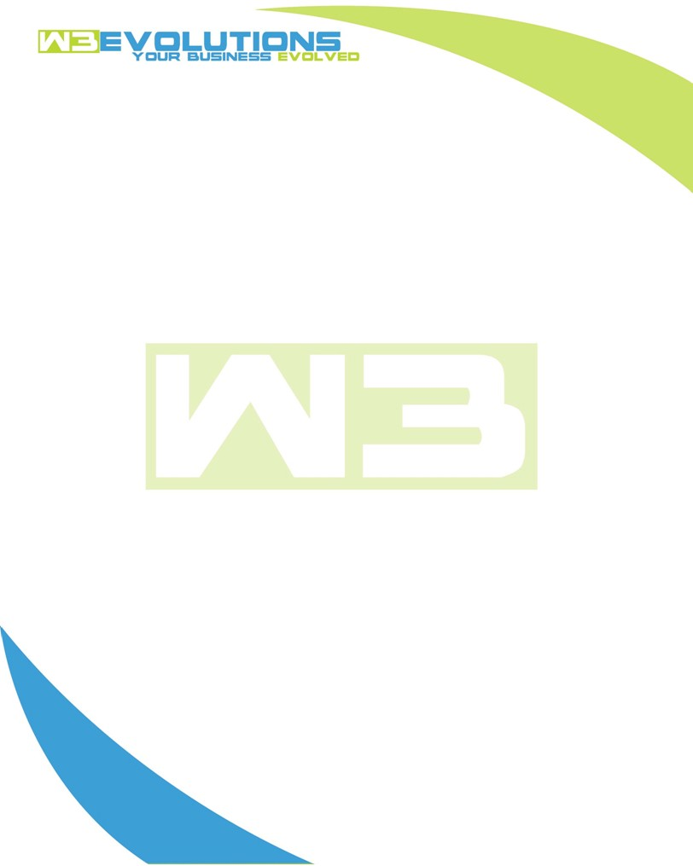

INVOICE

|  |  |
| --- | --- |
| **Bill To:** National Exemption Service, LLC 604 Packard Ct  Safety Harbor, FL 34695 | Invoice No.: NES01-5521  Customer ID: NES01 |

|  |  |  |  |  |  |  |
| --- | --- | --- | --- | --- | --- | --- |
| Date | Invoice No. | Sales Rep. | Ship Via | Terms | Date Due |  |
| 1/15/2025 | NES01-5521 | Brandon Kozak | Email | NET 30 | - |  |

|  |  |  |  |  |  |  |
| --- | --- | --- | --- | --- | --- | --- |
| Quantity | Item | Description | Discount | Taxable | Unit Price | Total |
| 93 | Enhancement | See attached | $49 / hr off $175 / hr | No | $126 | $11,718 |
| 24 | New Development | See attached | $49 / hr off $175 / hr | No | $126 | $3,024 |
|  |  |  |  |  |  |  |
|  |  |  |  |  |  |  |

|  |  |
| --- | --- |
| Subtotal: | $14,742 |
| Tax: | 0.00 |
| Balance Due: | $14,742 |

**Please make all checks payable to:** W3Evolutions Systems LLC

**Please send checks to:** 4826 Troydale Rd, Tampa FL 33615

**Zelle**: zelle.wf[@w3evolutions.com](mailto:brandon@w3evolutions.com)

|  |  |  |  |  |
| --- | --- | --- | --- | --- |
| **Date** | **Hours** | **Category** | **Task/Work** | **Persons** |
|  |  |  |  |  |
| **1/10/25** | **6** | **Enhancement** | **AAE-240, AAE-174, AAE-266, AAE-254 - Prep for stage-qa** | **BK** |
| **1/10/25** | **6** | **New Development** | **AAE-240, AAE-174, AAE-266, AAE-254 - Prep for stage-qa** | **BK** |
| **1/10/25** | **8** | **Enhancement** | **AAE-248 - debugging stored procedure for NC Hot Reads** | **DH** |
| **1/11/25** | **6** | **Enhancement** | **AAE-240, AAE-174, AAE-266, AAE-254 - Prep for stage-qa** | **BK** |
| **1/11/25** | **6** | **New Development** | **AAE-240, AAE-174, AAE-266, AAE-254 - Prep for stage-qa** | **BK** |
| **1/11/25** | **8** | **Enhancement** | **Review outstanding tickets for release and QA** | **DH** |
| **1/12/25** | **12** | **Enhancement** | **AAE-203 (#35), AAE-258 (#28), AAE-240 (#27), AAE-175 (#26), AAE-174 (#25) - Prep for stage-qa** | **BK** |
| **1/12/25** | **8** | **Enhancement** | **AAE-267 - Update XML for bilingual bills; QA outstanding tickets for release** | **DH** |
| **1/13/25** | **12** | **New Development** | **AAE-266 (#36), AAE-153 (#37) - Prep for stage-qa** | **BK** |
| **1/13/25** | **8** | **Enhancement** | **AAE-203 - debugging datatables v2, aligning features from v1** | **DH** |
| **1/14/25** | **12** | **Enhancement** | **AAE-176, AAE-188 (#41) - prep for stage-qa** | **BK** |
| **1/14/25** | **8** | **Enhancement** | **AAE-203 - Add feature; AAE-259 - investigate bug** | **DH** |
| **1/15/25** | **1** | **Enhancement** | **AAE-271 - Investigate and fix BT email** | **BK** |
| **1/15/25** | **8** | **Enhancement** | **AAE-270 - investigate and finx solution for decimal from float conversion for display** | **BK** |
| **1/15/25** | **8** | **Enhancement** | **AAE-203 - Add feature; AAE-259 - investigate bug** | **DH** |