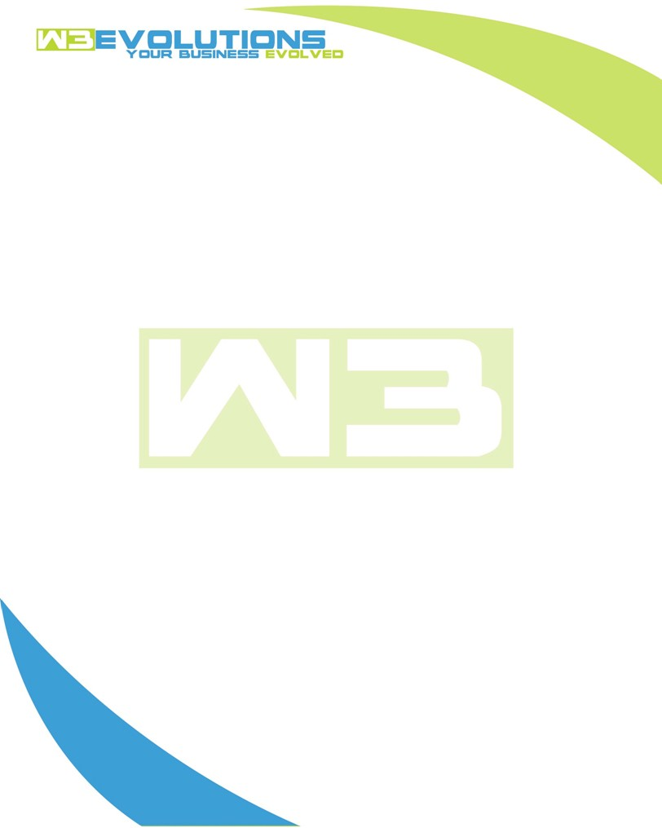

INVOICE

|  |  |
| --- | --- |
| **Bill To:** National Exemption Service, LLC 604 Packard Ct  Safety Harbor, FL 34695 | Invoice No.: NES01-5522  Customer ID: NES01 |

|  |  |  |  |  |  |  |
| --- | --- | --- | --- | --- | --- | --- |
| Date | Invoice No. | Sales Rep. | Ship Via | Terms | Date Due |  |
| 1/21/2025 | NES01-5522 | Brandon Kozak | Email | NET 30 | - |  |

|  |  |  |  |  |  |  |
| --- | --- | --- | --- | --- | --- | --- |
| Quantity | Item | Description | Discount | Taxable | Unit Price | Total |
| 100 | Enhancement | See attached | $49 / hr off $175 / hr | No | $126 | $12,600 |
| 6 | New Development | See attached | $49 / hr off $175 / hr | No | $126 | $756 |
|  |  |  |  |  |  |  |
|  |  |  |  |  |  |  |

|  |  |
| --- | --- |
| Subtotal: | $13,356 |
| Tax: | 0.00 |
| Balance Due: | $13,356 |

**Please make all checks payable to:** W3Evolutions Systems LLC

**Please send checks to:** 4826 Troydale Rd, Tampa FL 33615

**Zelle**: zelle.wf[@w3evolutions.com](mailto:brandon@w3evolutions.com)

|  |  |  |  |  |
| --- | --- | --- | --- | --- |
| **Date** | **Hours** | **Category** | **Task/Work** | **Persons** |
|  |  |  |  |  |
| **1/16/25** | **12** | **Enhancement** | **AAE-229 (#42) - prep and merge to stage-qa** | **BK** |
| **1/16/25** | **8** | **Enhancement** | **AAE-203 - debugging datatables v2, aligning features from v1** | **DH** |
| **1/17/25** | **12** | **Enhancement** | **AAE-229 - debug 2.000000000000000 display issues** | **BK** |
| **1/17/25** | **8** | **Enhancement** | **AAE-203 - debugging datatables v2, aligning features from v1; AAE-259 - investigating and testing** | **DH** |
| **1/18/25** | **12** | **Enhancement** | **AAE-229 - fix 2.000000000000000 display issues** | **BK** |
| **1/18/25** | **5** | **Enhancement** | **AAE-203 - debugging datatables v2, aligning features from v1** | **DH** |
| **1/19/25** | **6** | **New Development** | **AAE-100 - update stored procs and other files impacted by CO feature** | **DH** |
| **1/19/25** | **12** | **Enhancement** | **Prep stage-qa AAE-259, AAE-100, AAE-203, AAE-229, AAE-176, AAE-188, AAE-266, AAE-153, AAE-258, AAE-240, AAE-175, AAE-174, AAE-266, AAE-254, Sync DB & prep stage-qa launch** | **BK** |
| **1/20/25** | **8** | **Enhancement** | **AAE-101 - stage-qa relased** | **BK** |
| **1/20/25** | **8** | **Enhancement** | **AAE-203 - debugging datatables v2, aligning features from v1; AAE-259 - investigating and testing** | **DH** |
| **1/21/25** | **2** | **Enhancement** | **AAE-203 - Merge and updat stage-qa** | **BK** |
| **1/21/25** | **5** | **Enhancement** | **Investigate prod DB issue** | **BK** |
| **1/21/25** | **8** | **Enhancement** | **AAE-203 - debugging datatables v2, aligning features from v1; AAE-259 - investigating and testing** | **DH** |