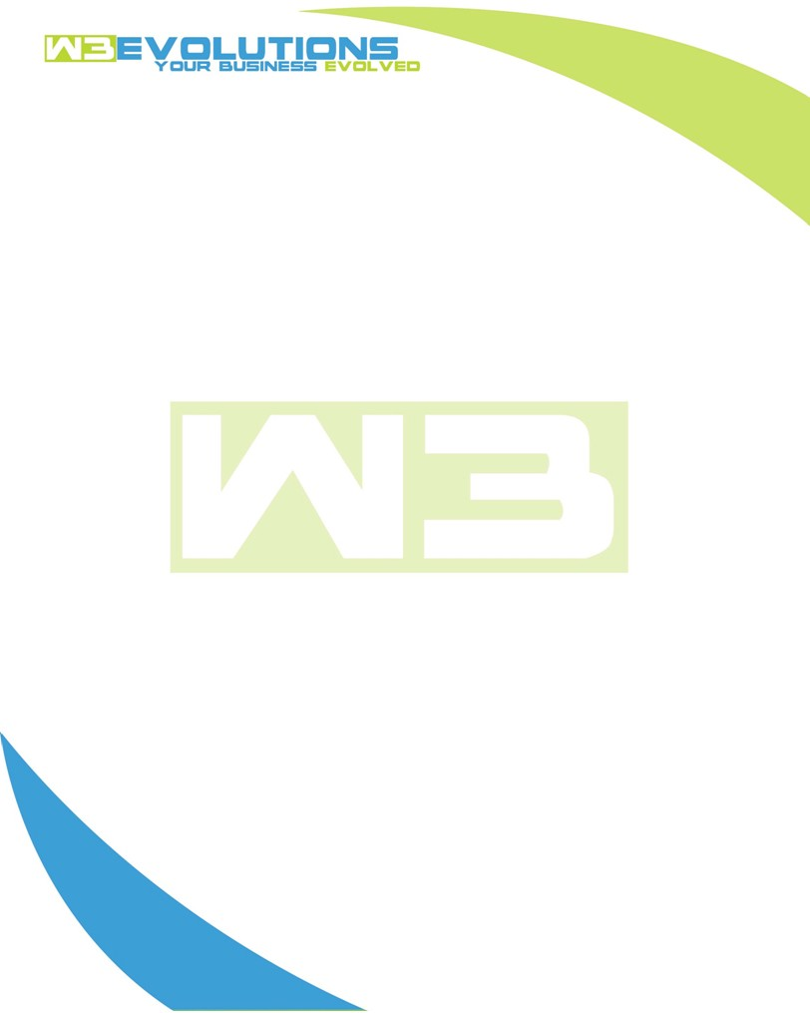

INVOICE

|  |  |
| --- | --- |
| **Bill To:** National Exemption Service, LLC 604 Packard Ct  Safety Harbor, FL 34695 | Invoice No.: NES01-5526  Customer ID: NES01 |

|  |  |  |  |  |  |  |
| --- | --- | --- | --- | --- | --- | --- |
| Date | Invoice No. | Sales Rep. | Ship Via | Terms | Date Due |  |
| 2/24/2025 | NES01-5526 | Brandon Kozak | Email | NET 30 | - |  |

|  |  |  |  |  |  |  |
| --- | --- | --- | --- | --- | --- | --- |
| Quantity | Item | Description | Discount | Taxable | Unit Price | Total |
| 48 | Enhancement | See attached | $49 / hr off $175 / hr | No | $126 | $6,048 |
| 32 | New Development | See attached | $49 / hr off $175 / hr | No | $126 | $4,032 |
|  |  |  |  |  |  |  |
|  |  |  |  |  |  |  |

|  |  |
| --- | --- |
| Subtotal: | $10,080 |
| Tax: | 0.00 |
| Balance Due: | $10,080 |

**Please make all checks payable to:** W3Evolutions Systems LLC

**Please send checks to:** 4826 Troydale Rd, Tampa FL 33615

**Zelle**: zelle.wf[@w3evolutions.com](mailto:brandon@w3evolutions.com)

|  |  |  |  |  |
| --- | --- | --- | --- | --- |
| **Date** | **Hours** | **Category** | **Task/Work** | **Persons** |
|  |  |  |  |  |
| **2/19/25** | **8** | **New Development** | **AAE-280 - Development** | **BK** |
| **2/19/25** | **8** | **Enhancement** | **AAE-289 - Development,** | **DH** |
| **2/20/25** | **8** | **New Development** | **AAE-280 - Development** | **BK** |
| **2/20/25** | **8** | **Enhancement** | **AAE-289 - Development,** | **DH** |
| **2/21/25** | **8** | **New Development** | **AAE-280 - Development** | **BK** |
| **2/21/25** | **8** | **Enhancement** | **AAE-289 - Development, AAE-269 - Development** | **DH** |
| **2/22/25** | **8** | **Enhancement** | **AAE-269 - Development** | **DH** |
| **2/23/25** | **8** | **Enhancement** | **AAE-269 - Development** | **DH** |
| **2/24/25** | **8** | **New Development** | **AAE-280 - Development** | **BK** |
| **2/24/25** | **8** | **Enhancement** | **AAE-269 - Development** | **DH** |