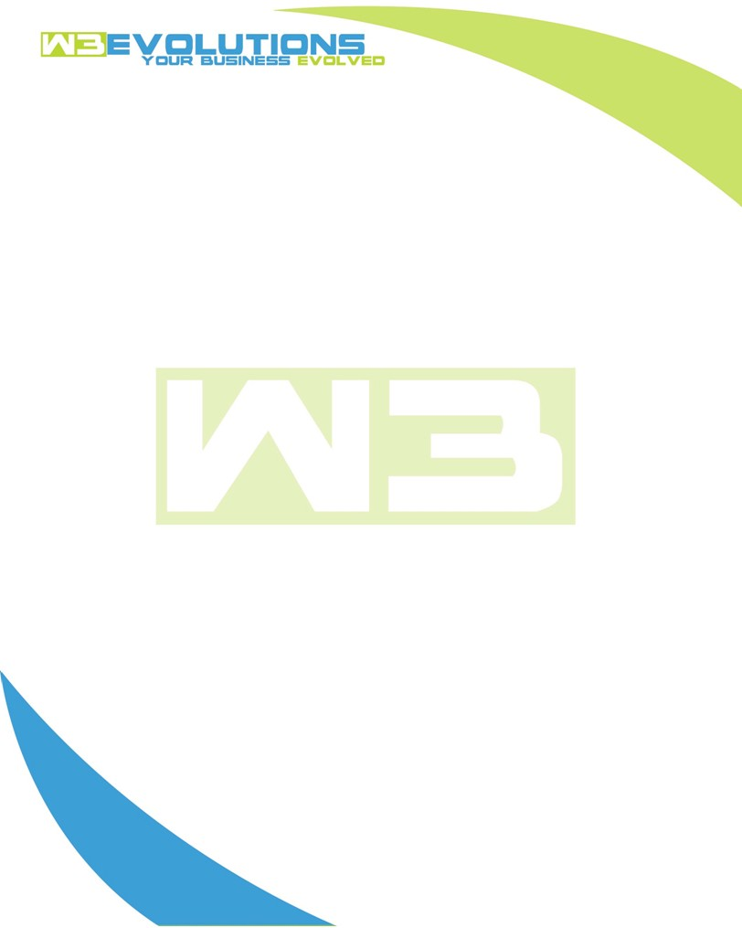

INVOICE

|  |  |
| --- | --- |
| **Bill To:** National Exemption Service, LLC 604 Packard Ct  Safety Harbor, FL 34695 | Invoice No.: NES01-5528  Customer ID: NES01 |

|  |  |  |  |  |  |  |
| --- | --- | --- | --- | --- | --- | --- |
| Date | Invoice No. | Sales Rep. | Ship Via | Terms | Date Due |  |
| 3/11/2025 | NES01-5528 | Brandon Kozak | Email | NET 30 | - |  |

|  |  |  |  |  |  |  |
| --- | --- | --- | --- | --- | --- | --- |
| Quantity | Item | Description | Discount | Taxable | Unit Price | Total |
| 44 | New Development | See attached | $49 / hr off $175 / hr | No | $126 | $5,544 |
|  |  |  |  |  |  |  |
|  |  |  |  |  |  |  |
|  |  |  |  |  |  |  |

|  |  |
| --- | --- |
| Subtotal: | $5,544 |
| Tax: | 0.00 |
| Balance Due: | $5,544 |

**Please make all checks payable to:** W3Evolutions Systems LLC

**Please send checks to:** 4826 Troydale Rd, Tampa FL 33615

**Zelle**: zelle.wf[@w3evolutions.com](mailto:brandon@w3evolutions.com)

|  |  |  |  |  |
| --- | --- | --- | --- | --- |
| **Date** | **Hours** | **Category** | **Task/Work** | **Persons** |
|  |  |  |  |  |
| **3/7/25** | **8** | **New Development** | **AAE-298 - Development** | **BK** |
| **3/8/25** | **7** | **New Development** | **AAE-157, AAE-168, AAE-298, AAE-171, AAE-258, AAE-189 - Development, stage-qa merge, prep aida-stage, dev-db2 migration** | **DH** |
| **3/9/25** | **12** | **New Development** | **AAE-157, AAE-168, AAE-298, AAE-171, AAE-258, AAE-189 - Development, stage-qa merge, prep aida-stage, dev-db2 migration** | **BK** |
| **3/10/25** | **8** | **New Development** | **AAE-157, AAE-168, AAE-298, AAE-171, AAE-258, AAE-189 - Development, stage-qa merge, prep aida-stage, dev-db2 migration** | **BK** |
| **3/11/25** | **9** | **New Development** | **AAE-157, AAE-168, AAE-298, AAE-171, AAE-258, AAE-189 - Development, stage-qa merge, prep aida-stage, dev-db2 migration** | **DH** |