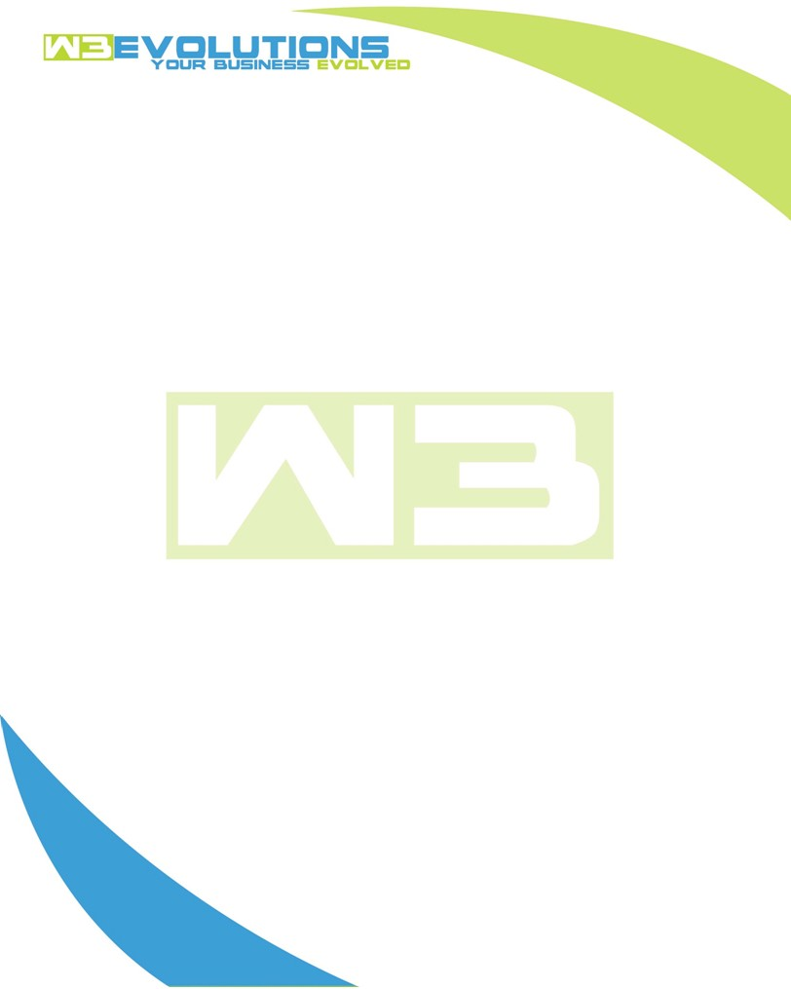

INVOICE

|  |  |
| --- | --- |
| **Bill To:** National Exemption Service, LLC 604 Packard Ct  Safety Harbor, FL 34695 | Invoice No.: NES01-5529  Customer ID: NES01 |

|  |  |  |  |  |  |  |
| --- | --- | --- | --- | --- | --- | --- |
| Date | Invoice No. | Sales Rep. | Ship Via | Terms | Date Due |  |
| 3/18/2025 | NES01-5529 | Brandon Kozak | Email | NET 30 | - |  |

|  |  |  |  |  |  |  |
| --- | --- | --- | --- | --- | --- | --- |
| Quantity | Item | Description | Discount | Taxable | Unit Price | Total |
| 68 | New Development | See attached | $49 / hr off $175 / hr | No | $126 | $7,686 |
| 61 | Enhancement | See attached | $49 / hr off $175 / hr | No | $126 | $8,568 |
|  |  |  |  |  |  |  |
|  |  |  |  |  |  |  |

|  |  |
| --- | --- |
| Subtotal: | $16,254 |
| Tax: | 0.00 |
| Balance Due: | $16,254 |

**Please make all checks payable to:** W3Evolutions Systems LLC

**Please send checks to:** 4826 Troydale Rd, Tampa FL 33615

**Zelle**: zelle.wf[@w3evolutions.com](mailto:brandon@w3evolutions.com)

|  |  |  |  |  |
| --- | --- | --- | --- | --- |
| **Date** | **Hours** | **Category** | **Task/Work** | **Persons** |
|  |  |  |  |  |
| **3/12/25** | **8** | **New Development** | **AAE-157, AAE-168, AAE-298, AAE-171, AAE-258, AAE-189 - Development, stage-qa merge, prep aida-stage, dev-db2 migration** | **BK** |
| **3/12/25** | **9** | **New Development** | **AAE-296 - Development** | **DH** |
| **3/13/25** | **8** | **New Development** | **AAE-157, AAE-168, AAE-298, AAE-171, AAE-258, AAE-189 - Development, stage-qa merge, prep aida-stage, dev-db2 migration** | **BK** |
| **3/13/25** | **2** | **Enhancement** | **AAE-302 - Research** | **BK** |
| **3/13/25** | **9** | **New Development** | **AAE-296 - Development** | **DH** |
| **3/14/25** | **3** | **Enhancement** | **AAE-302 - Research** | **BK** |
| **3/14/25** | **8** | **New Development** | **AAE-157, AAE-168, AAE-298, AAE-171, AAE-258, AAE-189 - Development, stage-qa merge, prep aida-stage, dev-db2 migration** | **BK** |
| **3/14/25** | **10** | **New Development** | **AAE-296 - Development** | **DH** |
| **3/15/25** | **8** | **Enhancement** | **AAE-302 - Investigation and development** | **BK** |
| **3/15/25** | **9** | **New Development** | **AAE-296 - Development** | **DH** |
| **3/16/25** | **12** | **Enhancement** | **AAE-302 - Continued Development & release deleteSmBatch_2** | **BK** |
| **3/16/25** | **9** | **Enhancement** | **AAE-293 - Development** | **DH** |
| **3/17/25** | **8** | **Enhancement** | **AAE-302 - Continued Development on deleteCommunity_2** | **BK** |
| **3/17/25** | **9** | **Enhancement** | **AAE-293 - Development** | **DH** |
| **3/18/25** | **8** | **Enhancement** | **AAE-302 - Continued Development on deleteCommunity_2, AAE-305 - Development, AAE-306 Development** | **BK** |
| **3/18/25** | **9** | **Enhancement** | **AAE-293 - Development** | **DH** |