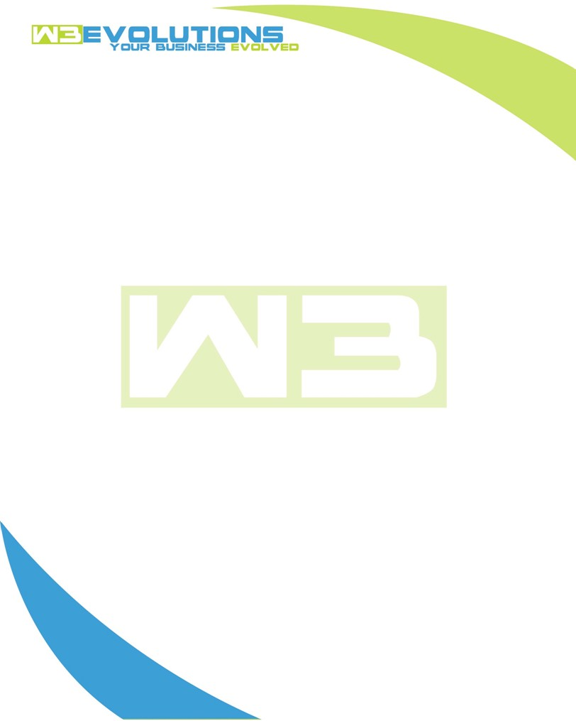

INVOICE

|  |  |
| --- | --- |
| **Bill To:** National Exemption Service, LLC 604 Packard Ct  Safety Harbor, FL 34695 | Invoice No.: NES01-5533  Customer ID: NES01 |

|  |  |  |  |  |  |  |
| --- | --- | --- | --- | --- | --- | --- |
| Date | Invoice No. | Sales Rep. | Ship Via | Terms | Date Due |  |
| 4/16/2025 | NES01-5533 | Brandon Kozak | Email | NET 30 | - |  |

|  |  |  |  |  |  |  |
| --- | --- | --- | --- | --- | --- | --- |
| Quantity | Item | Description | Discount | Taxable | Unit Price | Total |
| 166 | Enhancement | See attached | $49 / hr off $175 / hr | No | $126 | $20,916 |
| - | New Development | See attached | $49 / hr off $175 / hr | No | $126 | - |
|  |  |  |  |  |  |  |
|  |  |  |  |  |  |  |

|  |  |
| --- | --- |
| Subtotal: | $20,916 |
| Tax: | 0.00 |
| Balance Due: | $20,916 |

**Please make all checks payable to:** W3Evolutions Systems LLC

**Please send checks to:** 4826 Troydale Rd, Tampa FL 33615

**Zelle**: zelle.wf[@w3evolutions.com](mailto:brandon@w3evolutions.com)

|  |  |  |  |  |
| --- | --- | --- | --- | --- |
| **Date** | **Hours** | **Category** | **Task/Work** | **Persons** |
|  |  |  |  |  |
| **4/8/25** | **18** | **Enhancement** | **AAE-276 - Continued develoopment, production DB analyize and optimize tables, rework slow queries, AAE-280, AAE-277, continued AAE-101 et al, AAE-293, AAE-302, AAE-305, AAE-306, AAE-269, AAE-296, AAE-237, AAE-293 - Prep AiDA2 release, Release AAE-293** | **BK/DH** |
| **4/9/25** | **18** | **Enhancement** | **AAE-276 - Continued develoopment, production DB analyize and optimize tables, rework slow queries, AAE-280, AAE-277, continued AAE-101 et al, AAE-293, AAE-302, AAE-305, AAE-306, AAE-269, AAE-296, AAE-237, AAE-293 - Prep AiDA2 release, Release AAE-293** | **BK/DH** |
| **4/10/25** | **20** | **Enhancement** | **AAE-276 - Continued develoopment, production DB analyize and optimize tables, rework slow queries, AAE-280, AAE-277, continued AAE-101 et al, AAE-293, AAE-302, AAE-305, AAE-306, AAE-269, AAE-296, AAE-237, AAE-293 - Prep AiDA2 release, Release AAE-293** | **BK/DH** |
| **4/11/25** | **19** | **Enhancement** | **AAE-276 - Continued develoopment, production DB analyize and optimize tables, rework slow queries, AAE-280, AAE-277, continued AAE-101 et al, AAE-293, AAE-302, AAE-305, AAE-306, AAE-269, AAE-296, AAE-237, AAE-293 - Prep AiDA2 release, Release AAE-293, AAE-310 - start of development** | **BK/DH** |
| **4/12/25** | **16** | **Enhancement** | **AAE-276, AAE-175-ReadExceptionShowAlldoesnotwork, AAE-174-estimate-zero-usage, AAE-167-Read-Exception-List-For-Commercial-Prop, AAE-229, AAE-309, AAE-299, AAE-203-migrate-datatables-from-v1-to-v2, AAE-203, AAE-305, AAE-153-rates-auto-populate, AAE-176-188-refresh-subscriptions, AAE-237, AAE-159, AAE-247, AAE-248, AAE-289, AAE-293, AAE-269, AAE-258, AAE-173-click-ratio-read-exceptions, AAE-171, AAE-168-Add-Bcc-To-Final-Bill-For-Tenant, AAE-157-ledger-usage-stds, AAE-298, AAE-240, AAE-100-calculate-only, AAE-259-Processor-OnlyRelated-Fix, AAE-265, AAE-175, AAE-266-Store-Procs-Switcher, AAE-254-dev-toolbar, AAE-262, AAE-226-ProcSwitcher, AAE-255-unicode-pdfs, AAE-203-save-billing-screen-filters, AAE-208-dev-db-syncer, AAE-208-dev-db-sycer** | **BK/DH** |
| **4/13/25** | **17** | **Enhancement** | **AAE-276, AAE-175-ReadExceptionShowAlldoesnotwork, AAE-174-estimate-zero-usage, AAE-167-Read-Exception-List-For-Commercial-Prop, AAE-229, AAE-309, AAE-299, AAE-203-migrate-datatables-from-v1-to-v2, AAE-203, AAE-305, AAE-153-rates-auto-populate, AAE-176-188-refresh-subscriptions, AAE-237, AAE-159, AAE-247, AAE-248, AAE-289, AAE-293, AAE-269, AAE-258, AAE-173-click-ratio-read-exceptions, AAE-171, AAE-168-Add-Bcc-To-Final-Bill-For-Tenant, AAE-157-ledger-usage-stds, AAE-298, AAE-240, AAE-100-calculate-only, AAE-259-Processor-OnlyRelated-Fix, AAE-265, AAE-175, AAE-266-Store-Procs-Switcher, AAE-254-dev-toolbar, AAE-262, AAE-226-ProcSwitcher, AAE-255-unicode-pdfs, AAE-203-save-billing-screen-filters, AAE-208-dev-db-syncer, AAE-208-dev-db-sycer** | **BK/DH** |
| **4/14/25** | **19** | **Enhancement** | **Preping all branches to AiDA2 and Portal2, syncing dbs, staging code releases for both sites** | **BK/DH** |
| **4/15/25** | **20** | **Enhancement** | **Preping all branches to AiDA2 and Portal2, syncing dbs, staging code releases for both sites** | **BK/DH** |
| **4/16/25** | **19** | **Enhancement** | **Preping all branches to AiDA2 and Portal2, syncing dbs, staging code releases for both sites** | **BK/DH** |