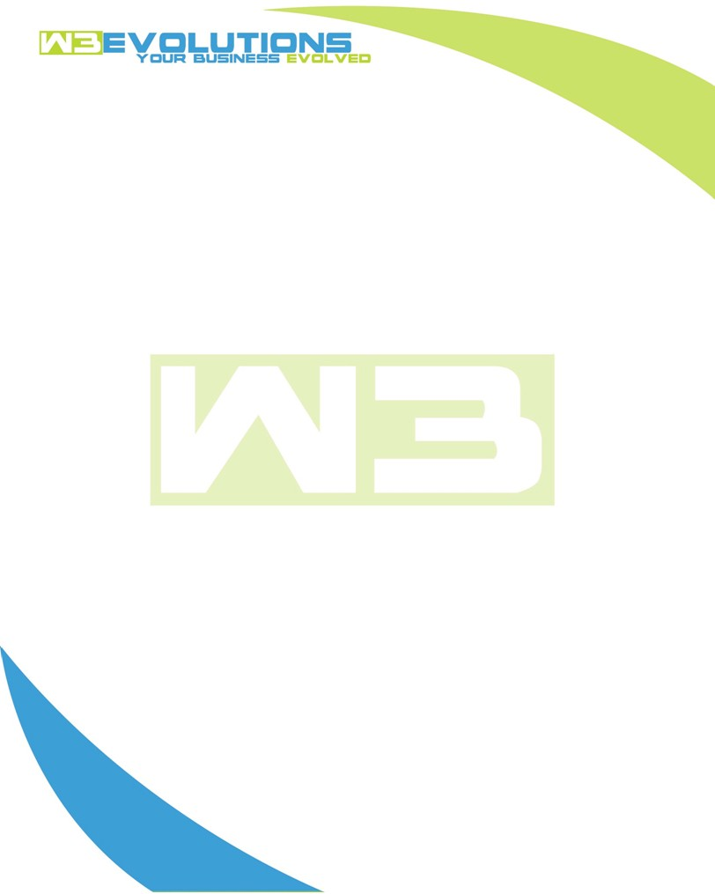

INVOICE

|  |  |
| --- | --- |
| **Bill To:** National Exemption Service, LLC 604 Packard Ct  Safety Harbor, FL 34695 | Invoice No.: NES01-5534  Customer ID: NES01 |

|  |  |  |  |  |  |  |
| --- | --- | --- | --- | --- | --- | --- |
| Date | Invoice No. | Sales Rep. | Ship Via | Terms | Date Due |  |
| 4/30/2025 | NES01-5535 | Brandon Kozak | Email | NET 30 | - |  |

|  |  |  |  |  |  |  |
| --- | --- | --- | --- | --- | --- | --- |
| Quantity | Item | Description | Discount | Taxable | Unit Price | Total |
| 119 | Enhancement | See attached | $49 / hr off $175 / hr | No | $126 | $14,994 |
| - | New Development | See attached | $49 / hr off $175 / hr | No | $126 | - |
|  |  |  |  |  |  |  |
|  |  |  |  |  |  |  |

|  |  |
| --- | --- |
| Subtotal: | $14,994 |
| Tax: | 0.00 |
| Balance Due: | $14,994 |

**Please make all checks payable to:** W3Evolutions Systems LLC

**Please send checks to:** 4826 Troydale Rd, Tampa FL 33615

**Zelle**: zelle.wf[@w3evolutions.com](mailto:brandon@w3evolutions.com)

|  |  |  |  |  |
| --- | --- | --- | --- | --- |
| **Date** | **Hours** | **Category** | **Task/Work** | **Persons** |
| 4/23/25 | 12 | Enhancement | AAE-101 - prep for AiDA + AiDA2 sync + Portal2 sync, AAE-304 Apple Pay research/set-up | BK/DH |
| 4/24/25 | 14 | Enhancement | AAE-101 - prep for AiDA + AiDA2 sync + Portal2 sync, AAE-304 Apple Pay research/set-up | BK/DH |
| 4/25/25 | 14 | Enhancement | AAE-101 - prep for AiDA + AiDA2 sync + Portal2 sync, AAE-304 Apple Pay research/set-up | BK/DH |
| 4/26/25 | 12 | Enhancement | AAE-101 - prep for AiDA + AiDA2 sync + Portal2 sync, AAE-304 Apple Pay research/set-up | BK/DH |
| 4/27/25 | 22 | Enhancement | AAE-101 - Aida2 launch continued support and Phase 4 ticket release | BK/DH |
| 4/28/25 | 17 | Enhancement | AAE-101 - Aida2 launch continued support and Phase 4 ticket release | BK/DH |
| 4/29/25 | 14 | Enhancement | AAE-101 - Aida2 launch continued support and Phase 4 ticket release | BK/DH |
| 4/30/25 | 14 | Enhancement | AAE-101 - Aida2 launch continued support and Phase 4 ticket release | BK/DH |