**Applicazioni per dispositivi mobili**

**course**

**a.y. 2017/2018**

**Events**

**Design documentation[1],[2]**

|  |  |  |
| --- | --- | --- |
| **Team Members[3]** | | |
| **Name** | **Student Number** | **E-mail address** |
| **Davide Micarelli** |  |  |
| **Tony D’Angelo** |  |  |
|  |  |  |
|  |  |  |
|  |  |  |

Strategy

# Product Overview

Platform for creation, organization and promote events all around the world.

We have a strong social integration with Facebook Twitter ecc, everyone can create a event and other people can visualize them and filter the list for their interests

# Competitors

Principal competitors are:

1. Eventbrite
2. Nearify

The first one doesn’t permits of create event in the app, you need to use another application, the interface in really poor, you can’t follow your friend interest ad event, all things that our app can do, these are the main difference.

Nearify instead at the moment of test doesn’t work, but the interface is really nice

# User Research

The needs that we want to satisfy are:

* Group of friend that want to find something interest in their city, not only party, but also cultural event, like museum, cinema, promotion
* Single person that want to find event in a new city and knows new people
* Pub, musem, cinema, locals that want to promote their event with low cost (without print any manifest for example) and monitoring the event

The main goals are: **(CHIEDERE AL PROF)**

* Provide easy and intuitive interface with the users can search, create and organize events.

# Personas

Propietario locale che si vuole pubblicizzare

Ragazzo in cerca di divertimento

Persona di mezz’età in cerca di degustazione vini

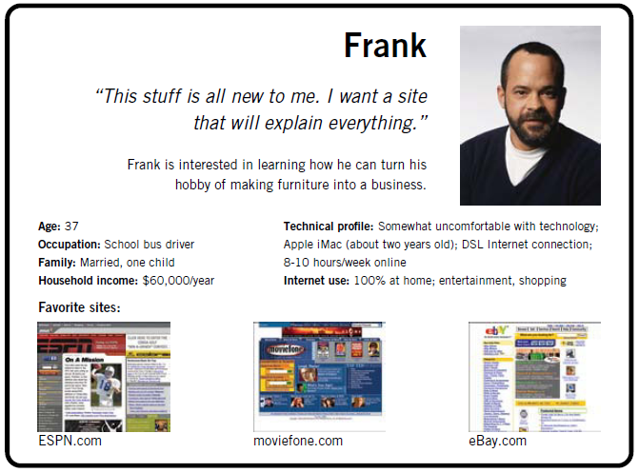

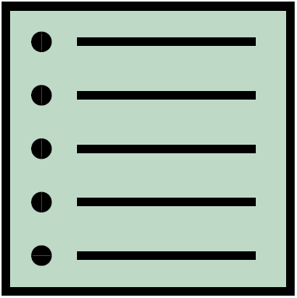Scope

**Features**

Provide a list of all the features of your app.

**Scenarios**

It is a short, simple narrative describing how a persona might go about trying to fulfill one of those user needs. By imagining the process our users might go through, we can come up with potential requirements to help meet their needs.

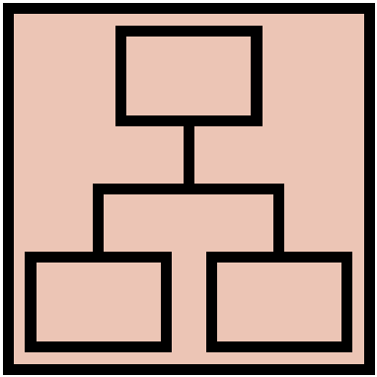Structure

# Navigation model

Navigation model of your app.

Description of its main parts and the relevant choices you made. For each view and for each main navigation flow you have to describe your design decisions and their main objectives.

# Data

Provide a class diagram representing all the contents you manage in your app. As a reference for class diagrams, use this: <http://it.wikipedia.org/wiki/Class_diagram>

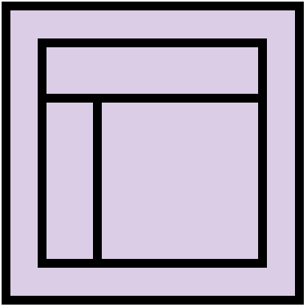Skeleton

Lo-Fi Wireframes of your app. In this phase you have to create a **complete wireframe** representing all the views described in the navigation model.

Description of the relevant choices you made about the user interaction and how information flows among views.

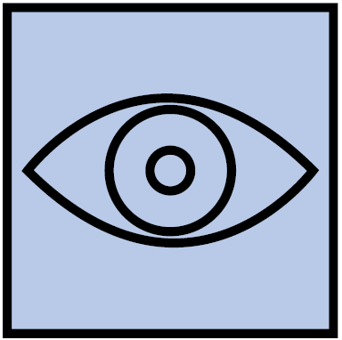Surface

Provide an Hi-Fi Wireframes of a **single view** of your app. Please choose a representative view to show here.

Description of the relevant choices you made about the layout and color palette, fonts, icons, etc.

1. The max length of this document is 20 pages
2. The structure of this document is fixed, it cannot be changed in any way
3. The team leader is listed as first member in this table