Restaurant inspections pipeline
David Ferrara for the Content AI team – July 20, 2026

When you go out to eat, you trust everything in the kitchen is on the up-and-up. However, restaurant health inspections regularly reveal that is not always the case.
Several USA TODAY Network markets already scrape and provide inspections to readers in a database format – giving readers high-quality, scalable service journalism.
What this project does is take that data a step further.
Using Copilot agents to dynamically generate scrapers and tip sheets, this working proof-of-concept shows how we can get essential data in the hands of dining, breaking and trending reports across the Network.
What was built
The proof-of-concept pulls live inspection data from two very different real-world sources: the South Carolina Department of Health and the Northern Kentucky Health Department. This proves the approach works even when source websites look nothing alike.
Each source has its own custom scraper script built using a Copilot agent. Both scripts are built to output the same standardized format, so downstream steps are unaffected by different sources of data.
Results are saved and then loaded into a shared database. A small web service then lets other tools or agents search, add or retrieve records via an API.
Another Copilot agent is able to retrieve records via the API, generate a tip sheet and route that tip sheet to the appropriate reporter.
How new sources get added at scale
Rather than writing a one-off script for every jurisdiction by hand, the project uses a repeatable "Scraper Builder" agent. The AI agent visually inspects a website, figures out where the data lives on the page and writes a new scraper script automatically.
A person then reviews that generated script before it goes into production, which keeps quality control in human hands while removing the slowest part of scaling to hundreds of markets.

Turning messy data into one format
No matter which website a scraper pulls from, every result gets normalized into the same handful of fields.
A separate import script then cleans up inconsistent date formats, strips out bad or duplicate entries, and matches each new inspection to the correct restaurant already in the database.
Handling breakage and errors
The scrapers and the pipeline both log every step — what worked, what failed and why — so a human can quickly see when a source has changed or gone down instead of discovering it days later through missing data.
When the automated Scraper Builder agent hits a dead end (for example, a page that returns zero results even after retries), it has a built-in fallback: it reopens the site with a more thorough visual check and rebuilds the scraper logic before giving up.
From raw data to a newsroom signal
The most newsroom-relevant piece of the project is the scoring system that decides which inspections are worth a reporter's time.
Each new inspection is scored on factors like how many online reviews the restaurant has, whether it's had significant prior news coverage, and how severe the violations are — and only inspections that cross a newsworthiness threshold get escalated.
Rather than dumping raw inspection data into a reporter's inbox, the system passes qualifying inspections to a "Tip Sheeter" agent that writes a plain-English tip sheet with the Five Ws, key facts, suggested reporting next steps, and an honest accounting of what still needs to be verified before publication.
Key files to review on GitHub
Within the provided GitHub repo for this assignment, please review the following files for a better understanding of the project:
- README.md – workflow schema and diagrams explaining the project at a high level.
- Agent_instructions.md – instructions provided to the Scraper Builder agent.
- Sample_tip_sheet.md – an example tip sheet generated by the Tip Sheeter Copilot agent with placeholder data.
- Sample_payload.json – an example of a payload sent to the Tip Sheeter Copilot agent from the restaurant inspections database, with placeholder data.
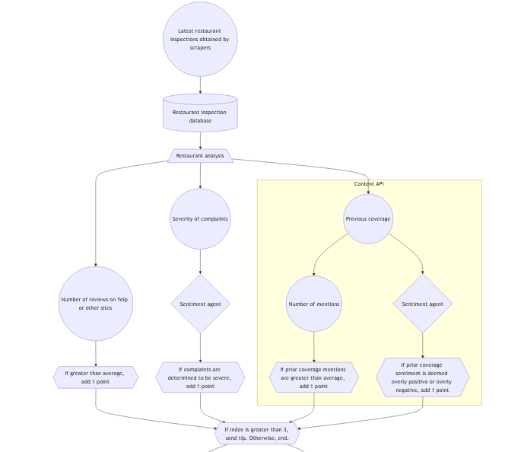
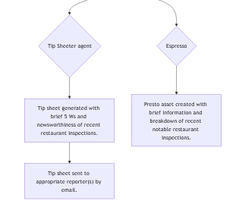
Workflow diagram

