# Financial Model GUI QuickStart Guide

***Brown indicates items where references to the User Manual and Documentation PDF may be required.***

**\*For inquiries, changes, updates or errors, please contact Lillian Lau (**[**lbl59@cornell.edu**](mailto:lbl59@cornell.edu)**)**

## Obtaining and organizing current data

1. Navigate to F:\MonteCarlo_Project Cornell_UNC TampaBayWater-GUI
2. Locate the ‘Data’ folder

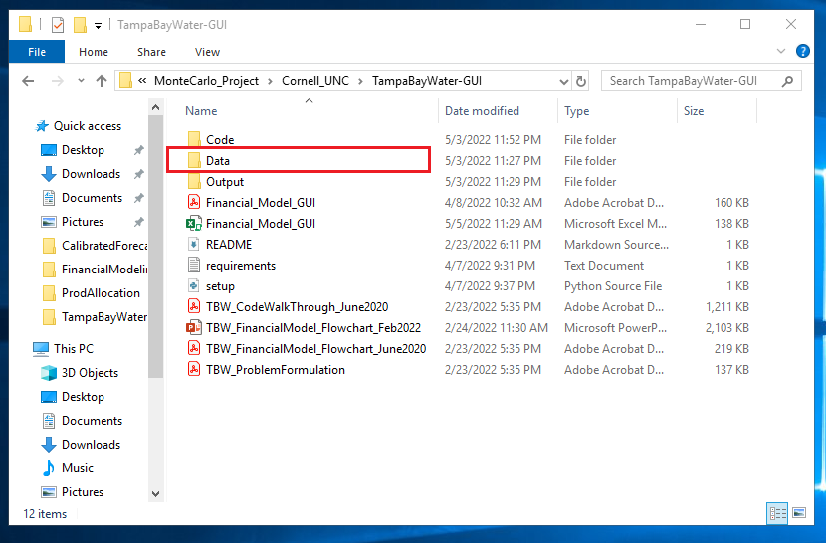

1. Navigate to Data model_input_data

This folder contains all the historical and projected financial data as provided by Tampa Bay Water Authority

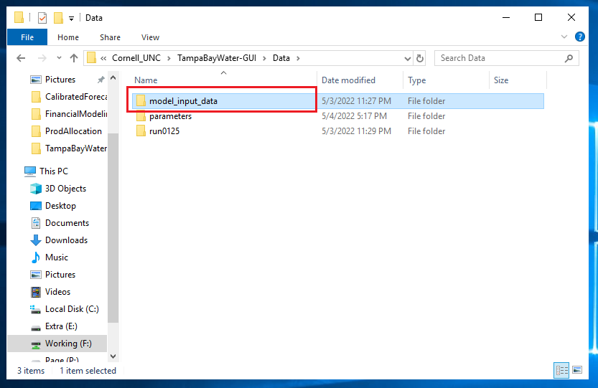

1. The formatting, creation and naming convention of each file can be found in the user manual. The following files should be stored within this current folder (reference figure below):
   1. Previous year water sales and deliveries
   2. Historical estimated budgets
   3. Historical estimated budgets
   4. Existing debt
   5. Potential projects
   6. Current and future bond issues
   7. Original CIP spending (all projects)
   8. Original CIP spending (major projects)
   9. Normalized CIP spending (all projects)
   10. Normalized CIP spending (major projects)
   11. Projected reserve fund starting balance
   12. Projected reserve fund deposits

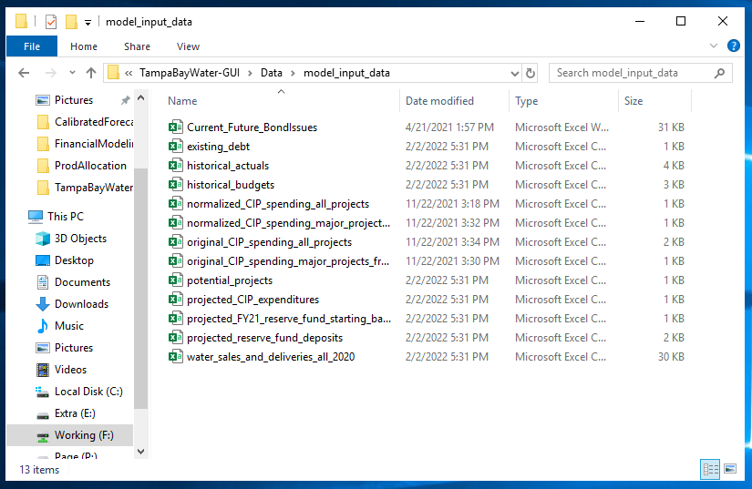

1. Next, navigate to F:\MonteCarlo_Project Cornell_UNC cleaned_AMPL_files

Copy the ‘runXXXX’ folder.

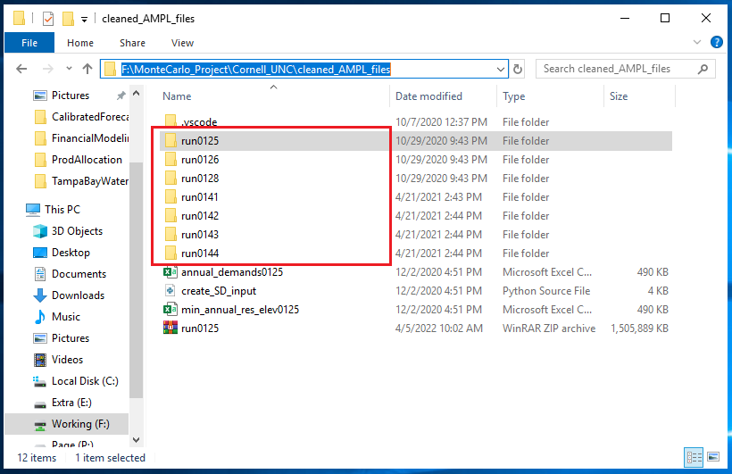

The description and explanation as to the selection and function of the ‘runXXXX’ folder can be found in the user manual.

Navigate back to F:\MonteCarlo_Project Cornell_UNC TampaBayWater-GUI Data and paste the copied ‘runXXXX’ folder in the current folder.

1. Navigate to F:\MonteCarlo_Project FNAII IM to Tirusew Integrated Models SWERP_V1 AMPL_Results_run_125

Copy the desired financial scenario files, named ‘simXXXX.mat’.

Navigate back to F:\MonteCarlo_Project Cornell_UNC TampaBayWater-GUI Data runXXXX and paste the copied ‘simXXXX.mat’ file in the current folder.

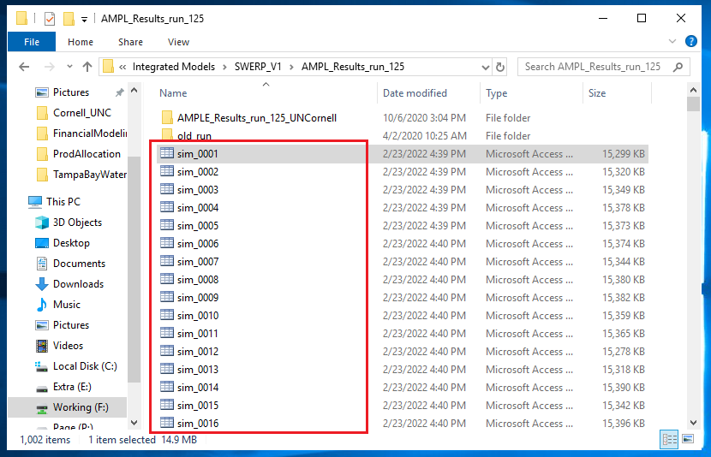

The description and explanation as to the selection and function of the ‘simXXXX.mat’ file can be found in the user manual.

1. Now, navigate to F:\MonteCarlo_Project Cornell_UNC TampaBayWater-GUI Output and create the following folders:
   1. error_files
   2. financial_model_results
   3. output_figures

## Model setup and running the GUI

1. Navigate to F:\MonteCarlo_Project Cornell_UNC TampaBayWater-GUI and locate the Financial_Model_GUI.xlsm file

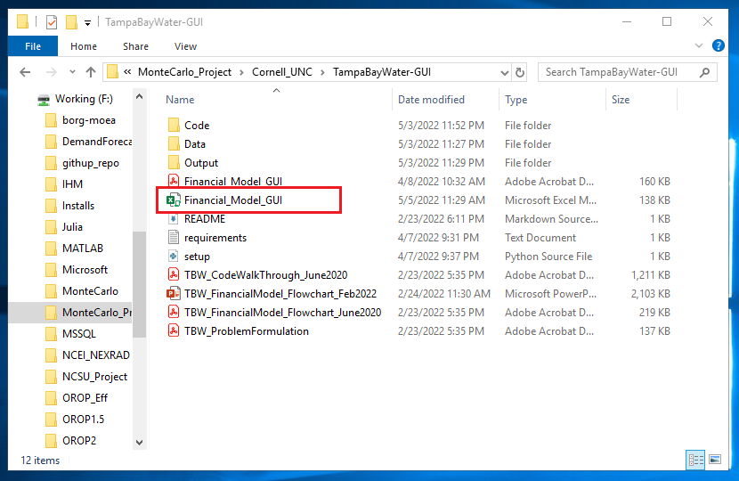

1. In the Financial_Model_GUI.xlsm file, navigate to '1-Setup'

Click on 'SETUP FINANCIAL MODEL'.

This will install all the necessary software to run the Financial Model.

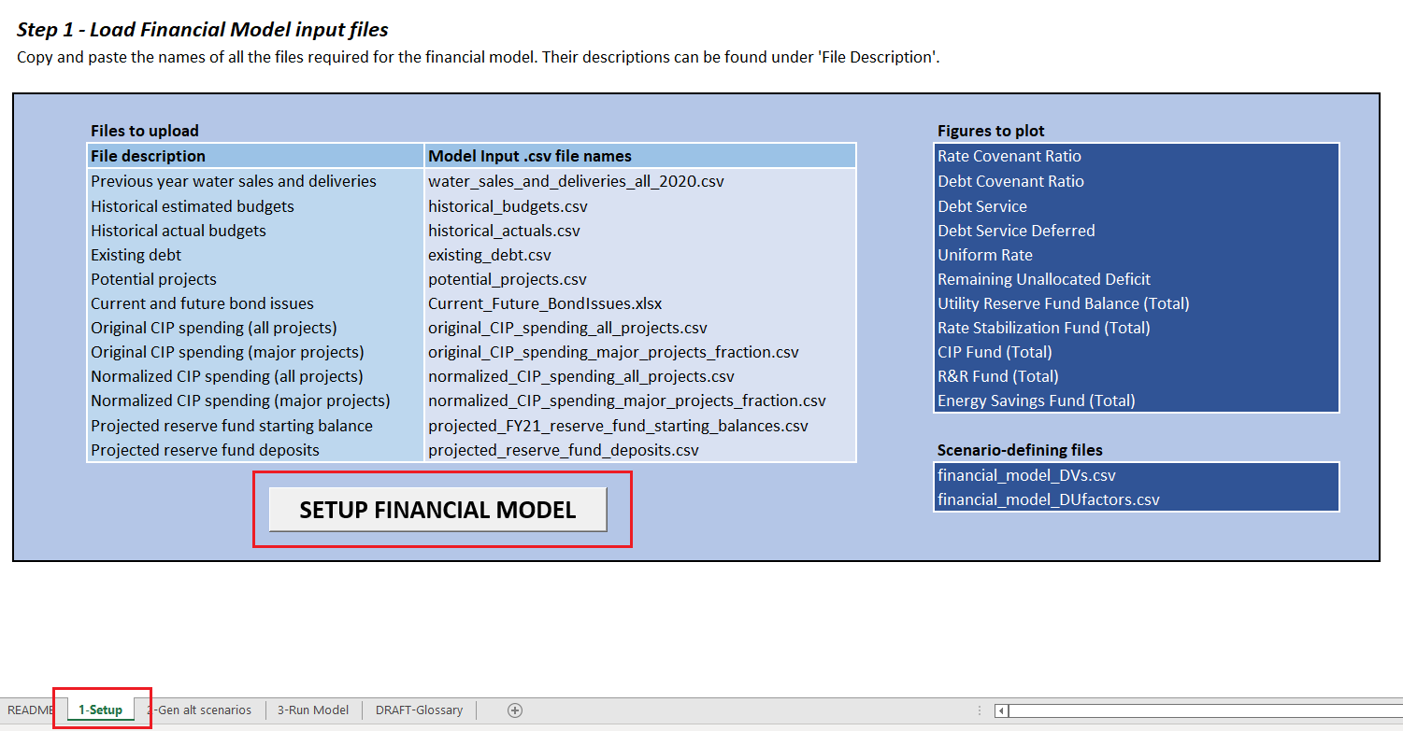

1. [THIS NEXT SERIES OF STEPS IS OPTIONAL]

*If you would like to generate one or a set of alternative financial scenarios, please continue to read. Otherwise, skip to Step 4.*

Navigate to ‘2-Gen alt scenarios’. This step generates one or a set of alternative financial scenarios.

If you would like to generate only ONE new scenario

In the column labeled ‘Upper’, enter your desired value, or select Yes/No.

Leave the values in the column labeled ‘Lower’ as zero.

Descriptions for each of the parameter names listed and a range of their reasonable values can be found in the user manual.

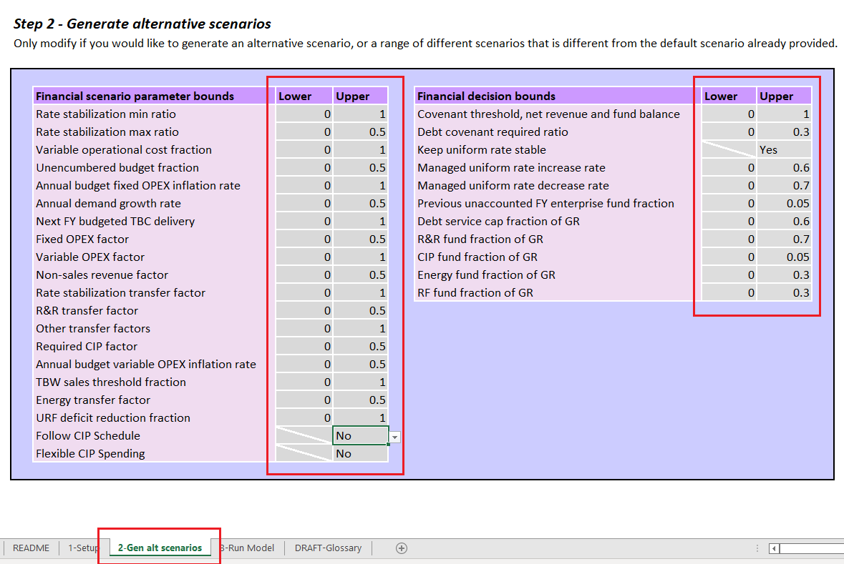

If you would like to generate A RANGE of new scenarios

In the column labeled ‘Lower’, enter your desiered lower bound value.

***IMPORTANT***: Do NOT enter values in the cells that are crossed.

In the column labeled ‘Upper’, enter your desired upper bound value value, or select Yes/No.

Descriptions for each of the parameter names listed and a range of their reasonable values can be found in the user manual.

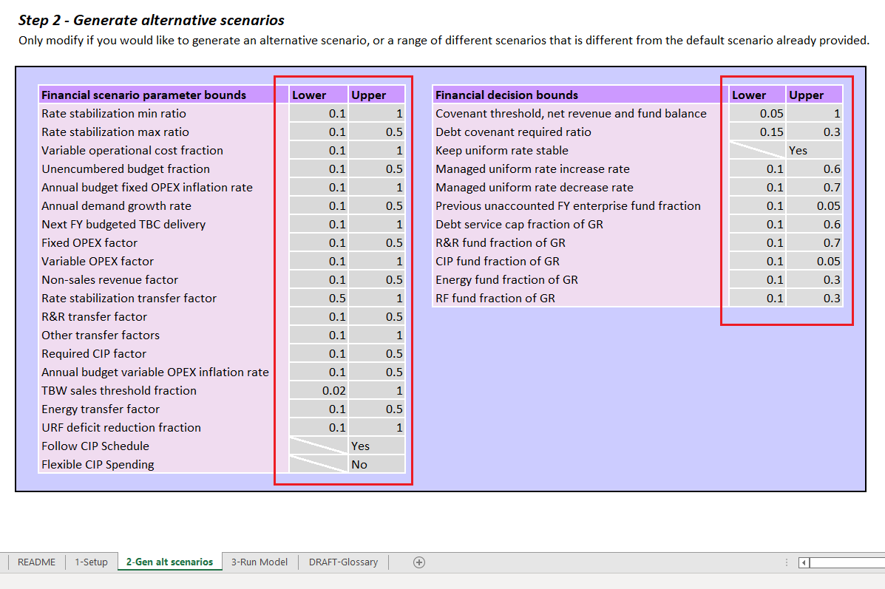

1. Navigate to ‘3-Run Model’

Step 4-1

* + 1. Identify the location of the TampaBayWater-GUI main folder.
    2. This can be done by clicking on the folder icon of the address bar of the TampaBayWater-GUI folder as shown below:

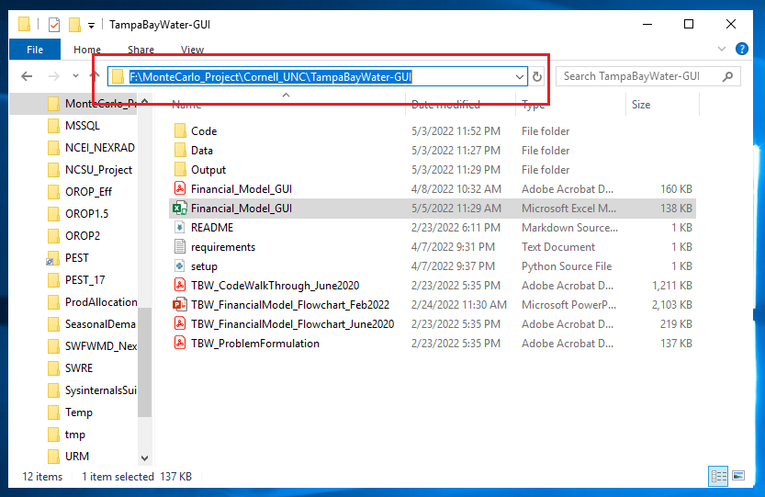

* + 1. Copy the location and paste it in the cell adjacent to ‘Main Folder Location’.

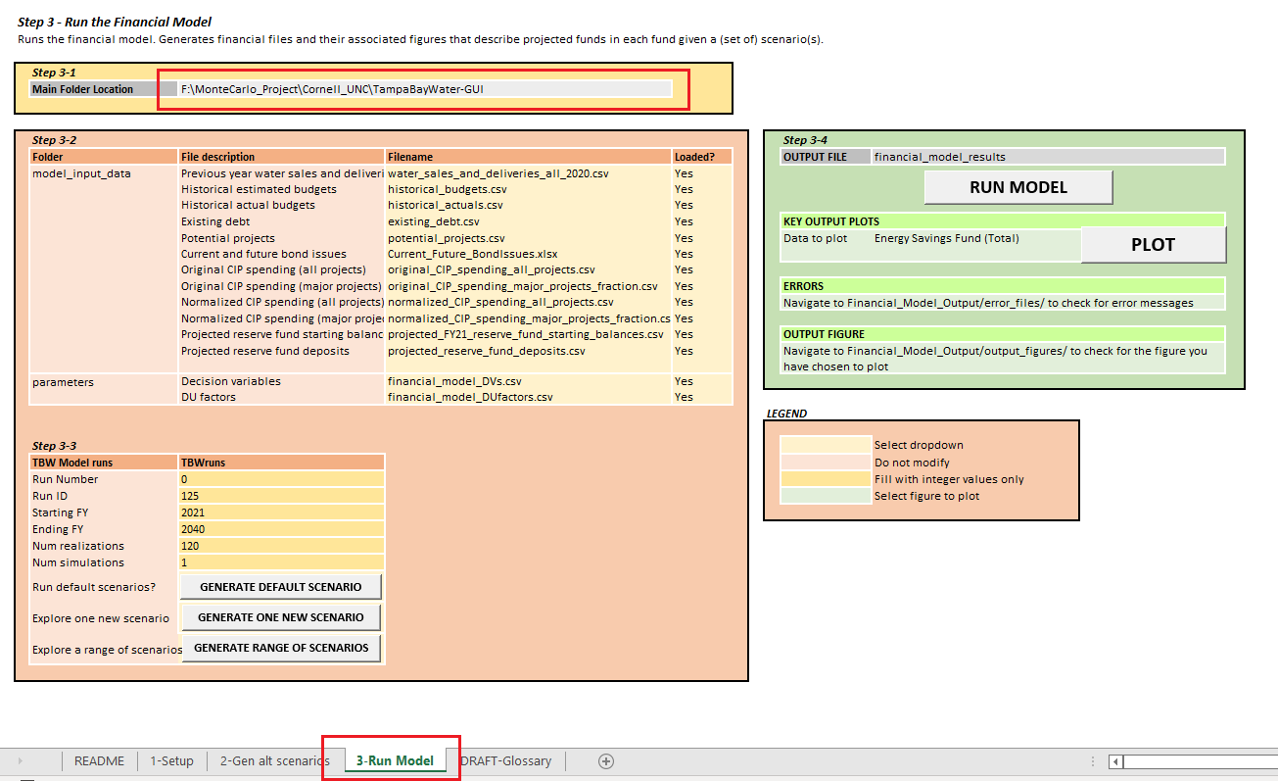

Step 4-2

1. In the column labeled ‘Filename’, select from the dropdown list each filename that corresponds to their description in the adjacent ‘File description’ column.

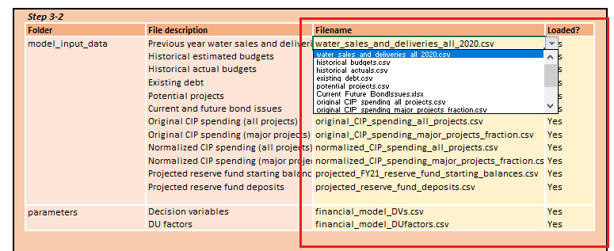

1. Check if the files have been uploaded into TampaBayWater-GUI/Data/model_input_data.
2. If the file is present in the folder, select ‘Yes’ for each file.

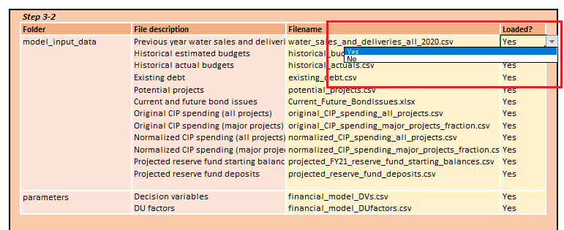

Step 4-3

1. Fill in the table corresponding to Step 3-3 as shown below:

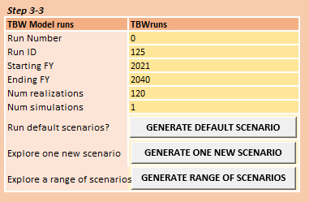

Descriptions for each of the parameter names and items in the table can be found in the user manual.

1. To generate the desired type of scenario:

* *To generate the default financial scenario*: Click on ‘GENERATE DEFAULT SCENARIO’
* *To generate one alternative financial scenario*: Click on ‘GENERATE ONE NEW SCENARIO’
* *To generate a range of alternative financial scenarios*:
  + Click on ‘GENERATE ONE NEW SCENARIO’
  + ***IMPORTANT***: This option will only run if ‘Num simulations’ is more than 1. Otherwise, an error message will be printed in the ‘TampaBayWater-GUI/Output/error_files/err_generate_scenarios.txt’ file

Step 4-4

1. Click on ‘RUN MODEL’ to run the model using the scenario(s) generated.

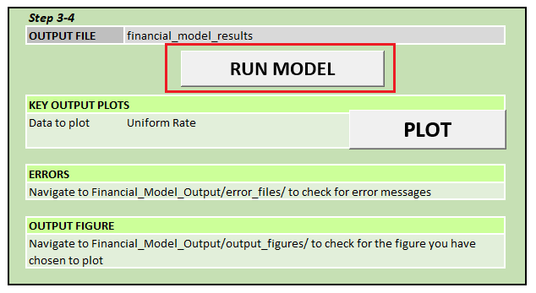

The financial model output can be found in ‘TampaBayWater-GUI/Output/financial_model_results/’

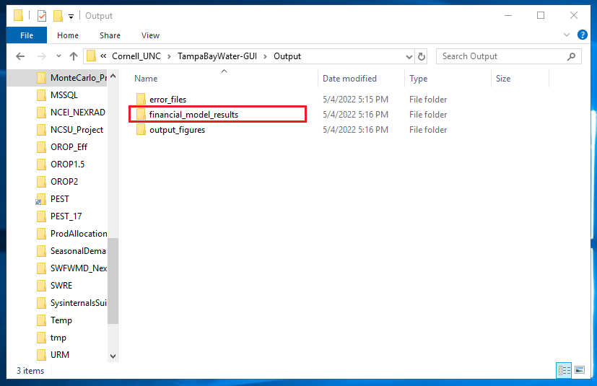

The following files should appear in the ‘financial_model_results’ folder:

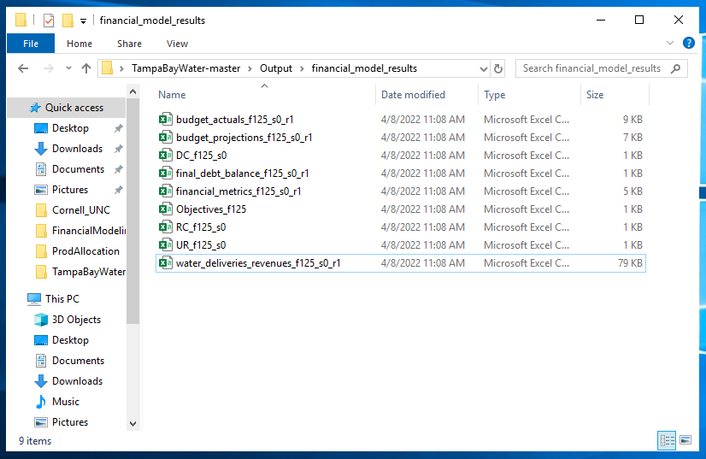

Any potential errors that occurred during the model run will be listed in ‘TampaBayWater-GUI/Output/error_files/’ folder within the ‘err_financial_model.txt’ file:

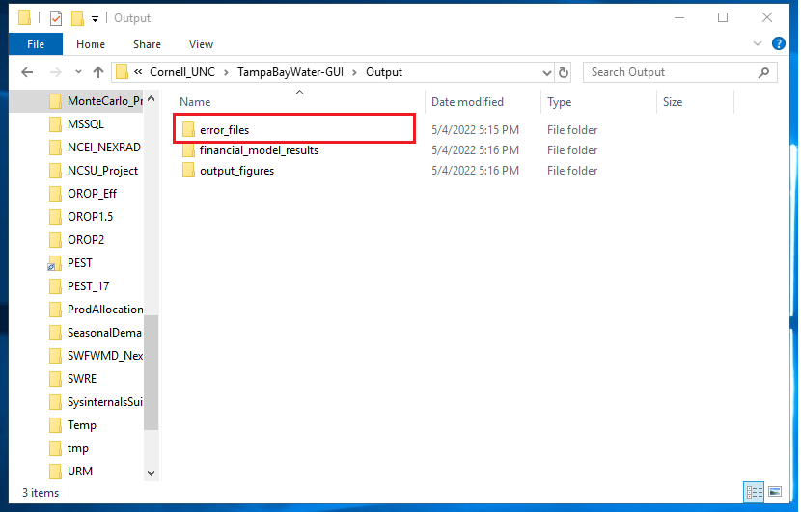

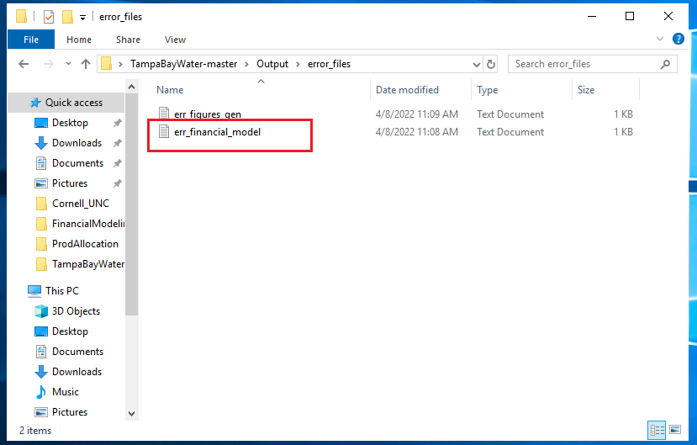

If there are no errors, only ‘End error file’ should be printed within ‘err_financial_model.txt’.

1. Select the figure you would like to plot in the cell next to ‘Data to plot’

Descriptions for each of these figures can be found in the user manual.

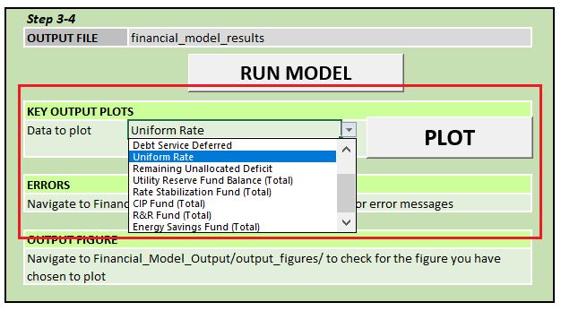

Save your choice of figure by hitting ‘Ctrl+S’

Click on ‘PLOT’.

The desired figure should appear in a new pop-up window *and* be saved in ‘TampaBayWater-GUI/Output/output_figures/’

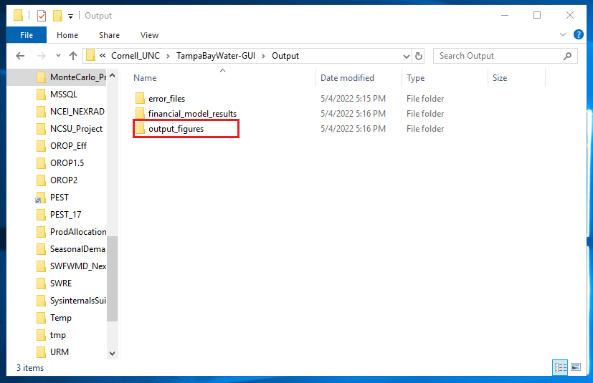

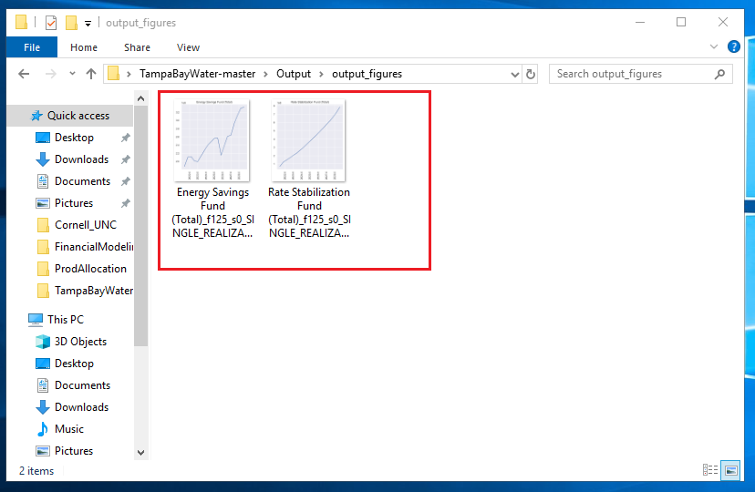

Similar to the financial model output error file, any potential errors will be listed in ‘TampaBayWater-GUI/Output/error_files/’ folder within the ‘err_figures_gen.txt’ file:

