
MINISTRY OF EDUCATION AND RESEARCH OF THE REPUBLIC OF MOLDOVA
Technical University of Moldova
Faculty of Computers, Informatics and Microelectronics
Department of Software Engineering and Automatics

REPORT
on laboratory work no. 6
Course: Operating Systems
Topic: Inside the xv6 File System

Done by: st. gr. FAF-242, Florea David
Checked by: Reitman Patricia

Chișinău, 2026

Purpose of the work
The xv6 file system has the same ideas as ext4: inodes, directories stored as tables of entries, hard links and a journal (log), in a few hundred readable lines. The purpose of this work is to read what xv6 shows about its files, to write my own stat program (mystat), to measure the limits defined in kernel/fs.h, and finally to write find, a program that walks the directory tree recursively (the find exercise of the MIT 6.1810 util lab).
Environment: Ubuntu 26.04.1 LTS (VirtualBox VM), xv6-riscv in ~/xv6-riscv (revision 06aad25 with my programs from the previous labs), QEMU for RISC-V. bash os2026-setup.sh --check passed. The new programs are user/mystat.c and user/find.c, added to UPROGS as $U/_mystat\ and $U/_find\.

Part 1. Read what xv6 shows you
On a fresh disk I listed the root directory, created a directory a and listed it. Each line of xv6 ls is: name, type, inode number, size in bytes.
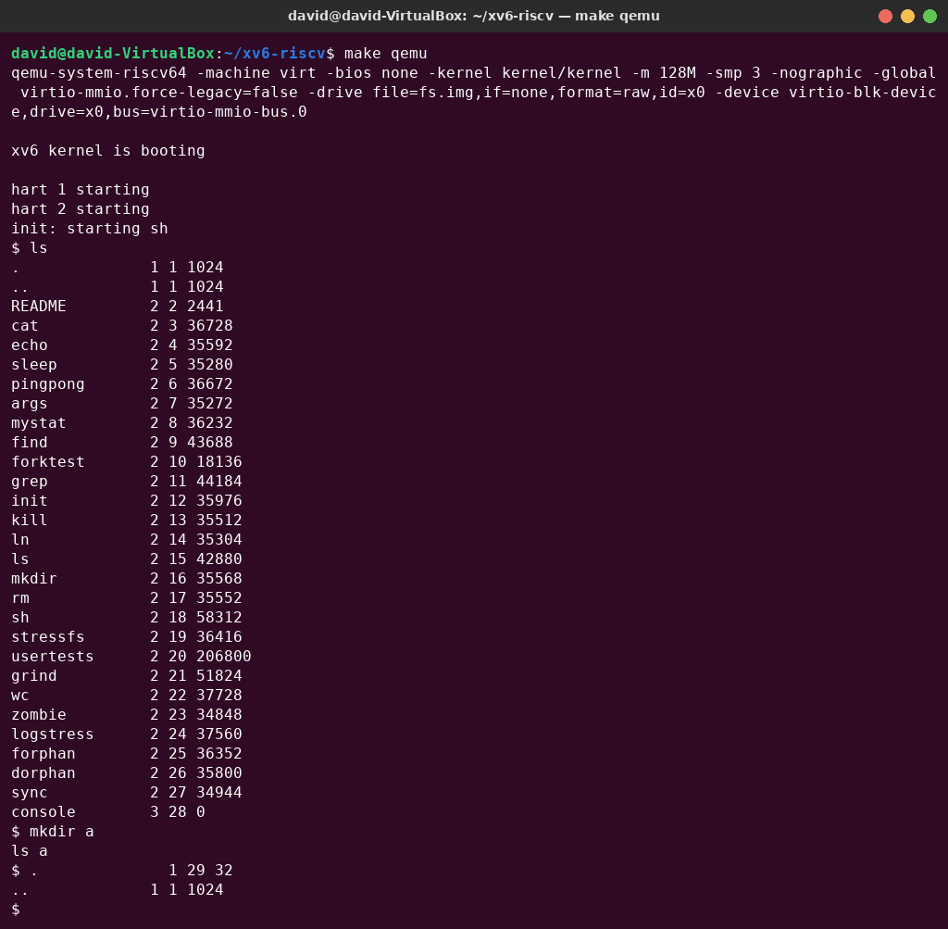
Figure 1.1 – ls in the root directory and in the new directory a
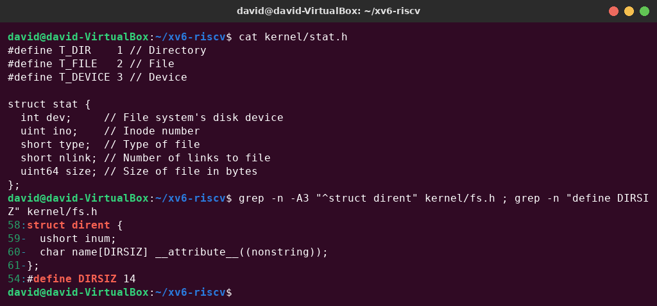
Figure 1.2 – kernel/stat.h and the directory entry in kernel/fs.h

Observe – answers
1. What do types 1, 2 and 3 mean (kernel/stat.h)? T_DIR 1 – directory; T_FILE 2 – regular file; T_DEVICE 3 – device. In the listing, . and .. are 1, README and all the programs are 2, and console is 3.
2. Which inode number does the root directory have, and why are . and .. the same there? The root directory is inode 1 (ROOTINO). Both . and .. show inode 1, because the root has no parent: when mkfs builds the disk, it makes the “..” entry of the root point back to the root itself. That is why cd .. in / stays in /.
3. An empty directory a has size 32. How big is one entry, and which two entries does a contain? A directory entry is struct dirent { ushort inum; char name[DIRSIZ]; }, so it is 2 + 14 = 16 bytes. 32 bytes = 2 entries: . (inode 29, the directory a itself) and .. (inode 1, its parent, the root), as ls a shows.

Part 2. Write mystat
I completed both TODOs. typename() maps T_DIR, T_FILE and T_DEVICE to a word. main() calls stat() for every argument; on error it writes a message to fd 2 and continues with the next argument, otherwise it prints NAME: TYPE, inode N, links N, size N bytes.
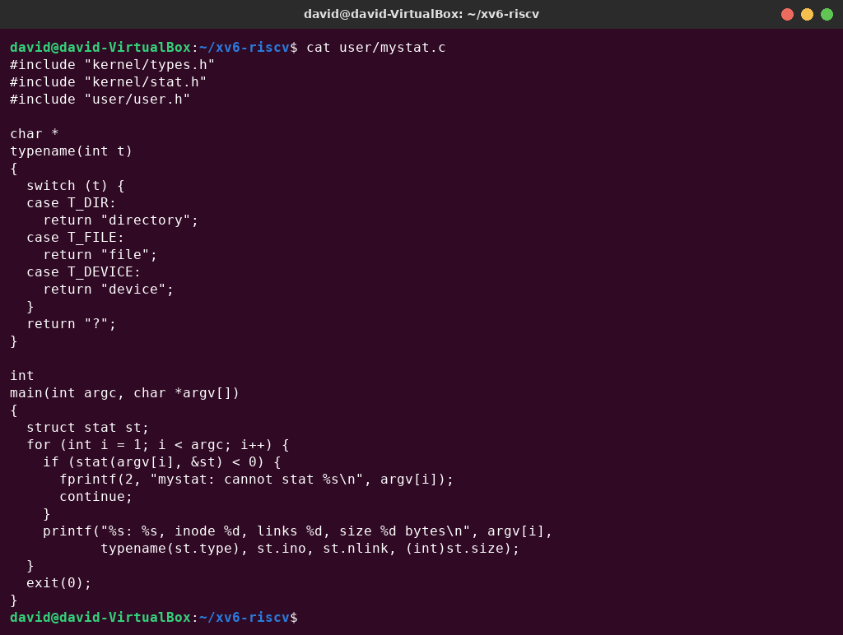
Figure 2.1 – user/mystat.c
$ mystat README . console
$ ln README r2
$ mystat README r2
$ rm README
$ mystat r2
$ cat r2 | wc
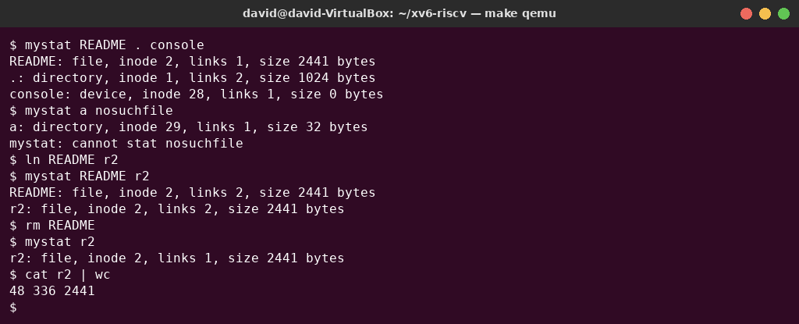
Figure 2.2 – mystat watching a hard link at work
The root shows links 2, not 1 as in the example of the assignment, because I had already created the directory a in Part 1, and the “..” entry of a counts as a link to the root. A new xv6 directory, such as a, has only 1 link: unlike Linux, xv6 does not count the “.” entry (see create() in sysfile.c, “No ip->nlink++ for '.'”).
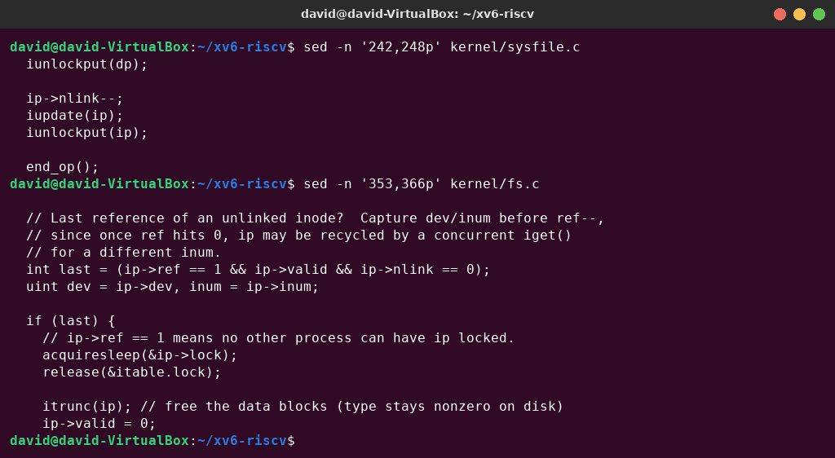
Figure 2.3 – The decrement in sys_unlink and the freeing of blocks in iput
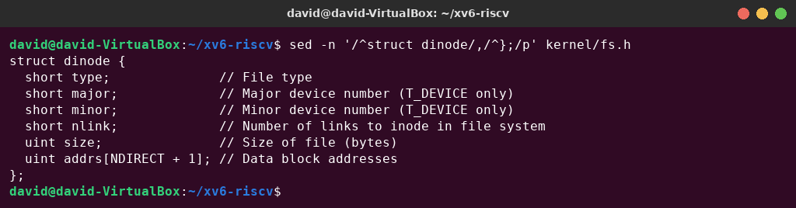
Figure 2.4 – struct dinode – the on-disk inode of xv6

Observe – answers
1. Paste the outputs after ln and after rm. What changed and what did not?
after ln: README: file, inode 2, links 2, size 2441 bytes
r2: file, inode 2, links 2, size 2441 bytes
after rm: r2: file, inode 2, links 1, size 2441 bytes
cat r2 | wc → 48 336 2441
ln did not copy anything. r2 is a second name for the same inode 2, and only the link count changed (1 → 2). rm README removed the name README and the link count went back to 1. The inode number (2), the size (2441 bytes) and the content did not change: cat r2 | wc still reads the 48 lines, 336 words and 2441 bytes of the original README.
2. Find the line in kernel/sysfile.c (sys_unlink) that decrements the link count. When are the data blocks freed? Line 244 of kernel/sysfile.c: ip->nlink--;, followed by iupdate(ip), which writes the inode back to disk. (Line 239, dp->nlink--, is for removing a directory, whose “..” no longer points to the parent.) sys_unlink does not free the blocks itself. They are freed in iput() in kernel/fs.c (lines 357–365): when the last in-memory reference is dropped (ip->ref == 1) and the link count is 0, iput calls itrunc(), which releases every data block with bfree(), and then marks the inode as free (type 0). So, as in Linux, the space is freed only when the file has no names and no process has it open.
3. Which fields does an xv6 inode have (struct dinode in kernel/fs.h)? Only six: type (0 = free, 1 dir, 2 file, 3 device), major and minor (device numbers, only for T_DEVICE), nlink (number of names), size (in bytes) and addrs[NDIRECT+1] (12 direct block numbers + 1 indirect block). That is 64 bytes per inode. There is no owner (uid/gid), no permission mode and no timestamps, so xv6 has no permissions. There is no symlink type, so it has no symbolic links either.

Part 3. Measure the limits
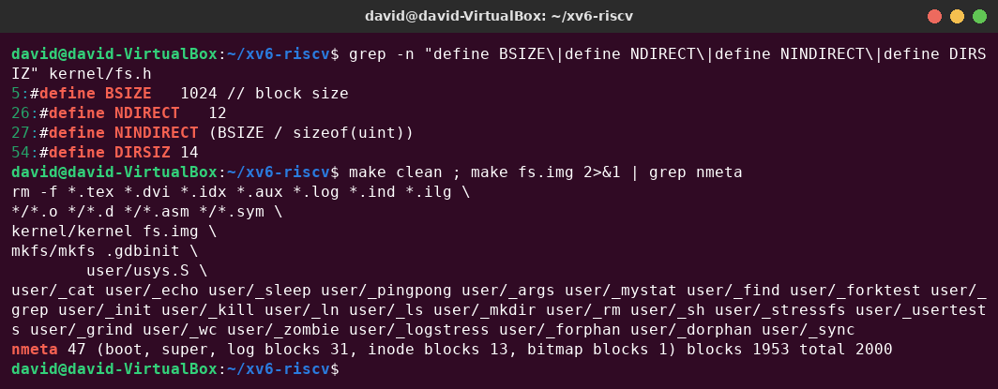
Figure 3.1 – The constants in fs.h and the nmeta line printed by mkfs
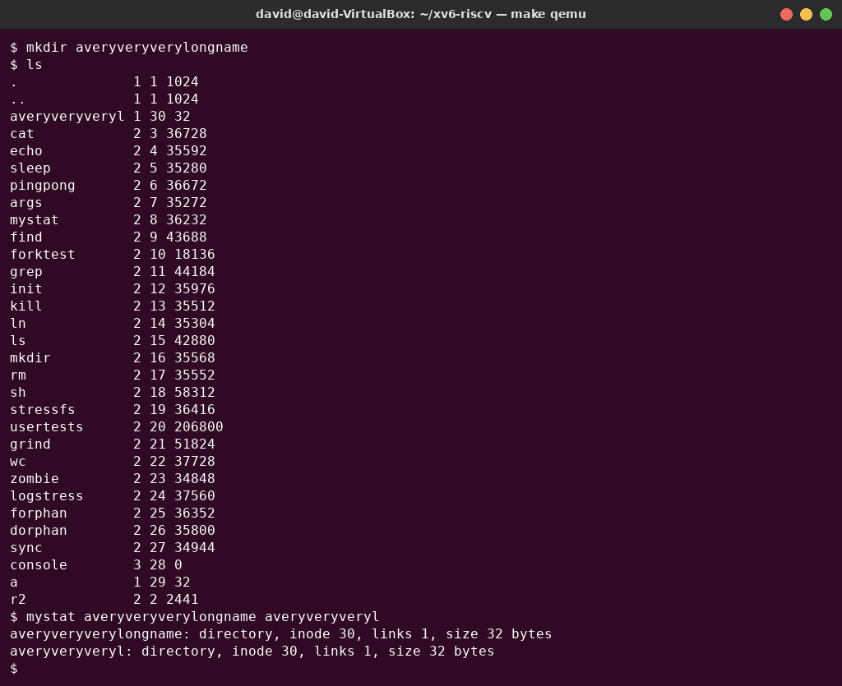
Figure 3.2 – A name longer than DIRSIZ

Observe – answers
1. What does ls show for averyveryverylongname, and which constant explains it? ls shows averyveryveryl, only the first 14 characters, because DIRSIZ = 14: a directory entry has room for 14 bytes of name. When a path is parsed, skipelem() copies at most DIRSIZ characters of each element, so mkdir silently truncated the name. mystat shows that both the long name and the truncated name lead to the same inode 30. Every lookup is truncated in the same way.
2. Compute the largest file xv6 can hold.
BSIZE = 1024 bytes
NDIRECT = 12 direct blocks
NINDIRECT = BSIZE / sizeof(uint) = 1024 / 4 = 256 (in the indirect block)
MAXFILE = NDIRECT + NINDIRECT = 12 + 256 = 268 blocks
max size = 268 × 1024 bytes = 274 432 bytes = 268 KiB
3. From the nmeta line: how many blocks does the whole disk have, and how many are for the log, the inodes, and the data?
nmeta 47 (boot, super, log blocks 31, inode blocks 13, bitmap blocks 1) blocks 1953 total 2000
The whole disk has 2000 blocks of 1 KiB (FSSIZE). 47 are metadata: 1 boot block + 1 superblock + 31 log blocks (LOGBLOCKS = 30 data blocks + 1 header) + 13 inode blocks (200 inodes / 16 inodes per block + 1) + 1 bitmap block. The remaining 1953 blocks are for data.

Part 4. Write find
user/find.c is based on user/ls.c. find(path, name) opens the directory, reads the struct dirent entries one by one, skips free slots (inum == 0), builds the full path in a buffer and calls stat() on it. If the last component of the path equals name (strcmp), the path is printed. If the entry is a directory, find recurses into it, but never into “.” and “..”, which would loop forever. Every opened directory is closed before returning, because a process can have only 16 open files (NOFILE), and the recursion would otherwise run out of descriptors. As the stretch task, an optional third argument -n prints the inode number next to each path.
#include "kernel/types.h"
#include "kernel/stat.h"
#include "user/user.h"
#include "kernel/fs.h"
#include "kernel/fcntl.h"
int show_inum; // -n: print the inode number next to each path
// Return the last component of path ("a/b/r2" -> "r2").
char *
lastname(char *path)
{
char *p;
for (p = path + strlen(path); p >= path && *p != '/'; p--)
;
return p + 1;
}
void
report(char *path, struct stat *st)
{
if (show_inum)
printf("%s %d\n", path, st->ino);
else
printf("%s\n", path);
}
void
find(char *path, char *name)
{
char buf[512], *p;
int fd;
struct dirent de;
struct stat st;
if ((fd = open(path, O_RDONLY)) < 0) {
fprintf(2, "find: cannot open %s\n", path);
return;
}
if (fstat(fd, &st) < 0) {
fprintf(2, "find: cannot stat %s\n", path);
close(fd);
return;
}
if (st.type != T_DIR) {
fprintf(2, "find: %s is not a directory\n", path);
close(fd);
return;
}
if (strlen(path) + 1 + DIRSIZ + 1 > sizeof buf) {
fprintf(2, "find: path too long\n");
close(fd);
return;
}
strcpy(buf, path);
p = buf + strlen(buf);
*p++ = '/';
while (read(fd, &de, sizeof(de)) == sizeof(de)) {
if (de.inum == 0) // free slot
continue;
memmove(p, de.name, DIRSIZ);
p[DIRSIZ] = 0;
if (strcmp(p, ".") == 0 || strcmp(p, "..") == 0)
continue;
if (stat(buf, &st) < 0) {
fprintf(2, "find: cannot stat %s\n", buf);
continue;
}
if (strcmp(lastname(buf), name) == 0)
report(buf, &st);
if (st.type == T_DIR)
find(buf, name);
}
close(fd);
}
int
main(int argc, char *argv[])
{
if (argc < 3 || argc > 4 || (argc == 4 && strcmp(argv[3], "-n") != 0)) {
fprintf(2, "usage: find <dir> <name> [-n]\n");
exit(1);
}
show_inum = (argc == 4);
find(argv[1], argv[2]);
exit(0);
}
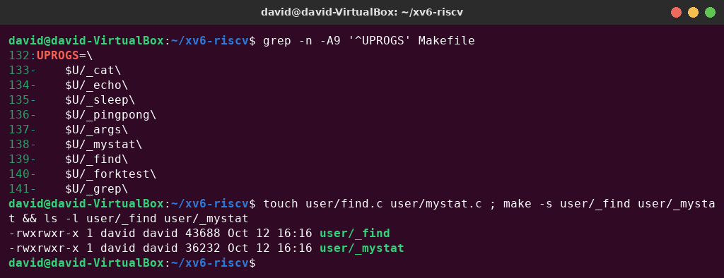
Figure 4.1 – UPROGS with mystat and find, and building them
Test on a fresh disk (make clean ; make qemu), with the commands from the assignment, plus two error cases:
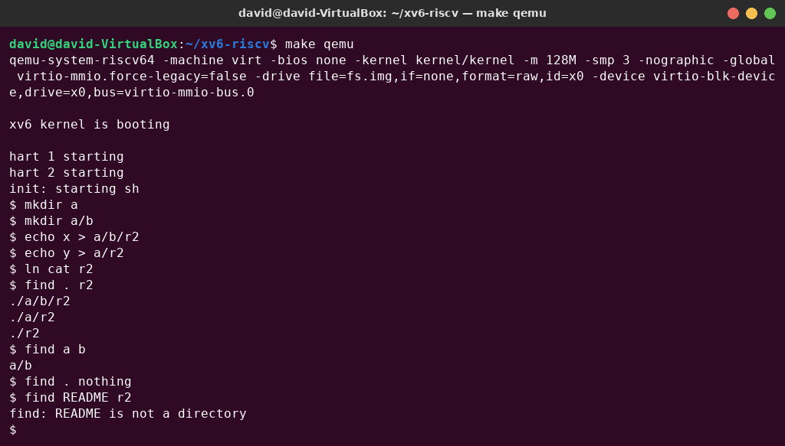
Figure 4.2 – find on a fresh disk
The output is exactly the expected one: find . r2 prints ./a/b/r2, ./a/r2 and ./r2, and find a b prints a/b. A name that does not exist prints nothing, and a start path that is not a directory gives an error message.

Stretch: find with inode numbers
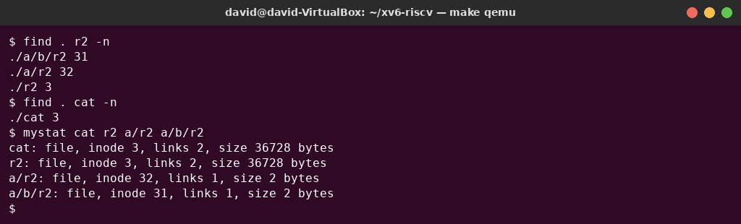
Figure 4.3 – find . r2 -n: which r2 is the same file as cat
./r2 has inode 3, the same as ./cat, and mystat shows links 2 for both: ln cat r2 made ./r2 a second name of the cat program. ./a/r2 (inode 32) and ./a/b/r2 (inode 31) are different, small files created by echo. So only one of the three r2 files is the same file as cat.

Conclusions
This laboratory work showed the xv6 file system from the inside. A directory is just a file of 16-byte entries (inode number + 14-character name), so an empty directory has 32 bytes, and the root, inode 1, is its own parent. With mystat I saw that a hard link is only a second directory entry for the same inode: ln increased the link count and rm decreased it, while the inode, the size and the data stayed the same. In the kernel, sys_unlink only decrements nlink, and the blocks are freed in iput when no name and no open reference is left.
The xv6 inode is minimal: type, device numbers, link count, size and 13 block addresses, with no owner, permissions, timestamps or symbolic links. Its limits come directly from the constants in fs.h. Names are truncated to 14 characters, the largest file is (12 + 256) × 1024 = 274 432 bytes, and the 2000-block disk has 47 metadata blocks (log, inodes, bitmap) and 1953 data blocks. Finally, writing find showed how a recursive tree walk works: read the entries, skip free slots, “.” and “..”, build each path, stat it, and close every directory, because a process has only 16 file descriptors.

