MINISTRY OF EDUCATION AND RESEARCH OF THE REPUBLIC OF MOLDOVA
Technical University of Moldova
Faculty of Computers, Informatics and Microelectronics
Department of Software Engineering and Automatics

REPORT
on laboratory work no. 3
Course: Operating Systems
Topic: The Command Line: Shell, Pipes and Text Filters

Done by: st. gr. FAF-242, Florea David
Checked by: Reitman Patricia

Chișinău, 2026

Purpose of the work
The purpose of this laboratory work is to learn to work fast and confidently in the bash command line: to use completion, history and the built-in help, to predict what the shell does to a command line (globbing, quoting, variable, command and arithmetic expansion) before it runs, to redirect the standard streams and chain commands, to control background jobs, and to answer real questions about data with one-line pipelines of small text filters (grep, cut, sort, uniq, wc, head, tail, tr). Finally, the best one-liners are turned into a small bash script with argument checking, error output and exit codes.
Environment: Ubuntu 26.04.1 LTS (VirtualBox VM, kernel 7.0.0-38-generic), GNU bash. The working directory is ~/os-lab3, where the data set access.log (500 lines) was generated with the loop given in the assignment; head -3 access.log ; wc -l access.log printed the first three lines and 500 access.log, as required.
Note: Ubuntu 26.04 ships the Rust re-implementation of the core utilities (uutils), so ls is the uutils version. This explains a few small differences from the classic GNU output (for example the help text of ls --help and the order of lines in Part 3).

Part 1. Move fast, find help
Tab completion: typing ls /usr/sh and pressing Tab completed the word to /usr/share/, because it is the only name in /usr starting with “sh”. The next Tab presses did not complete anything more, because /usr/share has 261 entries; bash asked “Display all 261 possibilities? (y or n)”. For an ambiguous prefix, ls /usr/l + Tab Tab, the first Tab only completes the common part and the second Tab lists the candidates (lib/ lib64/ libexec/ local/). cd /et + one Tab was completed immediately to cd /etc/.
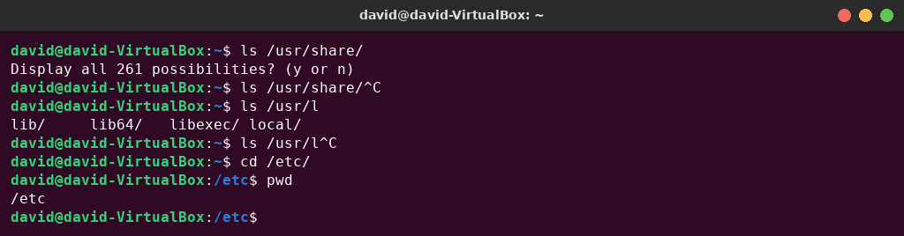
Figure 1.1 – Tab completion
Commands used to find out whether a command is a built-in or an external program, and where the shell looks for programs:
type cd ; type ls ; type echo ; which ls
echo $PATH
echo $PATH | tr ':' '\n' # one directory per line
nosuchprog ; echo "exit code: $?"
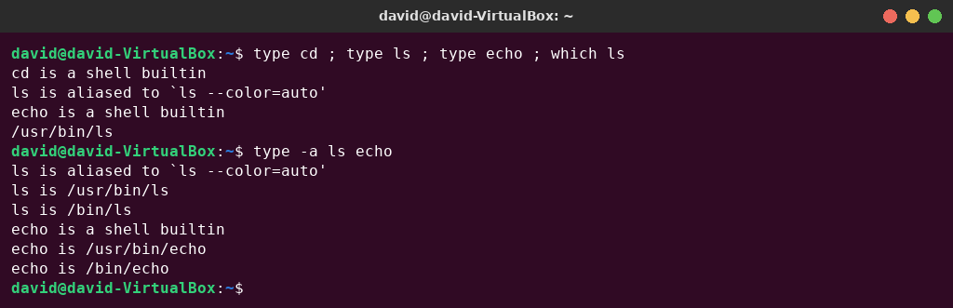
Figure 1.2 – Output of type and which
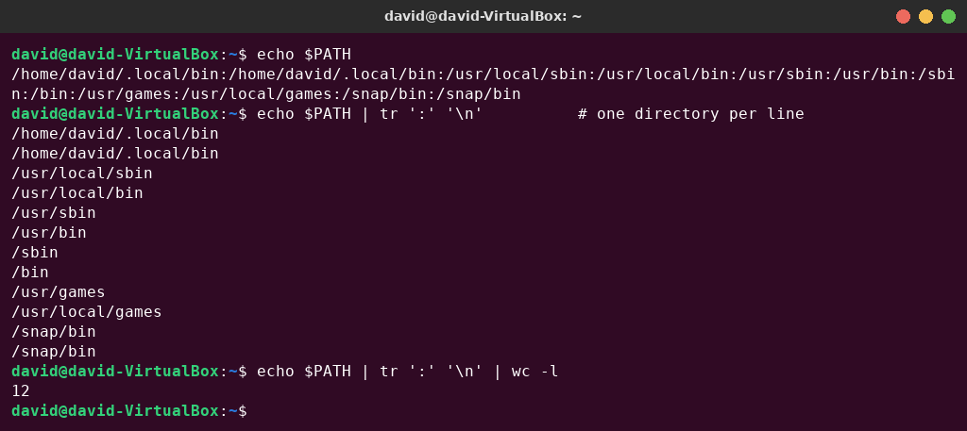
Figure 1.3 – The directories in PATH
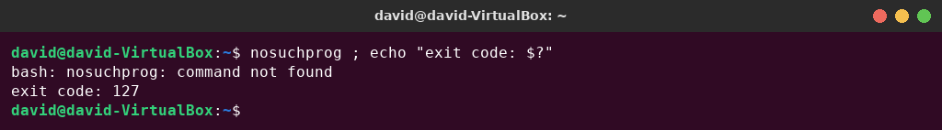
Figure 1.4 – Exit code of a missing command
History search: after running date, whoami and uname -r, I pressed Ctrl+R and typed “dat”. Bash showed (reverse-i-search)dat': date, i.e. it found the most recent command in the history that contains “dat”; pressing Enter ran date` again without retyping it.
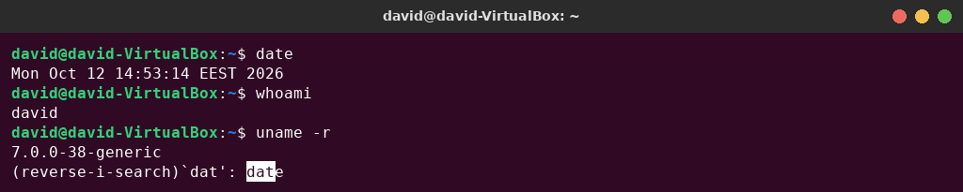
Figure 1.5 – Reverse history search with Ctrl+R
Help without a browser: in man ls I searched with /sort and n (next match), and then found the description of option -t. ls --help | head, man -k "list directory" (search in the names and descriptions of all manual pages) and help cd (help for bash built-ins, which have no separate man page) were also used.
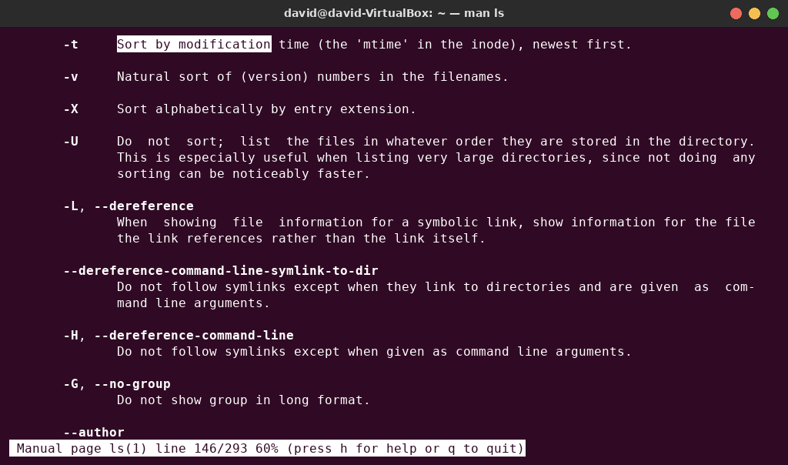
Figure 1.6 – Searching the manual page of ls (option -t)
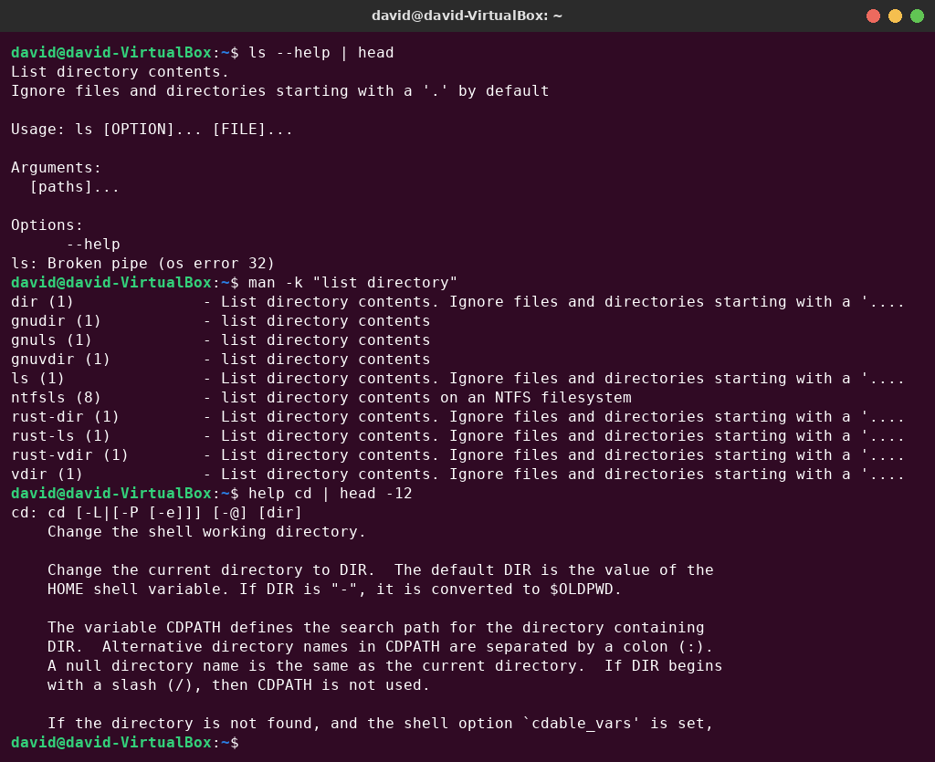
Figure 1.7 – ls --help, man -k and help cd

Observe – answers
1. Which of cd, ls, echo are built-ins, and why MUST cd be one? cd and echo are shell built-ins; ls is an external program, /usr/bin/ls (in this shell it is also an alias for ls --color=auto). type -a shows that echo also exists as /usr/bin/echo, but the built-in has priority. cd must be a built-in because the current directory is a property of each process. An external cd would run as a child process, change the directory of that child only, and exit; the directory of the shell itself would stay the same. Only the shell can change its own working directory, with the chdir() system call.
2. How many directories are in your PATH, and in which one is ls? PATH contains 12 entries (echo $PATH | tr ':' '\n' | wc -l prints 12). /home/david/.local/bin and /snap/bin appear twice, so there are 10 distinct directories. ls is found in /usr/bin (which ls → /usr/bin/ls). It is also visible as /bin/ls, because on Ubuntu /bin is a symbolic link to /usr/bin.
3. What exit code does a command that is not found return? 127 (bash: nosuchprog: command not found, then exit code: 127). A file that is found but cannot be executed returns 126.
4. Which option of ls sorts by modification time? -t: “Sort by modification time (the 'mtime' in the inode), newest first” (the same as --sort=time). It can be combined with -r to put the oldest first, e.g. ls -ltr.

Part 2. What the shell does to your line
A test directory was created with a few files, including one whose name contains a space:
mkdir -p ~/os-lab3/play && cd ~/os-lab3/play
touch a.c b.c file1.txt file2.txt notes.txt "alfa beta.txt"
ls
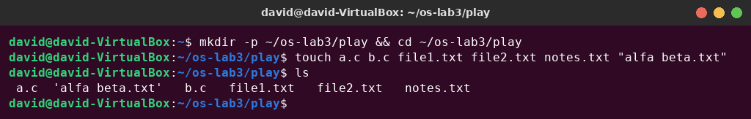
Figure 2.1 – Files created in the play directory
Before running each line I wrote my prediction. Table 2.1 compares the predictions with the real output.
Table 2.1 – Predictions compared with the real output
Command | My prediction | Real output | Explanation (if different)
echo *.c | a.c b.c | a.c b.c | As predicted.
echo file?.txt | file1.txt file2.txt | file1.txt file2.txt | As predicted: ? matches exactly one character.
echo [a-b]* | a.c b.c | a.c alfa beta.txt b.c | Different: I forgot that “alfa beta.txt” also starts with a. [a-b] matches the first character and * matches the rest, including the space.
echo *.xyz | (an empty line) | *.xyz | Different: when a pattern matches no file, bash leaves the pattern unchanged and passes it literally to echo (nullglob is off by default).
ls alfa beta.txt | alfa beta.txt | ls: cannot access 'alfa' ... ls: cannot access 'beta.txt' ... | Different: the unquoted space splits the name into two words, so ls receives two arguments, and neither file exists.
ls "alfa beta.txt" | alfa beta.txt | 'alfa beta.txt' | Almost the same: the file is found, and ls displays the name in quotes because it contains a space.
echo '$HOME' "$HOME" \$HOME | $HOME /home/david $HOME | $HOME /home/david $HOME | As predicted.
echo {1..5} ; echo $((7 * 6)) | 1 2 3 4 5  42 | 1 2 3 4 5  42 | As predicted: brace expansion and arithmetic expansion.
echo "today is $(date +%A), I am $(whoami)" | today is Monday, I am david | today is Monday, I am david | As predicted: command substitution works inside double quotes.
touch log{1..3}.txt && ls log* | log1.txt log2.txt log3.txt | log1.txt log2.txt log3.txt | As predicted.

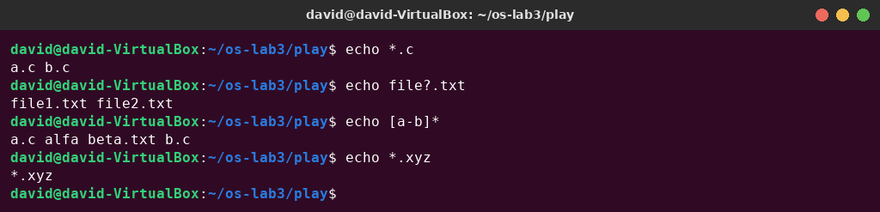
Figure 2.2 – Globbing results
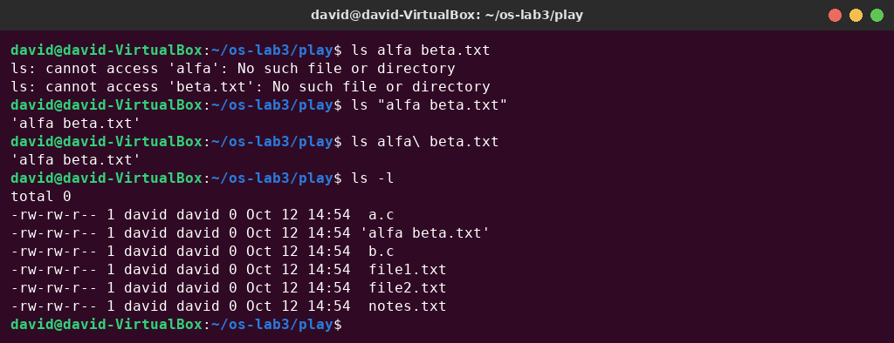
Figure 2.3 – The ls error on a name with a space, and the fix

Figure 2.4 – Single quotes, double quotes and backslash
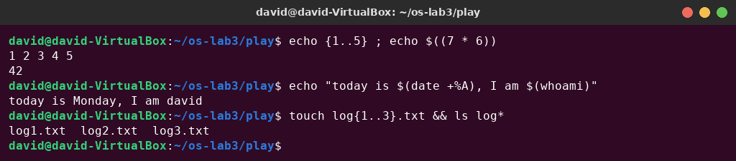
Figure 2.5 – Brace expansion, arithmetic expansion and command substitution

Observe – answers
1. Predictions, real output and explanations. See Table 2.1. My predictions were wrong for echo [a-b]*, echo *.xyz and ls alfa beta.txt; all three differences come from rules the shell applies before the command runs.
2. echo knows nothing about files, yet echo *.c printed file names. Who produced them? The shell (bash). Before it starts a command, bash performs pathname expansion (globbing): it replaces *.c with the sorted list of matching file names. echo only received the arguments a.c and b.c and printed them.
3. Why did ls alfa beta.txt fail? Give two different ways to fix it. Because of word splitting: the shell splits the line at unquoted spaces, so ls received two arguments, alfa and beta.txt, and neither file exists. Fixes: (a) put the name in quotes, ls "alfa beta.txt" or ls 'alfa beta.txt'; (b) escape the space with a backslash, ls alfa\ beta.txt (this is also what Tab completion inserts).
4. What is the difference between single and double quotes? Inside single quotes everything is literal: no expansion happens at all, so '$HOME' stays $HOME. Double quotes also prevent word splitting and globbing, but they still allow variable expansion ($HOME → /home/david), command substitution $(...) and arithmetic $((...)). A backslash quotes only the next character, so \$HOME prints a literal $HOME.
Note – why ls shows 'alfa beta.txt' in quotes. When ls writes to a terminal, it uses the “shell-escape” quoting style for names that contain spaces or special characters. This makes it clear that 'alfa beta.txt' is one file and not two, and the name can be copied and pasted back into a command line as it is. When the output goes to a pipe or a file, the names are printed without quotes.

Part 3. Redirection, chaining and jobs
cd ~/os-lab3
ls /etc /nope > out.txt 2> err.txt
wc -l out.txt ; cat err.txt

Figure 3.1 – stdout and stderr in separate files
ls /etc /nope > all.txt 2>&1 ; tail -2 all.txt
ls /etc /nope 2>&1 > all.txt
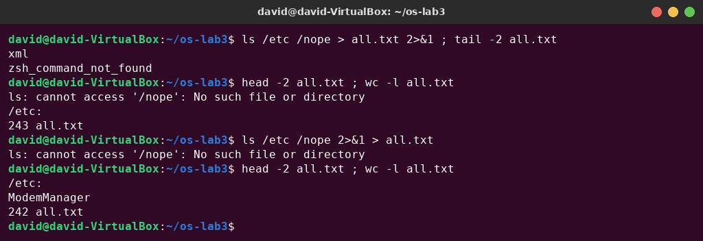
Figure 3.2 – Comparing the order of redirections
In the first case all.txt has 243 lines: the 242 lines of the listing plus the error. The error is the first line of the file because stderr is not buffered, while the listing on stdout is buffered and written at the end. In the second case the error appeared on the terminal, and all.txt has only the 242 lines of the listing.
echo first > notes.md ; echo second >> notes.md ; cat notes.md
wc -l < access.log
ls /nope 2> /dev/null || echo "failed with code $?"
mkdir -p tmp && cd tmp && echo "I am in $(pwd)" ; cd ~/os-lab3
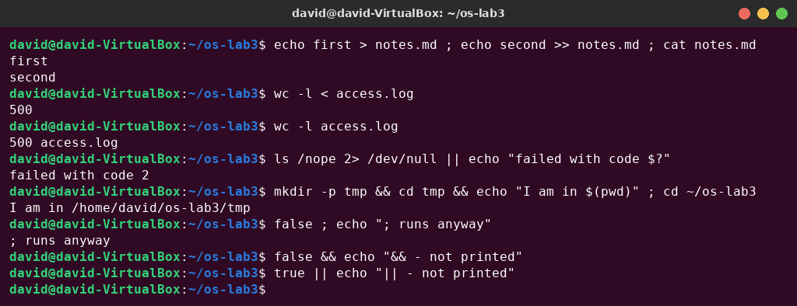
Figure 3.3 – The ; && || operators
> created (or truncated) notes.md and >> appended to it, so the file contains “first” and “second”. ls /nope failed with exit code 2, its error went to /dev/null, and || ran the echo. In the mkdir line both && conditions succeeded, so the echo printed the new directory; the cd ~/os-lab3 after ; runs in any case. The last three lines in Figure 3.3 show the operators with true/false.
sleep 100 &
jobs ; kill %1 ; jobs
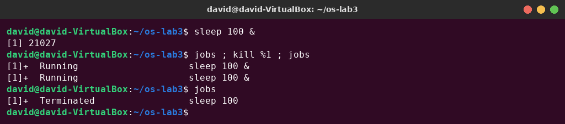
Figure 3.4 – Running a background job and stopping it
& started sleep in the background, and bash printed the job number and the PID ([1] 21027). jobs listed it as Running. kill %1 sent SIGTERM to job 1. The second jobs on the same line still showed Running, because the shell had not yet collected the status of the child. The next jobs reported Terminated.

Observe – answers
1. Which file got the error message, and which got the listing? 2> err.txt redirected stderr (file descriptor 2), so err.txt got the error “ls: cannot access '/nope': No such file or directory”. > out.txt redirected stdout (fd 1), so out.txt got the listing of /etc (242 lines).
2. What is the difference between > all.txt 2>&1 and 2>&1 > all.txt? Redirections are processed from left to right, and 2>&1 means “make fd 2 point to the place fd 1 points to now”. It copies the target; it is not a permanent link. In > all.txt 2>&1, stdout first goes to all.txt, and then stderr is copied from it, so both streams go to the file. In 2>&1 > all.txt, stderr is first copied from stdout, which is still the terminal, and only afterwards stdout is moved to the file. As a result the error appears on the screen and the file contains only the listing (243 vs. 242 lines in Figure 3.2).
3. Why does wc -l < access.log print only a number, while wc -l access.log also prints the file name? With < the shell opens the file and connects it to wc's standard input. wc reads anonymous data from stdin and does not know any file name, so it prints only 500. With wc -l access.log the name is an argument and wc opens the file itself, so it knows the name and prints 500 access.log.
4. Explain each operator in one sentence: ; && || ; runs the commands one after another, whatever the result of the first one; && runs the second command only if the first one succeeded (exit status 0); || runs the second command only if the first one failed (non-zero exit status).

Part 4. Answer questions with one-liners
Every line of access.log has the form date time user result page, with fields separated by single spaces, so cut -d' ' -fN selects field N. Each question is answered with one command line. All of them are saved in oneliners.sh, which runs with bash oneliners.sh inside ~/os-lab3:
# Lab 3 - one-liners on access.log (run inside ~/os-lab3: bash oneliners.sh)
# Florea David, FAF-242
# Q1. How many requests failed?
grep -c FAIL access.log
# Q2. How many different pages were requested, and which?
cut -d' ' -f5 access.log | sort -u | nl
# Q3. How many requests did each page get?
cut -d' ' -f5 access.log | sort | uniq -c
# Q4. Which user or users have the most failed requests, and how many?
grep FAIL access.log | cut -d' ' -f3 | sort | uniq -c | sort -rn | awk 'NR==1{max=$1} $1==max'
# Q5. How many requests did user3 make, and how many of them failed?
echo "user3: $(grep -cw user3 access.log) requests, $(grep -w user3 access.log | grep -c FAIL) failed"
# Q6. Print the last 3 failed requests, showing only time and user.
grep FAIL access.log | tail -3 | cut -d' ' -f2,3
# Q7. Which login shells appear in /etc/passwd, and how many accounts use each? (field 7, separator :)
cut -d: -f7 /etc/passwd | sort | uniq -c | sort -rn
# Q8. Why do ls /etc | wc -l and ls -l /etc | wc -l differ by exactly one?
# ls -l prints an extra first line "total N" (blocks used), the plain ls does not.
echo "ls: $(ls /etc | wc -l) ls -l: $(ls -l /etc | wc -l)"; ls -l /etc | grep "^total"

Q1. How many requests failed?
100 requests failed. grep -c counts the matching lines directly, so | wc -l is not needed.

Figure 4.1 – Number of failed requests

Q2. How many different pages were requested, and which?
4 different pages: /page0, /page1, /page2, /page3. sort -u removes duplicates, and nl numbers the lines, so the last number is the count.

Figure 4.2 – Different pages requested

Q3. How many requests did each page get?
Each page got 125 requests; 4 × 125 = 500, which equals the number of lines in the log (check passed).

Figure 4.3 – Number of requests per page

Q4. Which user or users have the most failed requests, and how many?
user3 and user5, with 15 failed requests each (a tie). The full per-user list is 15, 15, 14, 14, 14, 14, 14, which adds up to 100 = Q1 (check passed). The final awk keeps every line whose count equals the maximum, so a tie is not hidden by head -1.
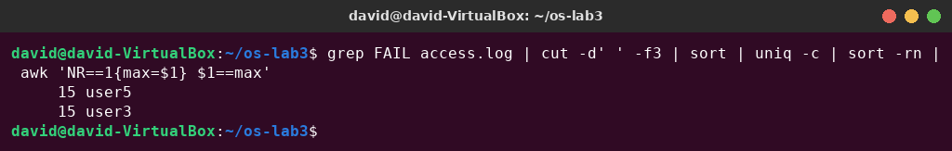
Figure 4.4 – Users with the most failed requests

Q5. How many requests did user3 make, and how many of them failed?
user3 made 72 requests, of which 15 failed. -w matches whole words only, so a user such as user30 would not be counted.
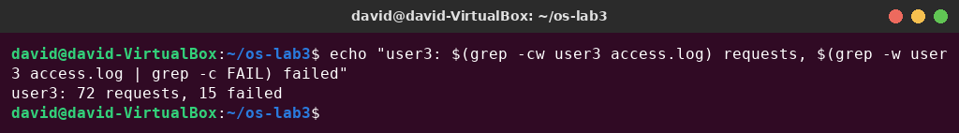
Figure 4.5 – Requests and failures of user3

Q6. Print the last 3 failed requests, showing only time and user.
10:10 user0, 10:15 user5, 10:20 user3. tail -3 keeps the last three FAIL lines, and cut -f2,3 keeps the time and the user.

Figure 4.6 – The last three failed requests

Q7. Which login shells appear in /etc/passwd, and how many accounts use each?
/usr/sbin/nologin – 40 accounts, /bin/false – 5, /bin/bash – 2, /bin/sync – 1. Most accounts are system accounts, which cannot log in (nologin/false); only root and david have bash.
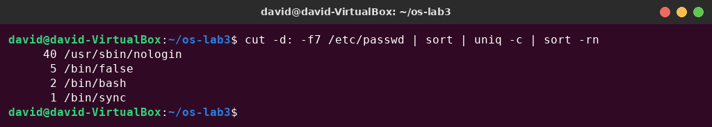
Figure 4.7 – Login shells in /etc/passwd

Q8. Why do ls /etc | wc -l and ls -l /etc | wc -l differ by exactly one?
Prediction: the long format prints an extra header line, so the second number will be bigger by one.
Result: 241 and 242. When the output of ls goes to a pipe, ls prints one name per line, so ls /etc | wc -l counts the 241 entries. ls -l prints the same 241 lines (one per entry) plus one first line, total 1176. This line is the total number of disk blocks used by the listed files, and it is the extra line. The prediction was correct.
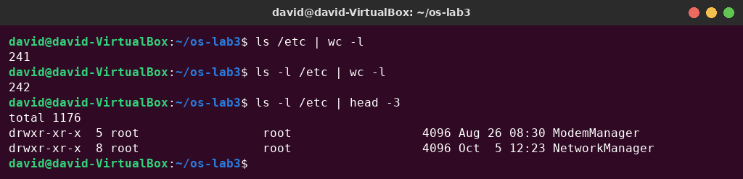
Figure 4.8 – Comparing ls and ls -l line counts

Full run of oneliners.sh
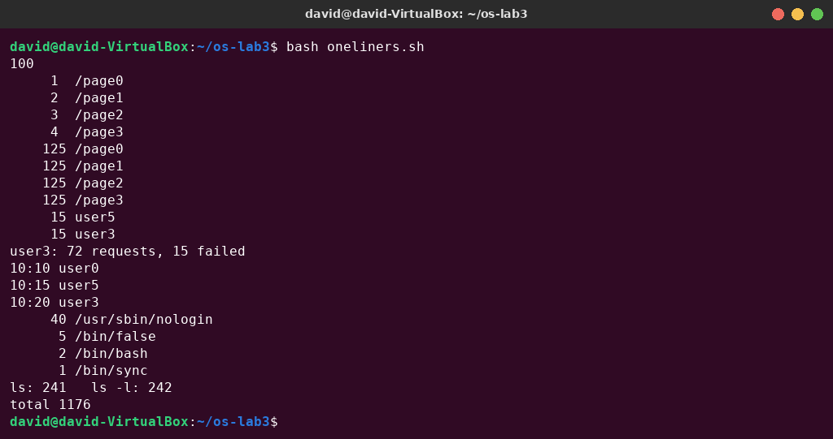
Figure 4.9 – Full run of oneliners.sh

Bonus: minute ending in 0 and failed request (grep -E)
grep -E '^[^ ]+ 10:[0-5]0 [^ ]+ FAIL' access.log # the lines
grep -cE '^[^ ]+ 10:[0-5]0 [^ ]+ FAIL' access.log # how many
There are 50 such lines (the first 12 are shown in the figure). This is not a coincidence: line i has the minute i mod 60, which ends in 0 exactly when i is a multiple of 10, and every multiple of 10 is also a multiple of 5, so it is a FAIL line. All 500 / 10 = 50 lines with a minute ending in 0 are failed requests.
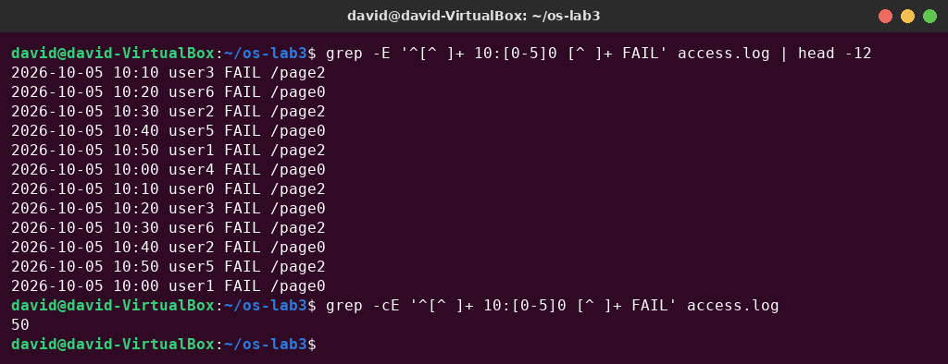
Figure 4.10 – Bonus – failed requests at minutes ending in 0

Part 5. Your first script
report.sh was created in ~/os-lab3 from the given template. The TODO is done with a for loop over 0…6, which counts the FAIL lines of each user (grep -w so that user1 cannot match user10):
#!/bin/bash
# usage: ./report.sh access.log
log=$1
if [ ! -f "$log" ]; then
echo "no such file: $log" >&2
exit 1
fi
total=$(wc -l < "$log")
fails=$(grep -c FAIL "$log")
echo "$total requests, $fails failed"
for n in $(seq 0 6); do
echo "user$n: $(grep -w "user$n" "$log" | grep -c FAIL) failures"
done
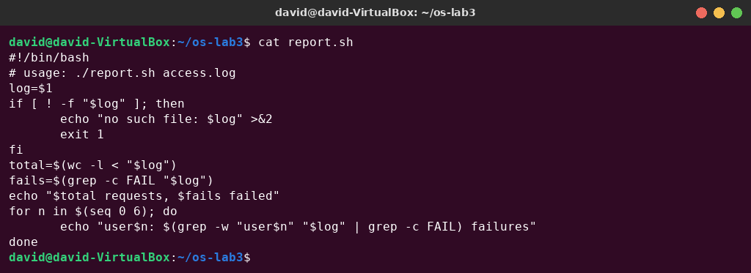
Figure 5.1 – Contents of report.sh
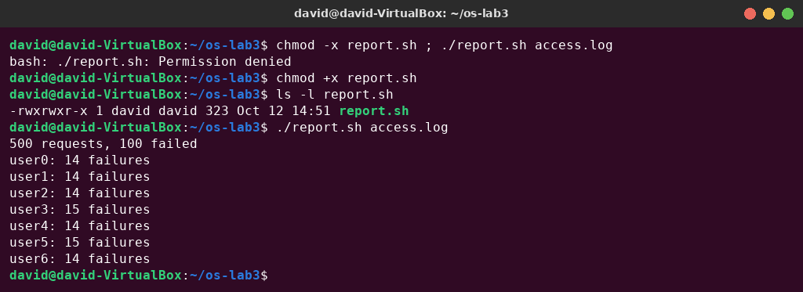
Figure 5.2 – Running the script on access.log
The per-user numbers (14, 14, 14, 15, 14, 15, 14) add up to 100, the same as the total number of failures. They also agree with Q4 and Q5.
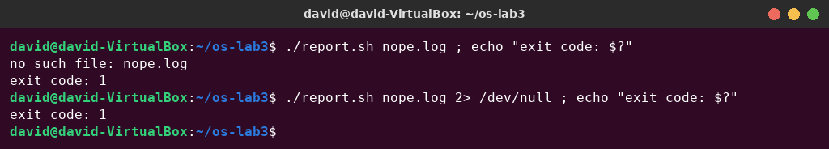
Figure 5.3 – Error handling for a missing file
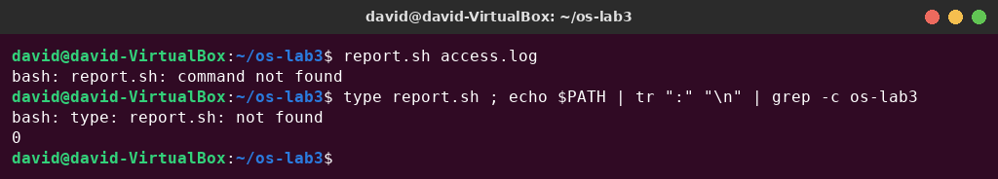
Figure 5.4 – Running the script without ./

Observe – answers
1. What does the first line #!/bin/bash do, and what happens if you run ./report.sh before chmod +x? The “shebang” line tells the kernel which interpreter must run the file. When the file is executed, execve() sees #! and actually runs /bin/bash ./report.sh access.log. Without the execute permission, the kernel refuses to run the file, and bash prints ./report.sh: Permission denied (Figure 5.2). bash report.sh would still work, because then bash only reads the file.
2. Why must you type ./report.sh and not just report.sh? A name without a slash is searched only in the directories listed in PATH, and the current directory is not in PATH, so bash prints report.sh: command not found (Figure 5.4). This is a security measure: otherwise a malicious program called, for example, ls placed in a directory would run instead of the real one. ./report.sh is a path, so the shell runs that file directly without searching PATH.
3. Why does the script write the error with >&2 and end with exit 1? >&2 sends the message to stderr, so it does not mix with the normal output: the report can be piped or saved to a file while errors still appear on the screen, or they can be discarded separately (2> /dev/null in Figure 5.3). exit 1 stops the script, so it does not continue with a missing file. The non-zero exit status also tells the caller ($?, &&, ||, other scripts, cron) that the script failed. With exit 0 the error could not be detected automatically.

Bonus: running report.sh with cron
The following line was added to the crontab. It runs the script every minute with full paths, because cron starts jobs with a minimal environment (short PATH, home directory as the working directory), and appends both stdout and stderr to report.log:
* * * * * /home/david/os-lab3/report.sh /home/david/os-lab3/access.log >> /home/david/os-lab3/report.log 2>&1
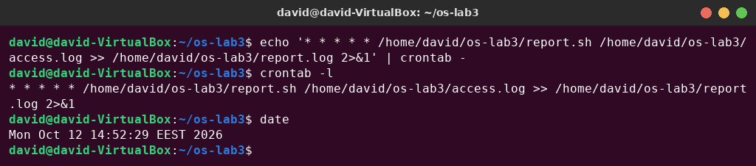
Figure 5.5 – Installing the crontab line
Three and a half minutes later report.log contained 4 complete reports, one for each minute. Then the crontab was removed with crontab -r, and crontab -l confirms that no crontab is left.
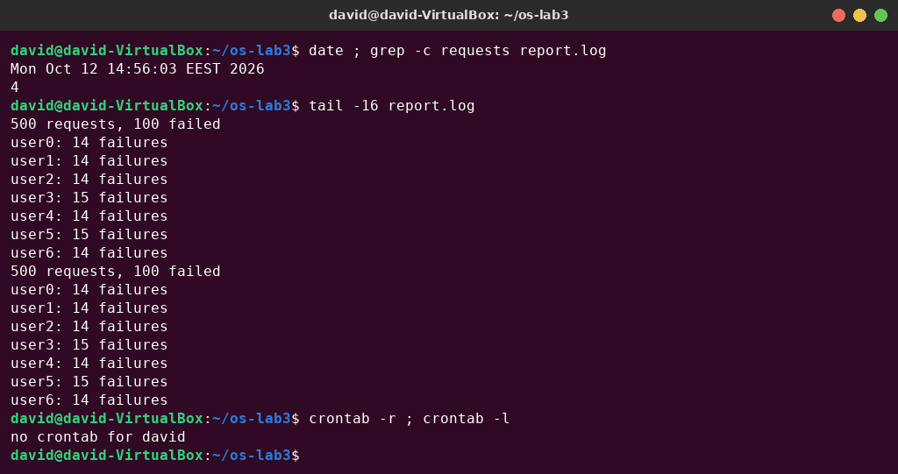
Figure 5.6 – The report.log written by cron, and removing the crontab

Conclusions
In this laboratory work I learned to use bash efficiently: Tab completion and Ctrl+R history search save typing, and type, which, man, man -k, --help and help give all the necessary information without a browser. The most important lesson was that the shell, not the command, processes the command line first. Globbing, word splitting, quoting and the different expansions happen before the program starts. My wrong predictions (echo [a-b]*, echo *.xyz, ls alfa beta.txt) all come from these rules.
I saw that every process has separate stdout and stderr streams that can be redirected independently, that the order of redirections matters because they are applied from left to right, and that the exit status is what makes && and || work. Jobs can be started in the background and stopped with kill %N.
Combining small filters with pipes was enough to answer every question about the access log in one line, and the cross-checks (125 × 4 = 500 requests and 100 failures in total) confirmed the pipelines. Finally, the one-liners became a reusable script with an interpreter line, argument checking, error messages on stderr and a meaningful exit code, and the script was scheduled with cron. These are the basic tools for automating work on a Linux system.

