
MINISTRY OF EDUCATION AND RESEARCH OF THE REPUBLIC OF MOLDOVA
Technical University of Moldova
Faculty of Computers, Informatics and Microelectronics
Department of Software Engineering and Automatics

REPORT
on laboratory work no. 8
Course: Operating Systems
Topic: The Same Calls, Inside Your Own OS

Done by: st. gr. FAF-242, Florea David
Checked by: Reitman Patricia

Chișinău, 2026

Purpose of the work
In Lab 7 I ran fork, exec and wait on Linux. The purpose of this work is to run the same program inside xv6, the small operating system built during this semester, and to see that the calls are the same, even without glibc, using only the system calls of the kernel I compiled. In the second part, two processes talk through pipes (pingpong). As the optional task, I also wrote primes, a chain of processes connected by pipes.
Environment: Ubuntu 26.04.1 LTS (VirtualBox VM), xv6-riscv in ~/xv6-riscv with my programs from the previous labs, QEMU for RISC-V. New programs: user/run.c and user/primes.c, added to UPROGS as $U/_run\ and $U/_primes\. $U/_pingpong\ was already there from Lab 2.

Part 1. run, inside xv6
user/run.c, written exactly as given: the same three steps as run.c in Lab 7, but the child becomes echo.
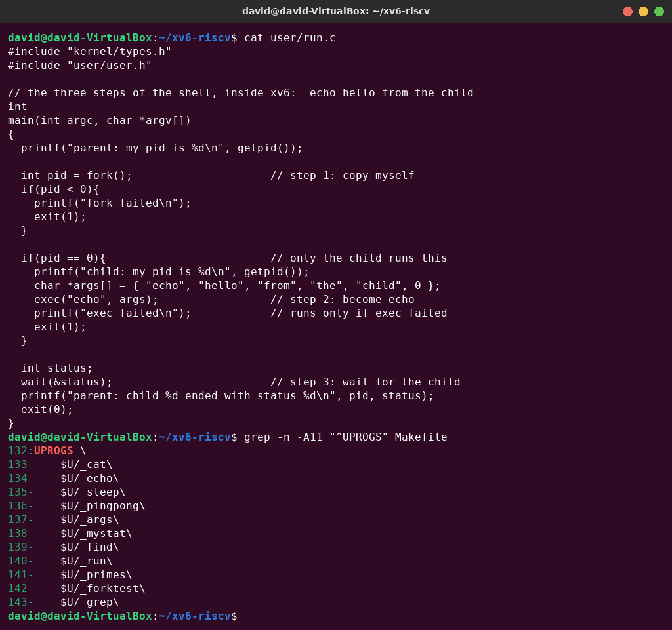
Figure 1.1 – user/run.c and the UPROGS lines
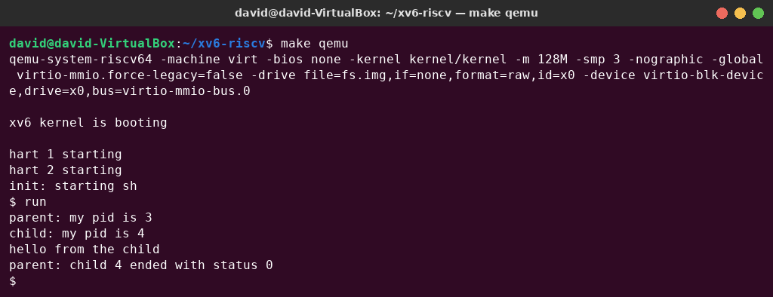
Figure 1.2 – run in xv6: the child becomes echo
Then I made the child run ls. The two lines were changed (with sed, to show the change), and make qemu rebuilt the program and the disk image:
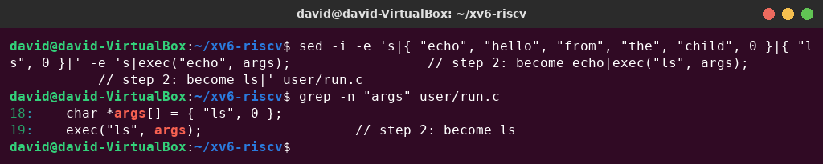
Figure 1.3 – The child now becomes ls
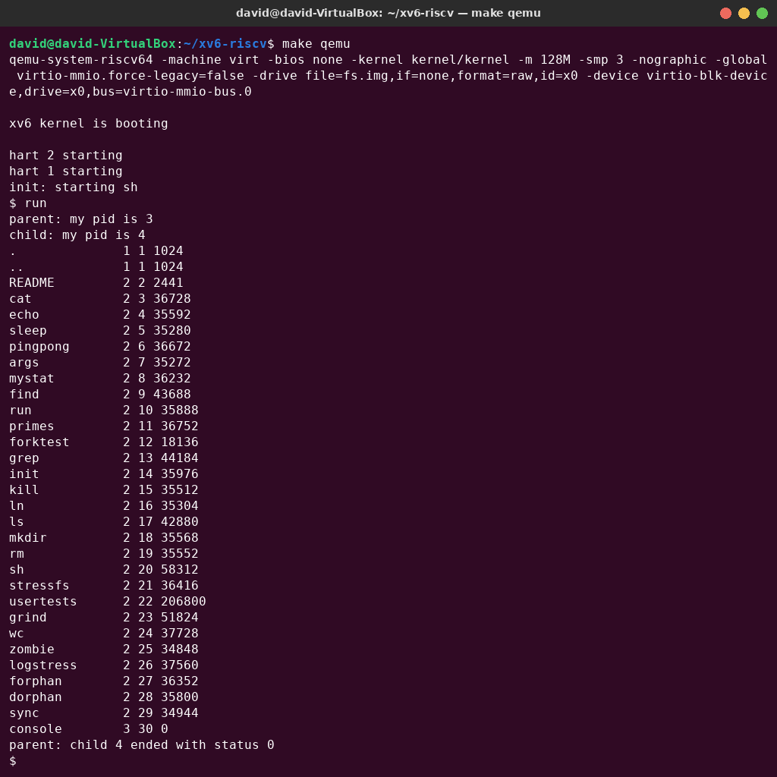
Figure 1.4 – run in xv6: the child becomes ls
Next, exec of a program that does not exist, exec("nosuchprog", args);:
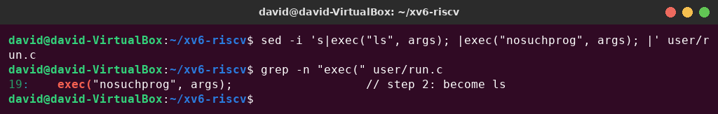
Figure 1.5 – exec of a program that does not exist
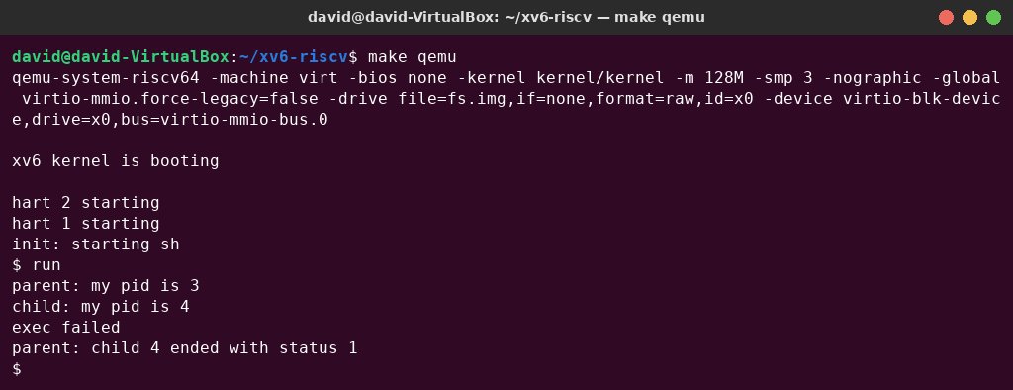
Figure 1.6 – exec failed, and the parent sees status 1
Finally, I restored the original version (echo), which is the one submitted in the repository:
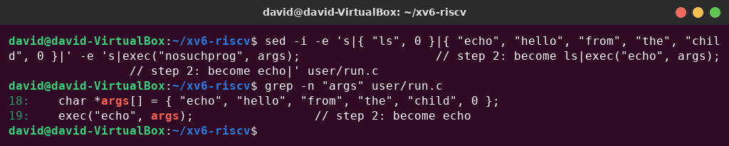
Figure 1.7 – run.c restored to echo

Observe – answers
1. Write the three calls that run.c uses in xv6 and the three calls run.c used on Linux in Lab 7. What is the same?
Table 1.1 – The three steps in xv6 and on Linux
Step | xv6 (user/run.c) | Linux (Lab 7 run.c)
1. copy | fork() | fork()
2. become another program | exec("echo", args) | execlp("ls", "ls", "-l", (char *)NULL)
3. wait for the child | wait(&status) | waitpid(pid, &status, 0)

The idea and the order are the same. fork returns 0 in the child and the child's PID in the parent. exec replaces the program of the child, keeping its PID, and returns only if it fails. wait blocks the parent until the child ends and gives its exit status. The differences are only in the interface. Linux's execlp is a glibc wrapper that searches PATH and takes the arguments as a list, while xv6's exec takes a path and an argv array (it finds echo because run runs in /, where all programs live). waitpid waits for a specific child and encodes the status (WEXITSTATUS), while xv6's wait waits for any child and stores the exit value directly.
2. Who prints "hello from the child": the code of run, or echo? echo. run.c has no printf with this text: it only builds the array {"echo", "hello", "from", "the", "child"} and passes it to exec. After exec the child process (PID 4) is running the echo program, which receives this array as its argv and prints argv[1..]. The same child printed “child: my pid is 4” while it was still run.
3. Why is the status 1 here and 127 on Linux? Because the status is simply the number the child passes to exit, and the two programs choose different numbers. The line after exec is exit(1); in the xv6 run.c and exit(127); in the Linux run.c. A failed exec does not produce any code by itself. 127 is only the convention of the Unix shells for “command not found”.

Part 2. pingpong
The parent sends one byte to the child through a first pipe (p2c). The child prints “<pid>: received ping”, writes the byte back through a second pipe (c2p) and exits. The parent reads it, prints “<pid>: received pong” and waits for the child. My user/pingpong.c (written in Lab 2) completes all the TODO lines of the template with read(fd, &b, 1) and write(fd, &b, 1). It also checks every call and closes every pipe end it does not use:
#include "kernel/types.h"
#include "user/user.h"
int
main(int argc, char *argv[])
{
int p2c[2], c2p[2]; // parent->child and child->parent pipes
char b = 'x';
if(pipe(p2c) < 0 || pipe(c2p) < 0){
fprintf(2, "pingpong: pipe failed\n");
exit(1);
}
int pid = fork();
if(pid < 0){
fprintf(2, "pingpong: fork failed\n");
exit(1);
}
if(pid == 0){
close(p2c[1]);
close(c2p[0]);
if(read(p2c[0], &b, 1) != 1){
fprintf(2, "pingpong: child read failed\n");
exit(1);
}
printf("%d: received ping\n", getpid());
if(write(c2p[1], &b, 1) != 1){
fprintf(2, "pingpong: child write failed\n");
exit(1);
}
close(p2c[0]);
close(c2p[1]);
exit(0);
}
close(p2c[0]);
close(c2p[1]);
if(write(p2c[1], &b, 1) != 1){
fprintf(2, "pingpong: parent write failed\n");
exit(1);
}
if(read(c2p[0], &b, 1) != 1){
fprintf(2, "pingpong: parent read failed\n");
exit(1);
}
printf("%d: received pong\n", getpid());
close(p2c[1]);
close(c2p[0]);
wait(0);
exit(0);
}
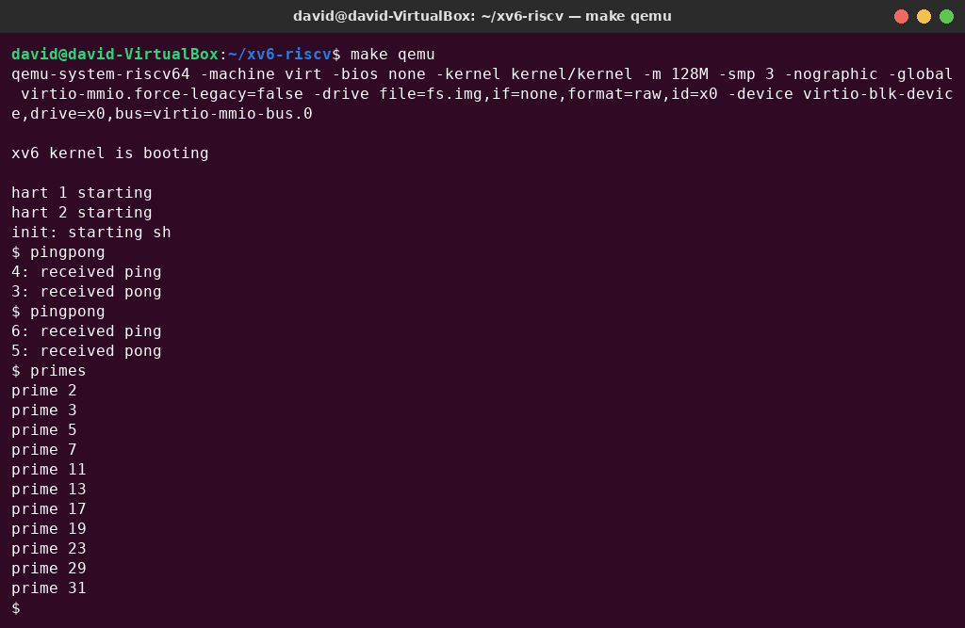
Figure 2.1 – pingpong (run twice) and the optional primes
“ping” always comes first, from the child (PID 4, then 6 on the second run), and “pong” follows from the parent (PID 3, then 5).

Observe – answers
1. Why do you need TWO pipes, and not one for both directions? A pipe is one-way: it is a single buffer with one end for writing and one for reading, and it does not know who wrote a byte. With one pipe, the parent could write the ping and then read it back itself, before the child got it (and the same for the child's pong). There would be no way to send a byte to the other process only. With two pipes each direction has its own buffer: p2c only carries parent → child and c2p only carries child → parent.
2. Nothing in your code says "wait until the child has replied". Which call makes the parent wait? read(c2p[0], &b, 1). read on an empty pipe blocks: the kernel puts the parent to sleep until a byte arrives (or until all write ends are closed, when read returns 0). The child writes the pong only after it has received the ping and printed its line, so the parent's read can only return after that. The child is synchronised the same way by its read on p2c[0]. The final wait(0) only collects the child's exit status.

Optional: primes
user/primes.c prints the primes from 2 to 35 with a chain of processes (the pipe sieve). The first process writes 2…35 into a pipe. Every stage reads its first number p, which must be prime, prints “prime p”, creates a new pipe and a child, and forwards to the child only the numbers not divisible by p. When a stage's input pipe reaches end-of-file, the stage closes its output (so the next stage also gets end-of-file), waits for its child and exits. Every unused pipe end is closed; otherwise the chain would never end, and the processes would run out of descriptors.
#include "kernel/types.h"
#include "user/user.h"
// Primes from 2 to 35 with a chain of processes (pipe sieve).
// Each stage reads its first number p (a prime), prints it, and
// forwards to the next stage only the numbers not divisible by p.
void sieve(int left) __attribute__((noreturn));
void
sieve(int left)
{
int p, n;
int right[2];
if (read(left, &p, sizeof(p)) != sizeof(p)) { // no numbers left: end of chain
close(left);
exit(0);
}
printf("prime %d\n", p);
if (pipe(right) < 0) {
fprintf(2, "primes: pipe failed\n");
exit(1);
}
if (fork() == 0) {
close(right[1]); // the next stage only reads
close(left);
sieve(right[0]);
}
close(right[0]);
while (read(left, &n, sizeof(n)) == sizeof(n))
if (n % p != 0)
write(right[1], &n, sizeof(n));
close(left);
close(right[1]); // end of file for the next stage
wait(0);
exit(0);
}
int
main(int argc, char *argv[])
{
int p[2];
if (pipe(p) < 0) {
fprintf(2, "primes: pipe failed\n");
exit(1);
}
if (fork() == 0) {
close(p[1]);
sieve(p[0]);
}
close(p[0]);
for (int i = 2; i <= 35; i++)
write(p[1], &i, sizeof(i));
close(p[1]);
wait(0);
exit(0);
}
The output (Figure 2.1) is prime 2, 3, 5, 7, 11, 13, 17, 19, 23, 29, 31, which are all the primes up to 35. Eleven stages were created, one per prime.

Conclusions
Running run inside xv6 showed that the process model of my own small OS is the same as Linux's. fork copies the process, exec replaces its program and returns only on failure, and wait suspends the parent until a child exits and gives back its exit status. Linux only adds library conveniences (PATH search, execlp's argument list, waitpid with encoded status). The text “hello from the child” is printed by echo, not by run, and the status of a failed exec is just the number the program passes to exit.
pingpong showed that pipes are one-way byte channels, so two-way communication needs two of them, and that a blocking read is enough to synchronise two processes: nothing else in the code makes the parent wait for the reply. The optional primes program combined everything: fork, pipe, read, write, close and wait build a chain of eleven cooperating processes, and closing unused pipe ends is what lets the chain end correctly.

