
MINISTRY OF EDUCATION AND RESEARCH OF THE REPUBLIC OF MOLDOVA
Technical University of Moldova
Faculty of Computers, Informatics and Microelectronics
Department of Software Engineering and Automatics

REPORT
on laboratory work no. 5
Course: Operating Systems
Topic: The File System with Your Own Hands

Done by: st. gr. FAF-242, Florea David
Checked by: Reitman Patricia

Chișinău, 2026

Purpose of the work
The purpose of this laboratory work is to check, on my own Linux system, the file-system ideas from the lecture: the directory tree and the file types, inodes behind the names, hard and symbolic links, file and directory permissions together with the special bits, and the disks, partitions and the kernel information that Linux shows as files in /proc. There is no programming: only commands, careful observation and short explanations.
Environment: Ubuntu 26.04.1 LTS in a VirtualBox VM, root file system ext4. All experiments were done as the normal user david, not as root (root ignores most permission checks), in the directory ~/os-lab5.
whoami # must not print root → david
mkdir -p ~/os-lab5 && cd ~/os-lab5

Part 1. The tree and the file types
ls /
ls -ld /etc /etc/passwd /bin /dev/null /tmp
ls -l /dev | head
file /usr/bin/ls /etc/passwd /bin
du -sh /var/log 2>/dev/null ; du -sh /usr 2>/dev/null
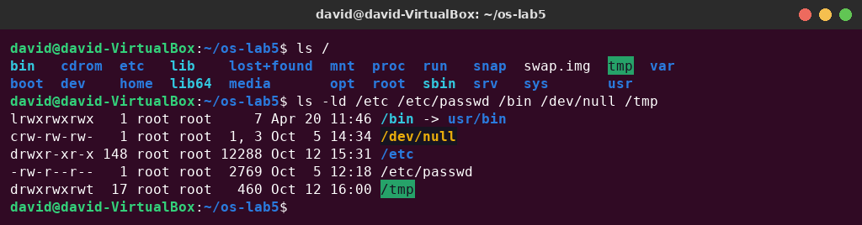
Figure 1.1 – The root directory and the types of five paths
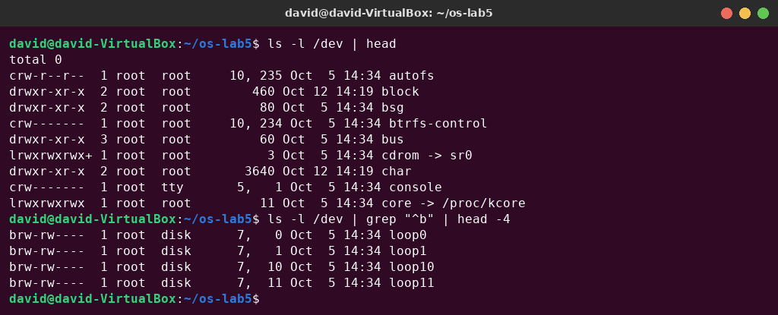
Figure 1.2 – Devices in /dev (character and block devices)
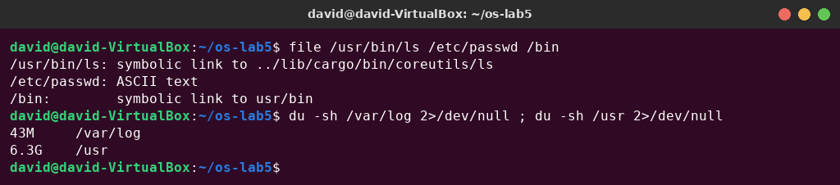
Figure 1.3 – file and du

Observe – answers
1. The type of each path from the first letter of ls -l. /etc – d, directory; /etc/passwd – -, regular file; /bin – l, symbolic link; /dev/null – c, character device (major 1, minor 3 instead of a size); /tmp – d, directory (with the sticky bit, drwxrwxrwt).
2. What is /bin on your system: a directory or a link, and to where? A symbolic link: /bin -> usr/bin (file says “symbolic link to usr/bin”). Modern Ubuntu uses the merged /usr layout, so /bin, /sbin and /lib are links into /usr. Even /usr/bin/ls is a link here, to ../lib/cargo/bin/coreutils/ls, because Ubuntu 26.04 uses the Rust coreutils.
3. Find one character device and one block device in /dev. Character device: /dev/null (crw-rw-rw-, 1, 3); others are /dev/console (5, 1) and /dev/autofs. Block device: /dev/loop0 (brw-rw----, 7, 0); the disk /dev/sda (8, 0) is also a block device. Character devices are read and written as a stream of bytes; block devices are accessed in fixed-size blocks, at any position.
4. Which is bigger, /var/log or /usr, and by roughly how much? /usr is much bigger: 6.3 G compared with 43 M for /var/log, about 150 times bigger. /usr holds all installed programs and libraries; /var/log only holds the log files.

Part 2. Inodes and links
echo hello > notes.txt
stat notes.txt
ls -li notes.txt
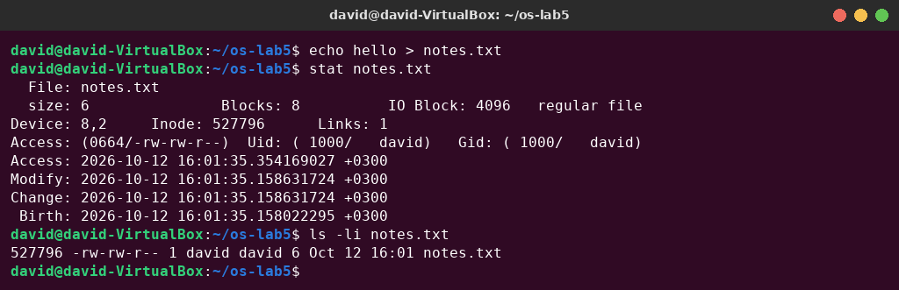
Figure 2.1 – stat and ls -li: the inode of notes.txt
ln notes.txt hard.txt
ls -li notes.txt hard.txt
rm notes.txt
cat hard.txt ; ls -li hard.txt
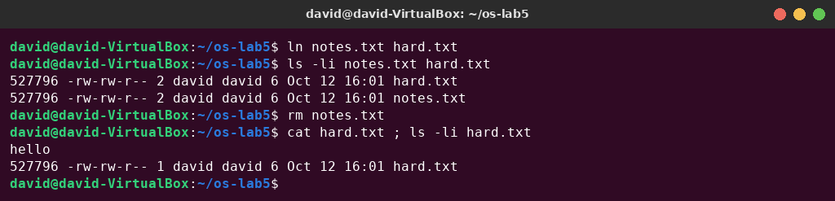
Figure 2.2 – A hard link, then removing the “original”
ln -s hard.txt soft.txt
ls -li hard.txt soft.txt
cat soft.txt
rm hard.txt
cat soft.txt ; ls -l soft.txt
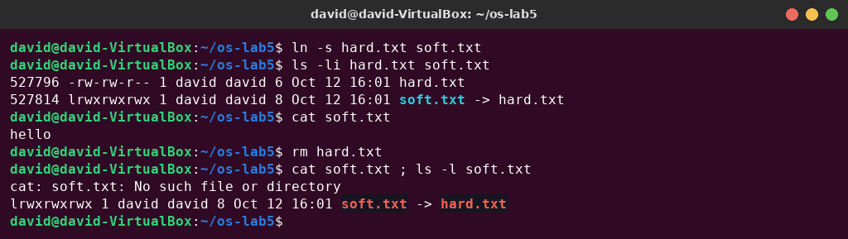
Figure 2.3 – A symbolic link, then removing its target
Prediction for the directory link count: a new directory has 2 links; after creating d/x and d/y it will have 4.
mkdir d ; ls -ld d
mkdir d/x d/y ; ls -ld d
ls -lai d # added: shows where the links come from
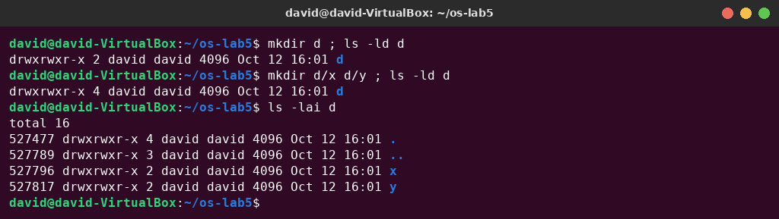
Figure 2.4 – Link count of a directory
The prediction was correct. (Inode 527796, freed when hard.txt was deleted, was reused by the new directory d/x. Inode numbers are recycled.)
echo x > one.txt ; ls -l one.txt ; du -h one.txt
truncate -s 1G big.img ; ls -lh big.img ; du -h big.img
rm big.img
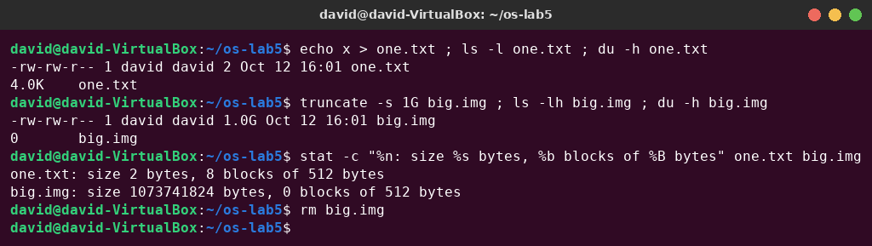
Figure 2.5 – Size is not space

Observe – answers
1. Which number in stat is the inode, and which tells how many names the file has? Inode: 527796 is the inode number (the same number that ls -li prints in the first column). Links: 1 is the link count: the number of directory entries (names) that point to this inode.
2. After rm notes.txt, why could you still read hard.txt? What does rm really remove? notes.txt and hard.txt were two names for the same inode 527796; ln only added a second directory entry, and the link count became 2. rm calls unlink(): it removes one name from the directory and decrements the link count to 1. The inode and the data are freed only when the link count reaches 0 and no process has the file open. So rm removes a name, not the file, and hard.txt still shows “hello”.
3. Why did cat soft.txt fail at the end, although soft.txt still exists? How big is soft.txt and why exactly that size? A symbolic link is a separate file (its own inode 527814, type l) that only stores a path. cat follows the path “hard.txt”, and after rm hard.txt no file has that name any more: the link is dangling, so cat prints “No such file or directory”. soft.txt is 8 bytes, because its content is the target path “hard.txt”, which is exactly 8 characters (no terminating zero is stored).
4. A new directory has 2 links, and 4 after you create two subdirectories. Explain where each link comes from. Link 1 is the entry “d” in the parent directory ~/os-lab5. Link 2 is the entry “.” inside d, which points to d itself. Every subdirectory has an entry “..” that points back to its parent, so d/x/.. and d/y/.. add links 3 and 4. In general, a directory's link count is 2 + the number of its subdirectories.
5. Why does a 2-byte file use 4.0K, and a 1 GB file use 0? ls shows the size (the length of the content), but du shows the space actually allocated on disk. ext4 allocates whole 4 KiB blocks, so even the 2 bytes "x\n" occupy one block: stat shows 8 sectors × 512 bytes = 4096 bytes. truncate -s 1G only sets the length in the inode and allocates no blocks. This is a sparse file: the “holes” read as zeros but use no disk space, so du shows 0.

Part 3. Permissions
echo secret > s.txt
chmod 600 s.txt ; ls -l s.txt
chmod 000 s.txt ; cat s.txt
chmod u+r s.txt ; cat s.txt
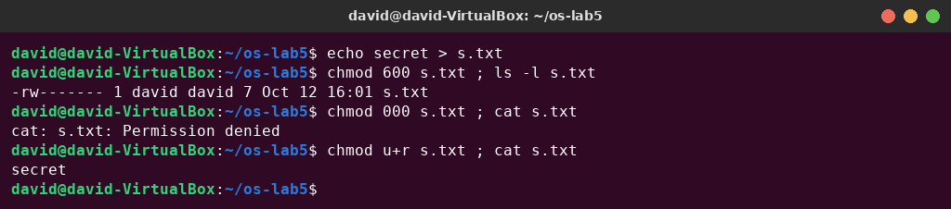
Figure 3.1 – File permissions: 600, 000 and u+r
umask ; touch new.txt ; mkdir newdir ; ls -ld new.txt newdir
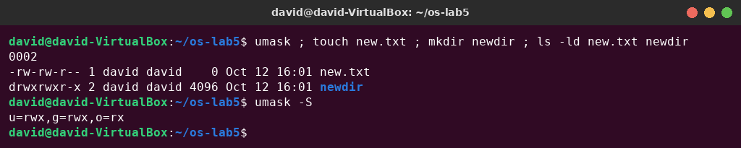
Figure 3.2 – The umask and the permissions of new files
Predictions for the box experiment. With read only (u=r), I predicted that ls box would list the name f, but cat box/f would be refused. With execute only (u=x), I predicted that ls box would be refused, but cat box/f would work because I know the name. Both predictions were correct:
mkdir box ; echo hi > box/f
chmod u=r,go= box ; ls box ; cat box/f # read only
chmod u=x,go= box ; ls box ; cat box/f # execute only
chmod 755 box
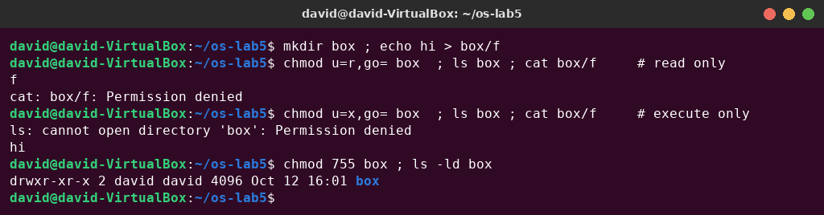
Figure 3.3 – The box experiment: r and x on a directory
ls -l /usr/bin/passwd ; ls -ld /tmp
cat /etc/shadow
ls -l /etc/shadow
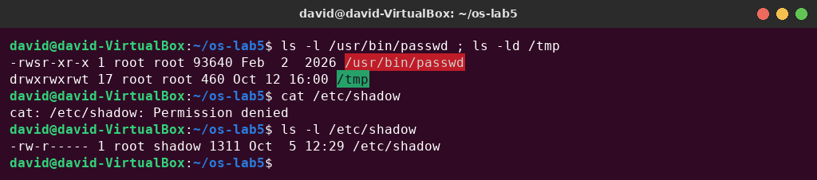
Figure 3.4 – Special bits (s, t) and a file of another user

Observe – answers
1. Write 600, 644, 755 and 700 as rwx strings, and give one real use for each.
Table 3.1 – Octal permissions as rwx strings
Octal | rwx | Real use
600 | rw------- | private files only the owner may read and change: ~/.ssh/id_ed25519 (SSH private key)
644 | rw-r--r-- | normal files everyone may read but only the owner changes: /etc/passwd, documents
755 | rwxr-xr-x | programs and public directories: /usr/bin/ls, the box directory restored above
700 | rwx------ | private directories or scripts: ~/.ssh, a personal script folder

2. With chmod 000 you own the file but cannot read it. Why does ownership not help? The kernel checks only one class of permission bits: if you are the owner, it uses the owner bits (here ---), and it does not fall back to the group or other bits. Ownership does not give access by itself. It only gives the right to change the permissions with chmod. That is why chmod u+r (allowed for the owner) made cat work again. Only root bypasses these checks.
3. What is your umask, and how does it explain the permissions of new.txt and newdir? The umask is 0002 (umask -S: u=rwx,g=rwx,o=rx), and it removes the write bit for “others”. Programs create files with 666 and directories with 777, and the umask bits are cleared: 666 & ~002 = 664 → new.txt is rw-rw-r--, and 777 & ~002 = 775 → newdir is rwxrwxr-x. New files are never executable by default, because touch asks for 666.
4. Explain the box experiment: what does r allow on a directory, and what does x allow? A directory is a table of names → inode numbers. r allows reading this table, i.e. listing the names (ls box printed f), but without x you cannot go through the directory to the files, so cat box/f was refused. x (search) allows using the directory in a path and looking up a name you already know, so cat box/f printed “hi”. Without r, the list cannot be read, so ls box was refused. To work normally in a directory you need both r and x.
5. What do the s in /usr/bin/passwd and the t in /tmp mean, and why does passwd need the s? s in the owner's execute position is the setuid bit: the program runs with the effective user ID of the file's owner (root), not of the user who started it. passwd needs it because it must write the new password hash into /etc/shadow, which is -rw-r----- root shadow: normal users cannot even read it, as cat /etc/shadow showed. t on /tmp is the sticky bit: /tmp is writable by everyone, but in a sticky directory a file can be deleted or renamed only by its owner (or the directory's owner or root), so users cannot delete each other's files.

Part 4. Disks and the kernel as files
lsblk
df -h
mount | grep " / "
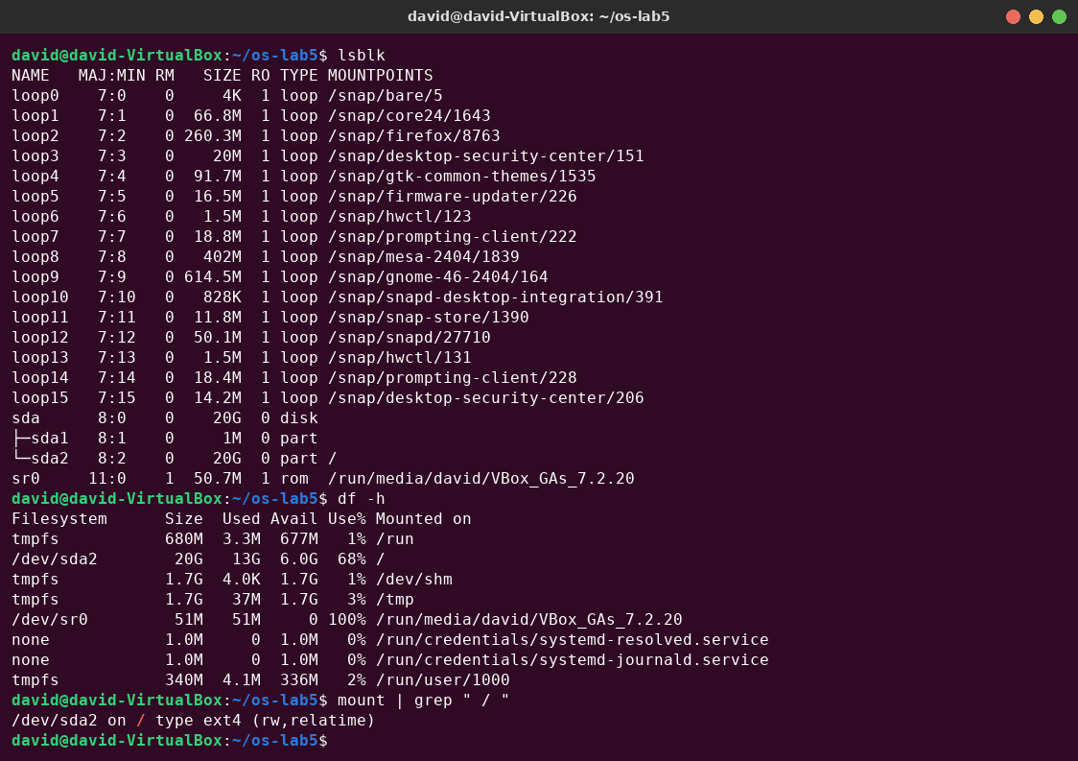
Figure 4.1 – lsblk, df -h and the root mount
grep -c processor /proc/cpuinfo
head -3 /proc/meminfo
head -5 /proc/self/status
ls -l /proc/self/fd
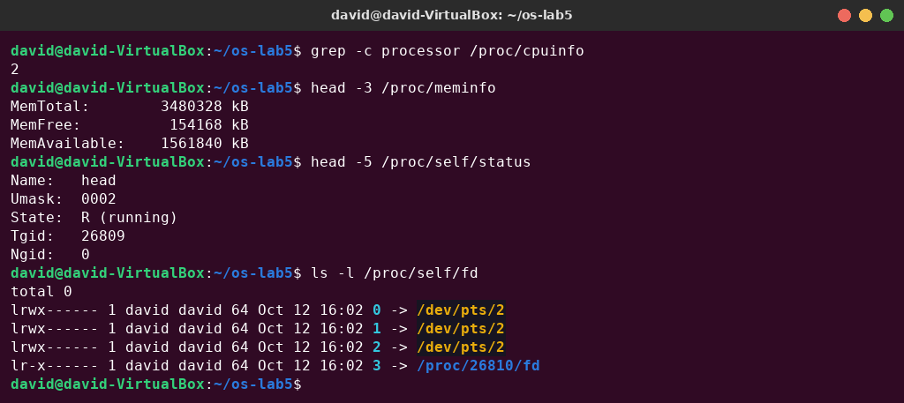
Figure 4.2 – CPU, memory and the current process in /proc

Observe – answers
1. Draw your disk: disk name, partitions, which one is mounted at / and with what file system type.
sda 20G virtual disk of the VM (8:0)
├─ sda1 1M not mounted (BIOS boot partition for GRUB, GPT)
└─ sda2 20G mounted at /, type ext4 (rw,relatime)
sr0 VirtualBox Guest Additions CD
loop0..15 read-only snap packages under /snap
swap the file /swap.img on the root file system
2. How full is your root file system? /dev/sda2 has 20G, of which 13G are used and 6.0G are available: it is 68% full.
3. How many CPU cores and how much RAM does your laptop have, according to /proc? 2 processors (grep -c processor /proc/cpuinfo → 2) and MemTotal: 3480328 kB ≈ 3.3 GiB of RAM. These are the resources given to the virtual machine, not those of the physical laptop.
4. /proc/self/status showed the name of a program. Which one, and why that one? Name: head. /proc/self is a link to the /proc directory of the process that opens it, and the process that opened /proc/self/status was head itself (the shell forked and exec'ed head, which then read the file). For the same reason, ls -l /proc/self/fd showed the descriptors of ls: 0, 1, 2 connected to the terminal /dev/pts/2, and 3, the directory /proc/26810/fd that ls was reading.

Stretch (optional)
I did three of the stretch tasks: (a), (b) and (c). Task (d) needs sudo, so I skipped it.

(a) Magic numbers
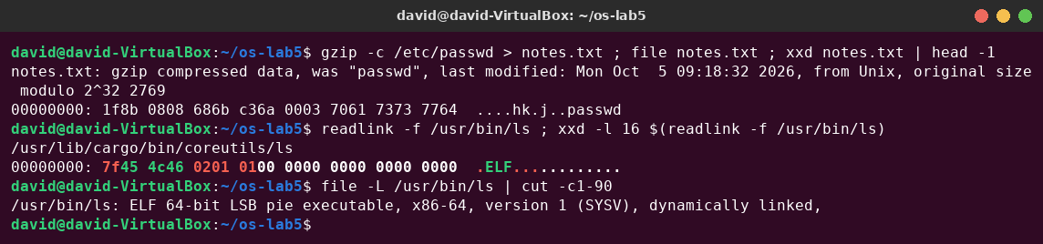
Figure 5.1 – Magic numbers of a gzip file and of an ELF program
notes.txt has a .txt name, but file reports “gzip compressed data”. file ignores the extension and reads the first bytes. Every gzip stream starts with the magic bytes 1f 8b (then 08 = deflate method), and the original name “passwd” is even stored in the header. In the same way, every Linux program starts with 7f 45 4c 46 = 0x7f “ELF”.

(b) Hunt for setuid programs
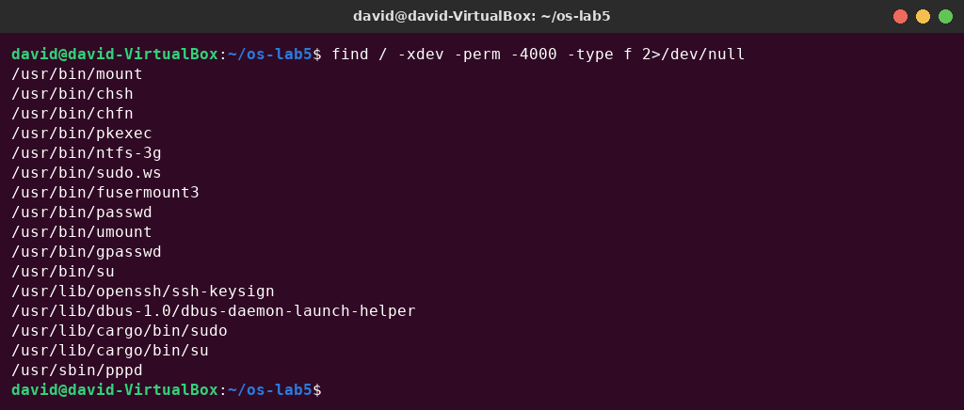
Figure 5.2 – setuid programs on the root file system
Besides the classic ones (passwd, su, sudo, mount, umount, chsh, chfn, gpasswd), this system has several less obvious setuid programs: pkexec (PolicyKit), fusermount3 (lets users mount FUSE file systems), ntfs-3g, pppd, ssh-keysign and the D-Bus launch helper. Ubuntu 26.04 also has two versions of sudo and su: the classic one (sudo.ws) and the new Rust version sudo-rs (/usr/lib/cargo/bin/sudo, su). Every one of them runs as root, so each is a possible attack surface.

(c) Delete a file that is still open
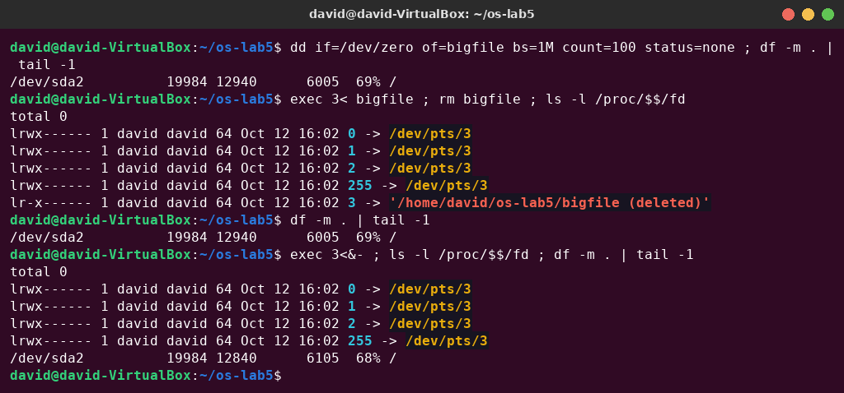
Figure 5.3 – A deleted file that is still open keeps its space
I created a 100 MB file (real blocks, written with dd), opened it on descriptor 3 of the shell, and deleted it. The link in /proc/$$/fd says 3 -> '/home/david/os-lab5/bigfile (deleted)'. The name is gone, but the inode is still in use. df still showed 12940 MB used. Only after exec 3<&- closed the last open descriptor did the kernel free the inode and the blocks: used space dropped to 12840 MB, so exactly the 100 MB were freed. A file is really deleted when its link count is 0 and no process has it open.

Conclusions
In this laboratory work I checked the file-system concepts in practice. The first letter of ls -l shows the file type (-, d, l, c, b), and on a modern system even /bin and ls are symbolic links. The most important idea is that a name is not the file: the file is the inode, and names are only directory entries that point to it. Hard links add names and increase the link count; rm only removes a name; and the data disappear only when the last name is removed and the file is no longer open. A symbolic link is a small separate file that stores a path, so it can become dangling. Directories have links too: their own name, “.” and the “..” of every subdirectory. The size of a file and the space it uses are different: blocks are allocated in units of 4 KiB, and sparse files use no space for holes.
Permissions are checked by the kernel for exactly one class (owner, group or others). Ownership only gives the right to chmod. On a directory, r means listing the names and x means passing through it. The umask decides the default permissions, the setuid bit lets passwd change /etc/shadow as root, and the sticky bit protects users' files in /tmp. Finally, lsblk, df and mount showed the disk sda with an ext4 root partition that is 68% full, and /proc showed that the kernel exposes the CPU, memory and even each process (/proc/self) as files.

