
MINISTRY OF EDUCATION AND RESEARCH OF THE REPUBLIC OF MOLDOVA
Technical University of Moldova
Faculty of Computers, Informatics and Microelectronics
Department of Software Engineering and Automatics

REPORT
on laboratory work no. 7
Course: Operating Systems
Topic: Three Small Programs: Processes, Redirection, a Pipe

Done by: st. gr. FAF-242, Florea David
Checked by: Reitman Patricia

Chișinău, 2026

Purpose of the work
The lecture asked three questions: how a process is born, where printf writes, and how ls | wc -l works. The purpose of this work is to run the answers on Linux with three short C programs, the same steps the shell does. run.c uses fork + exec + wait, zombie.c leaves a zombie on purpose, redirect.c does ls -l > out.txt, and pipeline.c does ls /etc | wc -l. For each program I compile it, run it, change one line, and explain what happens.
Environment: Ubuntu 26.04.1 LTS (VirtualBox VM), gcc (Ubuntu 15.2.0-16ubuntu1) 15.2.0. Everything was done in ~/os-lab7 (mkdir -p ~/os-lab7 && cd ~/os-lab7). Every program was compiled with gcc -Wall -Wextra without any warning.

Part 1. fork + exec + wait
run.c does what the shell does for ls -l: it copies itself with fork, the copy becomes ls with execlp, and the original waits for it with waitpid.
#include <stdio.h>
#include <stdlib.h>
#include <unistd.h>
#include <sys/wait.h>
/* the three steps of the shell for the command: ls -l */
int main(void)
{
printf("parent: my PID is %d\n", getpid());
fflush(stdout);
pid_t pid = fork(); /* step 1: copy myself */
if (pid < 0) { perror("fork"); return 1; }
if (pid == 0) { /* only the child runs this */
printf("child: my PID is %d, my parent is %d\n", getpid(), getppid());
fflush(stdout);
execlp("ls", "ls", "-l", (char *)NULL); /* step 2: become ls */
perror("exec"); /* runs only if exec failed */
exit(127);
}
int status;
waitpid(pid, &status, 0); /* step 3: wait for the child */
printf("parent: child %d ended with status %d\n", pid, WEXITSTATUS(status));
return 0;
}
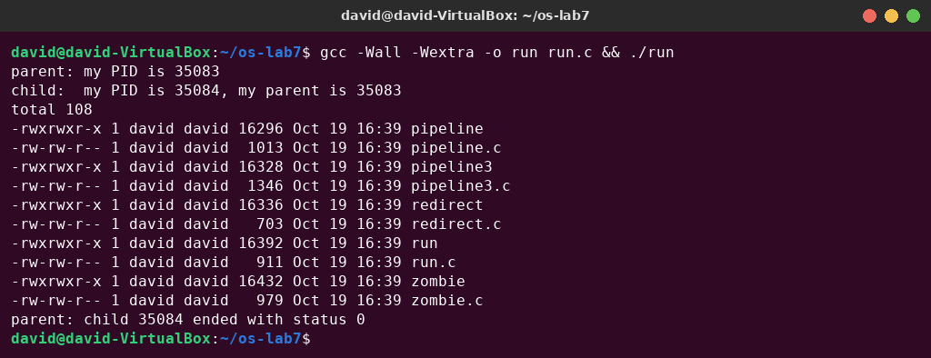
Figure 1.1 – run.c: the child becomes ls -l
The order of the lines is the expected one: the parent's line, the child's line, the listing produced by ls, and the parent's final line after waitpid returned. The child prints the PID of its parent (35083), which is the PID the parent printed in the first line.
Then I replaced the execlp line with execlp("date", "date", (char *)NULL); (with sed, to show the change), compiled and ran again:
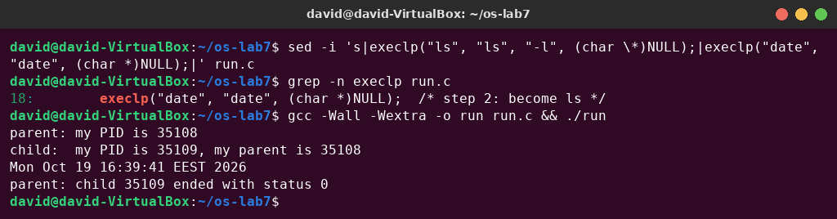
Figure 1.2 – The child becomes date
Next, a program that does not exist: execlp("nosuchprog", "nosuchprog", (char *)NULL);
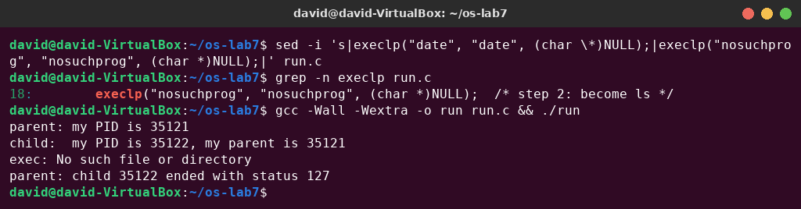
Figure 1.3 – exec of a program that does not exist
Finally I restored the original line (ls -l), which is the version submitted in the repository:
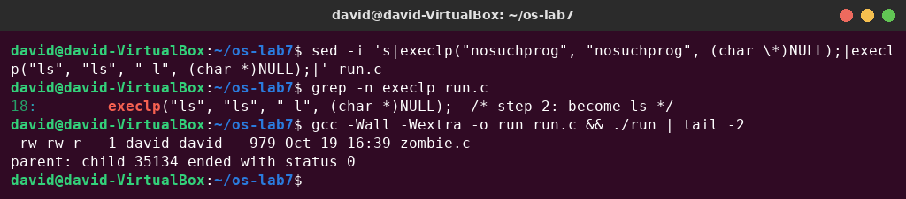
Figure 1.4 – run.c restored to ls -l

Observe – answers
1. The line perror("exec") is in the child, right after execlp. Why is it printed only with nosuchprog? When execlp succeeds, it never returns. The kernel replaces the whole memory image of the child (code, data, stack) with the new program, ls or date. The process keeps its PID and its open descriptors, but the code of run.c, including the perror line, no longer exists in it. execlp returns only when it fails, for example because no program called nosuchprog exists in PATH. Only then does the next line run and print exec: No such file or directory.
2. Which number does the child print as "my parent", and whose PID is it? It prints 35083 (getppid()), which is the PID of the original ./run process. The parent printed the same number in its first line, “parent: my PID is 35083”. fork returned the child's PID (35084) to the parent and 0 to the child.
3. What status does the parent see with ls, and what status with nosuchprog? With ls (and date) the status is 0, the exit code of ls, which succeeded. With nosuchprog the status is 127: exec failed, so the child ran exit(127) itself. WEXITSTATUS(status) extracts this number from the value filled in by waitpid. 127 is the same code bash uses for “command not found” (Lab 3).
Note – why fflush(stdout) before fork? printf only puts the text into a buffer inside the process. Without fflush, the unwritten buffer would be copied by fork, and the “parent:” line could be printed twice (for example when the output goes to a file or a pipe).

Part 2. A zombie, on purpose
zombie.c is run.c (the ls version) with one extra line, sleep(20);, just before waitpid:
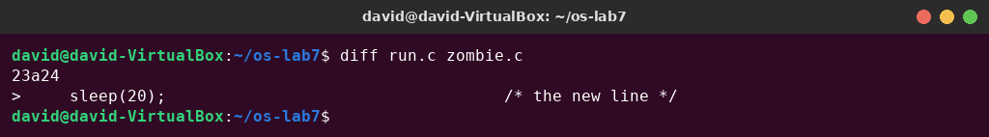
Figure 2.1 – The only difference between run.c and zombie.c
gcc -Wall -Wextra -o zombie zombie.c
./zombie > /dev/null &
sleep 2; ps -o pid,ppid,stat,cmd
sleep 20; ps -o pid,ppid,stat,cmd # 2.3: twenty seconds later
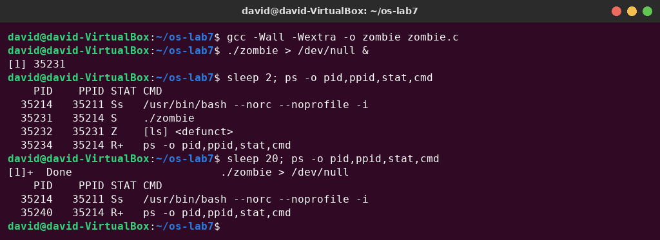
Figure 2.2 – The zombie [ls] <defunct>, and the table 20 seconds later
The first ps shows ./zombie (PID 35231, sleeping, S) and its child ls (PID 35232, PPID 35231) in state Z, shown as [ls] <defunct>. The first line is the bash session that ran the commands. 20 seconds later bash reported [1]+ Done ./zombie, and both lines had disappeared.

Observe – answers
1. Which letter does ls have in the STAT column, and what does it mean? Z, a zombie (defunct) process. ls has already finished, so it uses no memory or CPU, but the kernel still keeps its entry in the process table (PID, exit status, resource usage). The parent must read this status with wait. Until the parent calls wait, the dead child stays a zombie.
2. After 20 seconds, is the [ls] <defunct> line still there? Which line of zombie.c made it disappear? No, it is gone. The line waitpid(pid, &status, 0); reaped it: after sleep(20) the parent called waitpid, which read the exit status and let the kernel remove the zombie's entry. Then the parent printed its last line and exited too. (If a parent exits without waiting, its zombie children are adopted by init, which reaps them.)

Part 3. Redirection: ls -l > out.txt
redirect.c does what the shell does for ls -l > out.txt. In the child it closes descriptor 1, opens the file (which gets the smallest free number, 1), and then runs ls, which is not changed at all.
#include <stdio.h>
#include <stdlib.h>
#include <fcntl.h>
#include <unistd.h>
#include <sys/wait.h>
/* does the same as the shell command: ls -l > out.txt */
int main(void)
{
pid_t pid = fork();
if (pid == 0) {
close(1); /* descriptor 1 is now free */
int fd = open("out.txt", O_WRONLY | O_CREAT | O_TRUNC, 0644);
if (fd < 0) { perror("open"); exit(1); }
fprintf(stderr, "open gave descriptor %d\n", fd);
execlp("ls", "ls", "-l", (char *)NULL); /* ls writes to 1, as always */
perror("exec");
exit(127);
}
waitpid(pid, NULL, 0);
printf("done: the listing is in out.txt\n");
return 0;
}
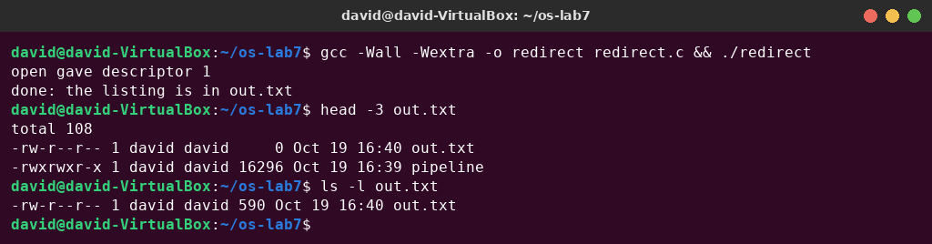
Figure 3.1 – redirect: the listing goes into out.txt
out.txt appears in its own listing with size 0. The file was created and truncated by open before ls ran, and ls was still writing into it. After ls finished, the file has 590 bytes.

Observe – answers
1. Which number did open give, and why exactly that one? 1 (“open gave descriptor 1”). open always returns the lowest-numbered descriptor that is free. 0 (stdin) was still open and 1 had just been closed, so 1 was the smallest free number. Descriptor 2 stayed connected to the terminal, which is why the fprintf(stderr, …) message still appeared on the screen.
2. ls was not changed at all. Why does its listing not appear on the screen? ls always writes its output to descriptor 1 and does not know what 1 is. exec replaces the program but keeps the table of open descriptors, so in the new ls, descriptor 1 still points to out.txt and not to the terminal. The redirection is done by the parent's code before exec, exactly as the shell does it.
3. To redirect the errors instead (like 2> err.txt), which descriptor would you close before open? Descriptor 2 (stderr): close(2); and then open("err.txt", …) would return 2, so the error messages of the program would go into the file, while the normal output stayed on the screen.

Part 4. A pipe: ls /etc | wc -l
pipeline.c builds the pipeline by hand, with one pipe and two forks. In ls, descriptor 1 becomes the writing end p[1]; in wc, descriptor 0 becomes the reading end p[0]. dup copies a descriptor into the smallest free number, exactly like open does.
#include <stdio.h>
#include <stdlib.h>
#include <unistd.h>
#include <sys/wait.h>
/* does the same as the shell command: ls /etc | wc -l */
int main(void)
{
int p[2];
if (pipe(p) < 0) { perror("pipe"); return 1; }
if (fork() == 0) { /* ls: its 1 becomes p[1] */
close(1);
dup(p[1]); /* smallest free number: 1 */
close(p[0]);
close(p[1]);
execlp("ls", "ls", "/etc", (char *)NULL);
perror("exec ls");
exit(127);
}
if (fork() == 0) { /* wc: its 0 becomes p[0] */
close(0);
dup(p[0]); /* smallest free number: 0 */
close(p[0]);
close(p[1]);
execlp("wc", "wc", "-l", (char *)NULL);
perror("exec wc");
exit(127);
}
close(p[0]); /* the parent uses neither end */
close(p[1]);
wait(NULL);
wait(NULL);
return 0;
}
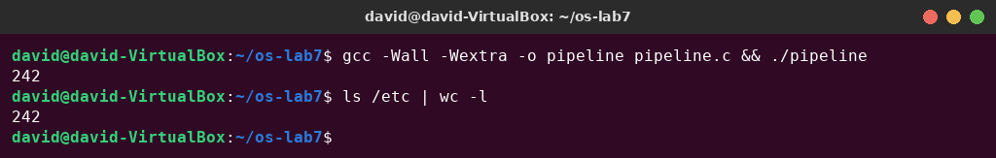
Figure 4.1 – pipeline compared with the real shell
Then I broke it on purpose: in the parent, the line close(p[1]); became a comment. The program did not end, so I stopped it with Ctrl-C (^C). To see which child was stuck, I ran it once more in the background and looked at the process table, then killed the whole job (kill -- -$! sends the signal to the process group of the job):
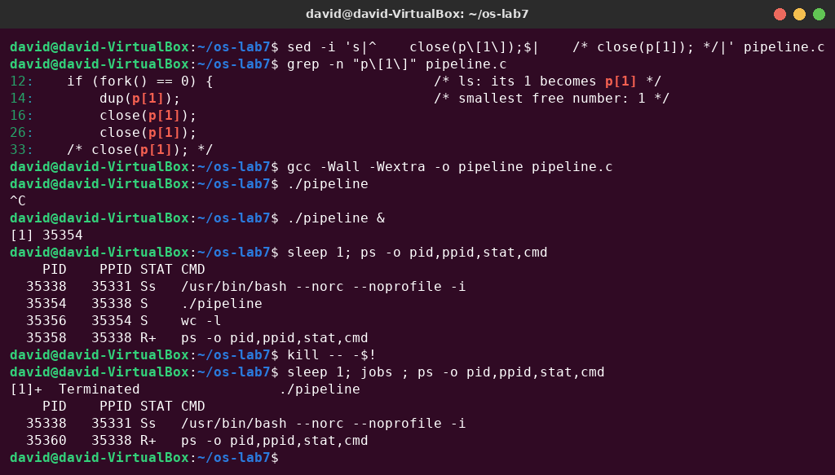
Figure 4.2 – The broken pipeline: wc never ends
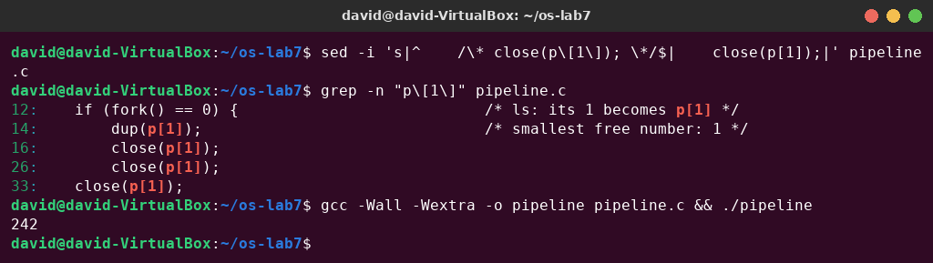
Figure 4.3 – pipeline.c restored: it ends again and prints 242

Observe – answers
1. Did ./pipeline and ls /etc | wc -l give the same number? Yes, both printed 242 (the number of entries in /etc).
2. After the change, which of the two children never ends, ls or wc? wc. In the ps output only ./pipeline and its child wc -l (state S, sleeping) are left. ls had already written its listing, exited, and been reaped by the parent's first wait.
3. Why, in one sentence: what is wc waiting for? wc keeps reading until end-of-file, and a pipe reports end-of-file only when every writing end is closed. The parent still holds p[1] open, so wc waits forever for more data, and the parent waits forever in wait() for wc.

Optional: three stages (pipeline3.c)
pipeline3.c does ls /usr/bin | grep x | wc -l with two pipes and three children: p connects ls → grep, and q connects grep → wc. Every child closes all four pipe ends after its dups, and so does the parent; otherwise grep or wc would never see end-of-file, as in the broken version above.
#include <stdio.h>
#include <stdlib.h>
#include <unistd.h>
#include <sys/wait.h>
/* does the same as the shell command: ls /usr/bin | grep x | wc -l */
static void closeall(int a[2], int b[2])
{
close(a[0]); close(a[1]);
close(b[0]); close(b[1]);
}
int main(void)
{
int p[2], q[2]; /* p: ls -> grep, q: grep -> wc */
if (pipe(p) < 0 || pipe(q) < 0) { perror("pipe"); return 1; }
if (fork() == 0) { /* ls: its 1 becomes p[1] */
close(1);
dup(p[1]);
closeall(p, q);
execlp("ls", "ls", "/usr/bin", (char *)NULL);
perror("exec ls");
exit(127);
}
if (fork() == 0) { /* grep: 0 is p[0], 1 is q[1] */
close(0);
dup(p[0]);
close(1);
dup(q[1]);
closeall(p, q);
execlp("grep", "grep", "x", (char *)NULL);
perror("exec grep");
exit(127);
}
if (fork() == 0) { /* wc: its 0 becomes q[0] */
close(0);
dup(q[0]);
closeall(p, q);
execlp("wc", "wc", "-l", (char *)NULL);
perror("exec wc");
exit(127);
}
closeall(p, q); /* the parent uses no end */
wait(NULL);
wait(NULL);
wait(NULL);
return 0;
}
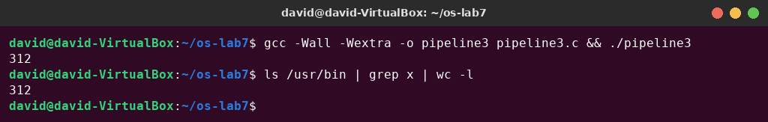
Figure 4.4 – pipeline3 prints the same number as the shell

Conclusions
With four short programs I ran, on Linux, what the shell does for every command. A process is born with fork (a copy of the parent, with its own PID), becomes another program with exec (which never returns when it succeeds, but keeps the PID and the open descriptors), and is waited for with wait/waitpid, which also collects its exit status (0 for ls, 127 for a failed exec). A child that has ended but has not been waited for stays a zombie (state Z) until its parent calls wait.
printf writes to descriptor 1, whatever 1 is. Because open and dup always use the smallest free number and exec keeps the descriptors, closing 1 and then opening a file (redirection) or duplicating a pipe end (a pipeline) changes where an unmodified program like ls writes. The broken pipeline showed the most important rule about pipes: the reader gets end-of-file only when every write end is closed, so every process must close the pipe ends it does not use.

