
MINISTRY OF EDUCATION AND RESEARCH OF THE REPUBLIC OF MOLDOVA
Technical University of Moldova
Faculty of Computers, Informatics and Microelectronics
Department of Software Engineering and Automatics

REPORT
on laboratory work no. 4
Course: Operating Systems
Topic: The xv6 Shell from the Outside

Done by: st. gr. FAF-242, Florea David
Checked by: Reitman Patricia

Chișinău, 2026

Purpose of the work
The purpose of this laboratory work is to understand what a shell must do and what bash adds on top of that. I use the xv6 shell (user/sh.c, about 500 lines) side by side with bash, and find the differences by experiment. I also write a small program that prints the arguments it receives. It shows exactly who expands * and who removes quotes. Finally, I read the source of the xv6 shell to explain the observed behaviour. As a preparation step, the sleep program from Lab 2 is checked against the current xv6, where the sleep() system call was renamed pause().
Environment: Ubuntu 26.04.1 LTS (VirtualBox VM), xv6-riscv at revision 06aad25 in ~/xv6-riscv, QEMU for RISC-V. bash os2026-setup.sh --check passed: the tools are present, xv6 builds, and xv6 booted and ran ls.

Part 1. Fix sleep for the current xv6
cd ~/xv6-riscv
grep -n "pause\|sleep" user/user.h
user.h declares only int pause(int); (line 25); there is no sleep() any more. So my tree already uses the new name.
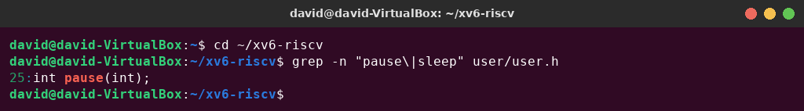
Figure 1.1 – The grep result in user.h
My user/sleep.c from Lab 2 already calls pause(atoi(argv[1])), and $U/_sleep\ is in UPROGS in the Makefile (each line starts with a TAB and ends with a backslash).
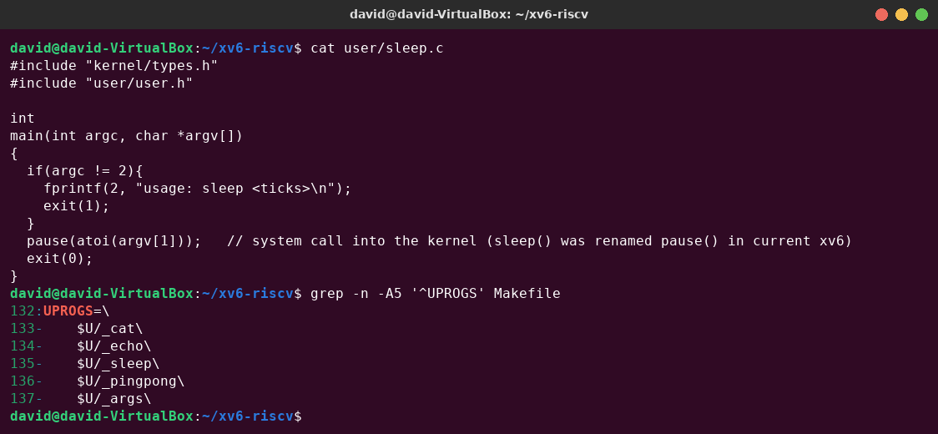
Figure 1.2 – The updated sleep.c and the UPROGS lines
After make qemu, sleep 20 paused for 20 ticks (about 2 seconds) before the prompt came back, and sleep without an argument printed the usage message and exited with status 1.
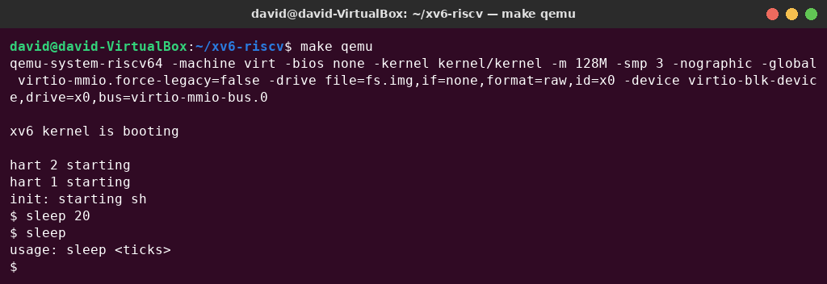
Figure 1.3 – sleep running in xv6, with and without an argument

Part 2. bash versus the xv6 shell
Every command was run twice. In bash, it ran in an empty test folder that contains a README file (mkdir ~/shtest && cd ~/shtest && touch README). In xv6, it ran at the $ prompt after make qemu, in the root directory, where README and all the programs live. Table 2.1 summarises what each shell printed and why.
Table 2.1 – The same commands in bash and in the xv6 shell
Command | Tests | bash | xv6 | Why
echo hello > f ; cat < f | redirection | hello | hello | Both shells support < and >: the shell opens the file and replaces fd 0 / fd 1 before exec (REDIR in xv6).
ls | grep READ | pipe | README | README 2 2 2441 | Both connect the two programs with a pipe. xv6 ls prints name, type, inode and size on one line, so grep shows the whole line.
(echo a; echo b) | wc | grouping, list | 2 2 4 | 2 2 4 | Both parse ( ) and ;. The output of both echo commands goes into one pipe: 2 lines, 2 words, 4 bytes.
echo one ; echo two | sequence | one  two | one  two | Both run the commands one after another (LIST in xv6).
echo bg & | background | [1] 25315  bg  [1]+ Done echo bg | bg$ | Both run the command without waiting. bash has job control: job number, PID and a “Done” message. xv6 only forks; the output races with the next prompt, so “$” was printed right after “bg”.
ls * | globbing | README f | ls: cannot open * | bash replaces * with the file names. xv6 has no globbing, so ls receives the literal “*”.
echo $HOME | variables | /home/david | $HOME | bash expands variables. xv6 has no variables (and no environment), so $HOME is just text.
echo "a b" | quotes | a b | "a b" | bash removes the quotes and keeps a b as one word. xv6 does not know quotes: it splits at the space and echo prints the quote characters.
mkdir d ; cd d ; ls .. | PATH | README d f  (prompt is now ~/shtest/d) | exec cd failed  + listing of / | bash: cd is a built-in and ls is found through PATH. xv6 handles cd only when the line starts with “cd ”. Inside a list it tries to exec a program “cd”, which does not exist. The shell stays in /, and ls .. lists / (.. of the root is the root).
arrow up, Tab, Ctrl+R | history, completion | previous line recalled; ../REA → ../README; (reverse-i-search) found the echo hello line | no effect: the key codes become part of the line → exec … failed | bash (readline) has history, completion and search. The xv6 console only supports backspace and Ctrl-U, so the raw bytes (ESC [ A, TAB, Ctrl-R) are sent to the shell as characters.

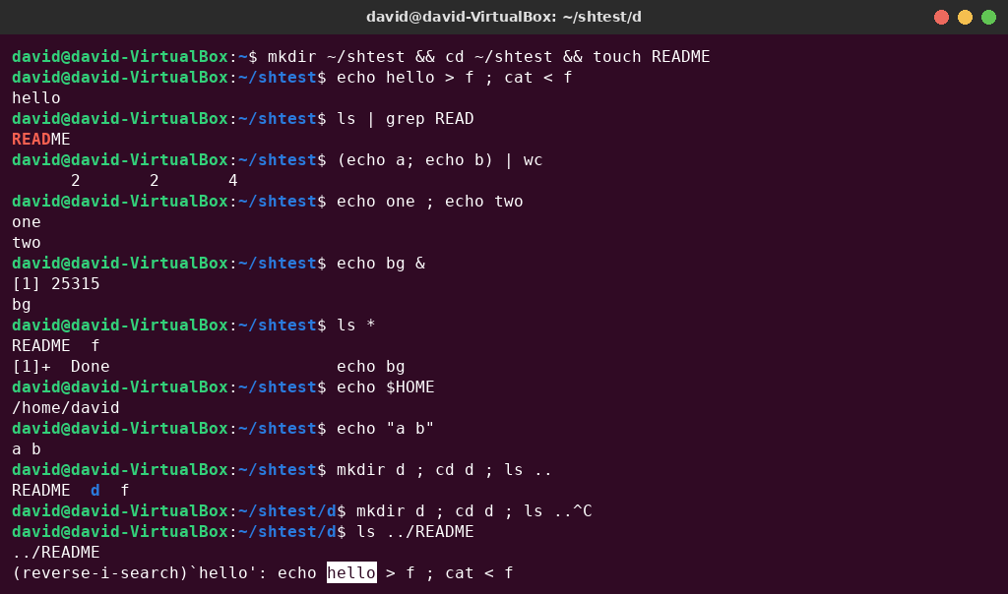
Figure 2.1 – The commands run in bash
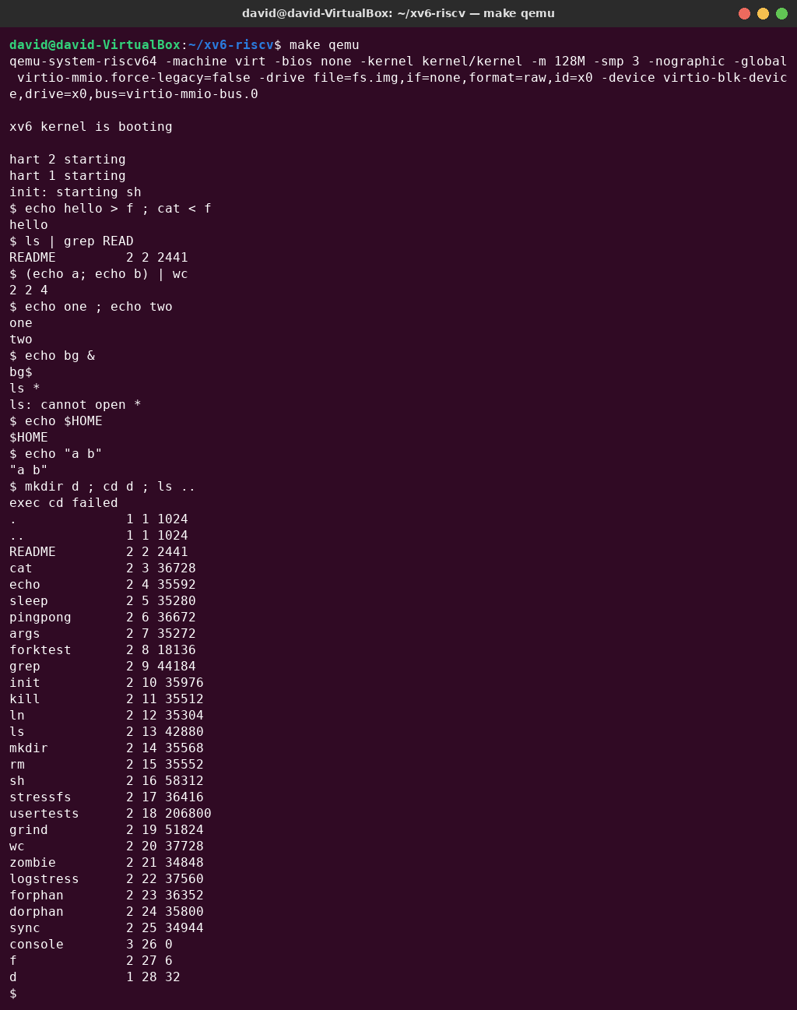
Figure 2.2 – The same commands run in xv6
After a plain cd d (on its own line, so the shell handles it), ls and ls .. both fail with exec ls failed. Giving the path of the program works: /ls, /ls .. | /grep README and ../echo hello from d. After cd /, the short names work again.
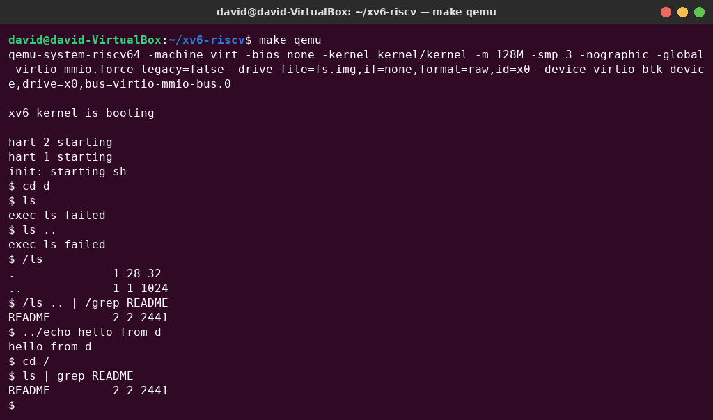
Figure 2.3 – ls failing after cd d, and the working alternative
History and completion in xv6 (Figure 2.4). After echo one I pressed the up arrow and Enter. The terminal sends the bytes ESC [ A, the xv6 console echoes them back, and my terminal interprets them as “cursor up”. That is why “failed” is printed over the line “one”: the shell tried to exec a program called “ESC[A”. ec + Tab + Enter gives exec ec failed, because the Tab is only a whitespace character. Ctrl+R followed by one gives exec one failed, because the Ctrl-R byte is invisible and is not a command.
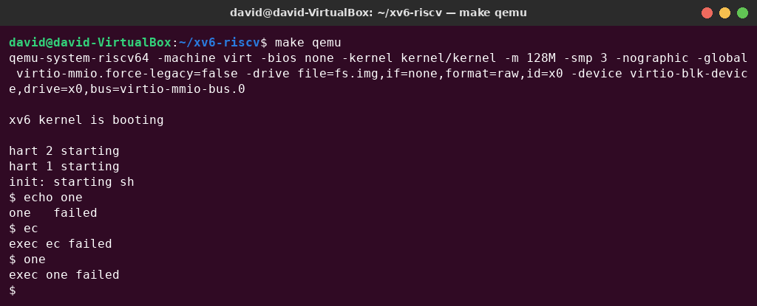
Figure 2.4 – Arrow up, Tab and Ctrl+R in the xv6 shell

Observe – answers
1. List the features both shells have, and the ones only bash has. Both: running programs with arguments, redirection < > (and >>), pipes |, sequences with ;, grouping with ( ), background execution with &, and a built-in cd. Only bash: globbing (* ? [ ]), variables and the environment ($HOME), quoting with ' " and \, searching programs in PATH, job control (jobs, %1, “Done” messages), command history (arrow keys, Ctrl+R), Tab completion and line editing, cd anywhere in a list, && and ||, 2>&1, command substitution $( ), arithmetic $(( )), brace expansion { }, and the scripting language (if, for, functions).
2. In xv6, ls stops working after cd d. Why? Find a way to run ls from inside d anyway. The xv6 shell has no PATH. It calls exec(argv[0], argv) with the name exactly as typed, and the kernel looks the name up relative to the current directory. All xv6 programs are in the root directory /, so ls works only while the current directory is /. Inside /d, “ls” means /d/ls, which does not exist. Workarounds: use the absolute path /ls (or /ls ..), use the relative path ../ls, or go back with cd / (Figure 2.3).
3. Which missing feature would you miss most in daily work, and which would be easiest to add? I would miss command history with Tab completion the most, followed by globbing, because they save the most typing. The easiest feature to add is a PATH-like fallback: in runcmd(), case EXEC, if exec(argv[0]) fails and the name has no '/', try again with "/" in front of it. That is a few lines of code, and ls would work from any directory. Allowing cd inside a list would also be simple: handle an EXEC command named “cd” in the parent.

Part 3. Who expands *? A program that prints its argv
user/args.c prints argc and every argv[i] between brackets, so that spaces are visible. $U/_args\ was added to UPROGS after $U/_pingpong\.
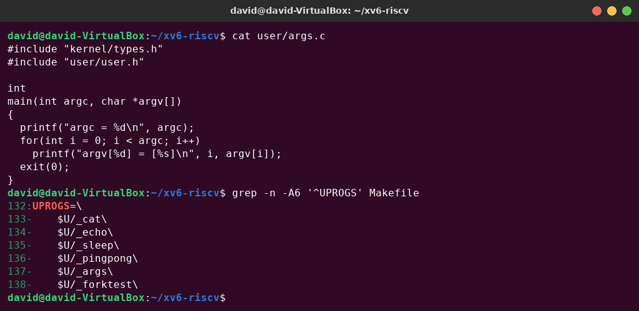
Figure 3.1 – args.c and the UPROGS line
The same lines were run at the xv6 prompt:
args one two three
args *.c "x y"
args $HOME
args 'single quoted'
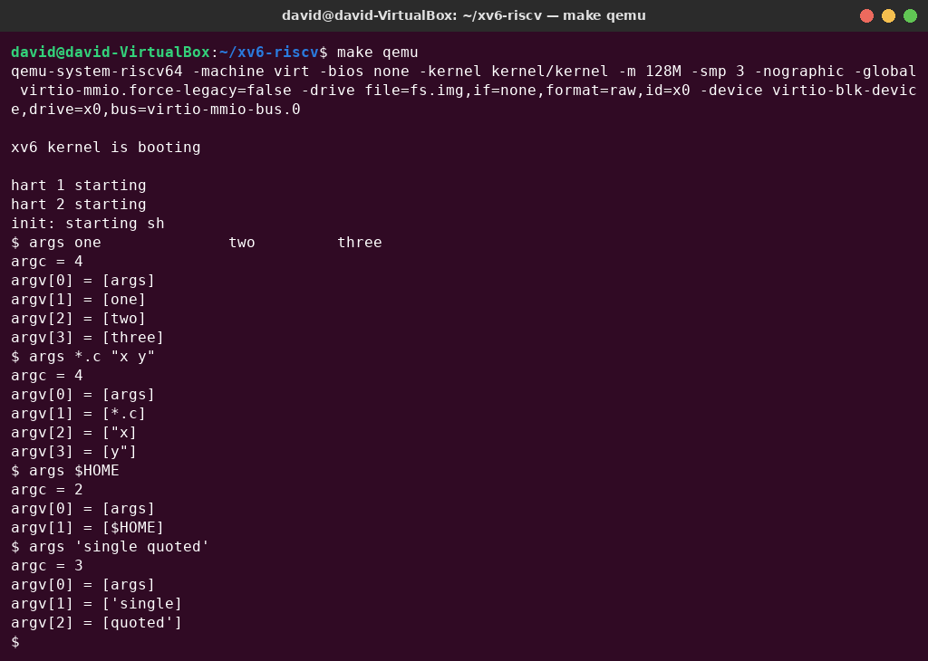
Figure 3.2 – args output in xv6
For Linux, args_linux.c is the same program with #include <stdio.h> and return 0. It was compiled with gcc -o args args_linux.c in ~/os-lab4, a folder with three .c files (args.c, args_linux.c, sleep.c), and run with ./args:
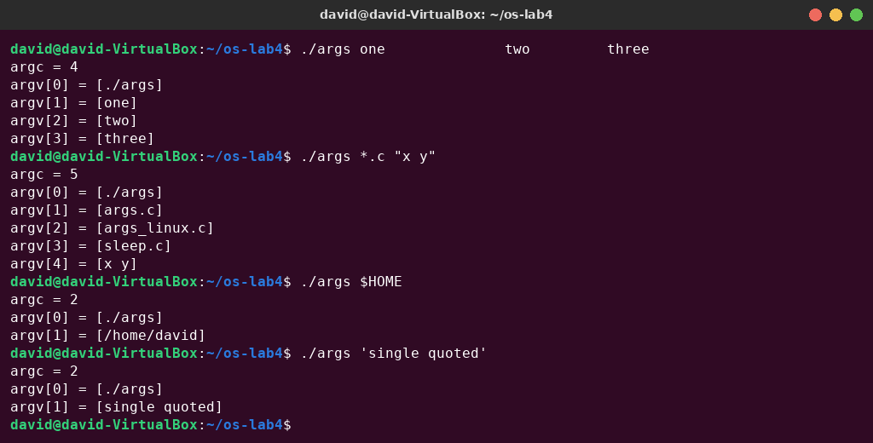
Figure 3.3 – args_linux output in bash
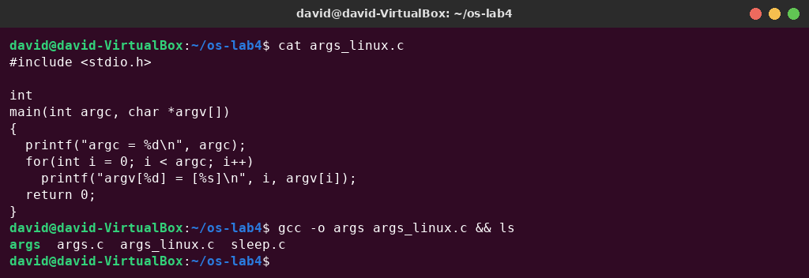
Figure 3.4 – args_linux.c and its compilation

Observe – answers
1. Paste both outputs for args *.c "x y". How many arguments did each program receive?
xv6: bash (Linux):
argc = 4 argc = 5
argv[0] = [args] argv[0] = [./args]
argv[1] = [*.c] argv[1] = [args.c]
argv[2] = ["x] argv[2] = [args_linux.c]
argv[3] = [y"] argv[3] = [sleep.c]
argv[4] = [x y]
In xv6 the program received 4 arguments (its name plus 3): the literal *.c, and "x and y" with the quote characters still attached. In bash it received 5 (its name plus 4): the three .c file names and the single argument x y, without quotes.
2. So who turns *.c into file names and removes the quotes: the program, the kernel, or the shell? The shell. The program is the same C code in both cases, and it only prints what it gets. The kernel does not change the arguments either: exec() copies the argv strings unchanged into the new process. The difference is in what the shell puts into argv. bash performs globbing, variable expansion ($HOME → /home/david) and quote removal ('single quoted' → one argument) before calling exec. The xv6 shell only splits the line at whitespace.
3. What happened to the extra spaces in one two three? They disappeared in both shells: argc = 4 and the arguments are exactly [one] [two] [three]. A run of spaces only separates words, and the shell throws it away while splitting the line (xv6 skips every character from its whitespace[] list). The program never sees the spaces. To keep them, in bash the text must be quoted; xv6 has no way to do this.

Part 4. Read the shell
wc -l user/sh.c
grep -n "#define" user/sh.c # the kinds of commands
grep -n "case " user/sh.c # where each kind is run
grep -n "cd" user/sh.c | head
The whole xv6 shell is 499 lines.
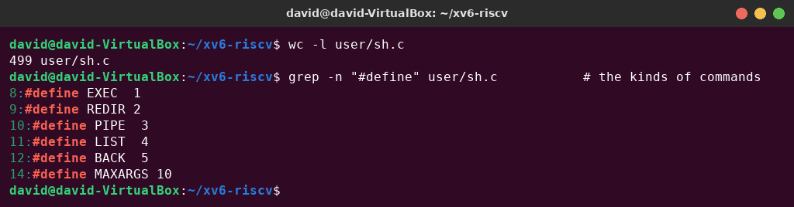
Figure 4.1 – The command kinds defined in sh.c
Lines 75–125 are the cases of the switch in runcmd(), which executes each kind of command. Lines 284–294 are in gettoken(), which recognises the special characters. Lines 391–397 are in parseredirs(), and lines 469–493 are in nulterminate(), which ends the strings of each kind of node.
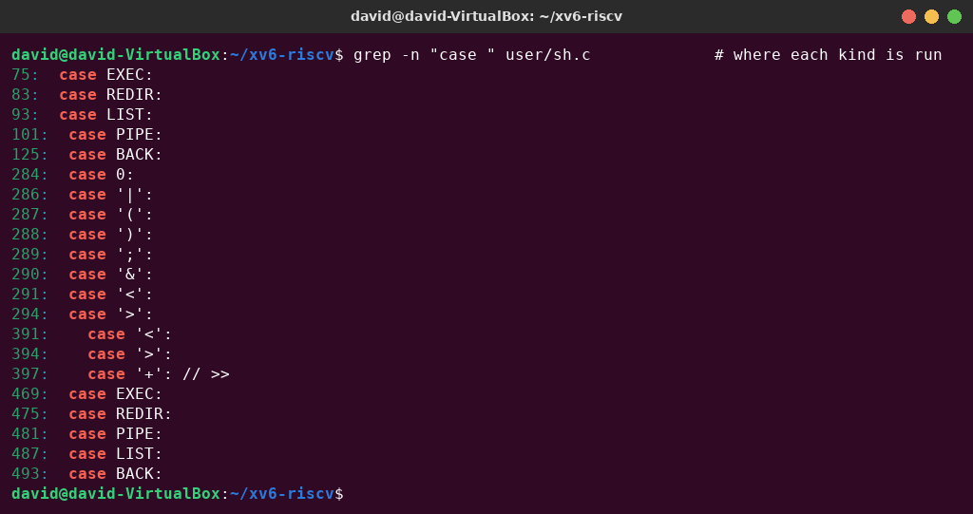
Figure 4.2 – Where each kind is run
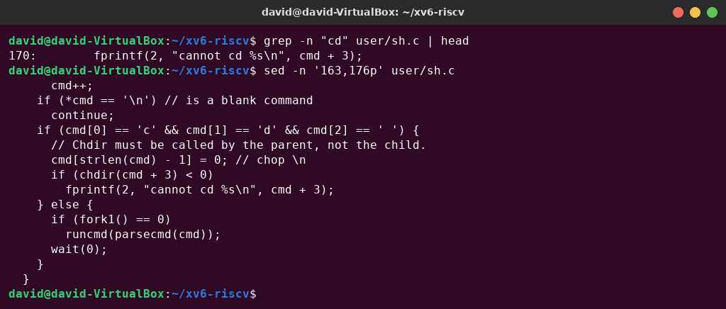
Figure 4.3 – The code that handles cd
To answer question 3, I searched sh.c for any handling of $ and *, and printed the characters the tokenizer treats as special:
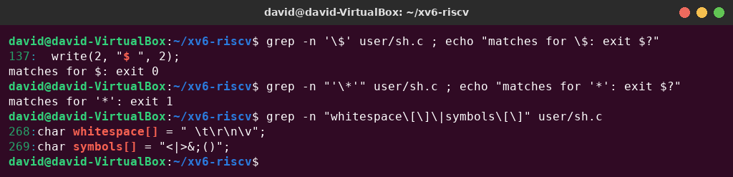
Figure 4.4 – Searching sh.c for code that handles * or $

Observe – answers
1. Name the five kinds of command the xv6 shell knows and the character that produces each. EXEC (1) – a plain command with its arguments, produced by ordinary words (no special character); REDIR (2) – redirection, produced by <, > and >>; PIPE (3) – produced by |; LIST (4) – a sequence, produced by ;; BACK (5) – a background command, produced by &. Parentheses ( ) only group commands and do not create a new kind. MAXARGS (10) is not a kind of command; it is the maximum number of arguments.
2. Where is cd handled, and why is it not run as a separate program? In main(), lines 166–170, before any fork. If the line starts with “cd ”, the shell itself calls chdir(cmd + 3) and prints “cannot cd …” on error; every other line is run by a forked child (fork1() + runcmd). The comment says it: “Chdir must be called by the parent, not the child.” The current directory belongs to each process, so a separate cd program, or a forked child, would change only its own directory and then exit; the shell would not move. This check only looks at the beginning of the line, which explains “exec cd failed” for mkdir d ; cd d ; ls .. in Part 2.
3. Search sh.c for any code that handles * or $. What does that explain about Part 2? There is none. The only $ in the file is the prompt string write(2, "$ ", 2) on line 137, and there is no '*' character test at all. The tokenizer knows only whitespace[] = " \t\r\n\v" and symbols[] = "<|>&;()"; every other character, including *, $, ' and ", is an ordinary part of a word. This explains Part 2 and Part 3: ls * receives a literal *, echo $HOME prints $HOME, and quotes are printed instead of being removed. Globbing, variables and quoting simply do not exist in this shell.

Conclusions
Running the same commands in bash and in the xv6 shell showed that the core of a shell is small. It reads a line, splits it into words, builds a tree of five kinds of command (exec, redirection, pipe, list, background), and runs the tree with fork, exec, open/close/dup, pipe and wait. With these ~500 lines xv6 already supports redirection, pipes, sequences, grouping and background jobs. cd has to be a special case run by the shell itself, because the current directory belongs to each process.
Everything else that makes bash comfortable is added on top: PATH search, globbing, variables, quoting, job control, history, completion and a scripting language. The args program showed this clearly. The same C code, under the same kernel exec interface, received 4 arguments in xv6 and 5 in bash for the same line. So the shell, not the program and not the kernel, expands *, substitutes $HOME, removes quotes and throws away extra spaces. Reading sh.c confirmed it: the tokenizer knows only whitespace and the symbols <|>&;(). I also confirmed that sleep from Lab 2 works on the current xv6 using pause().

